STATE OF MARYLAND
AGRICULTURAL OUTREACH PLAN

July 1, 2014 through June 30, 2015
Program Year 2014

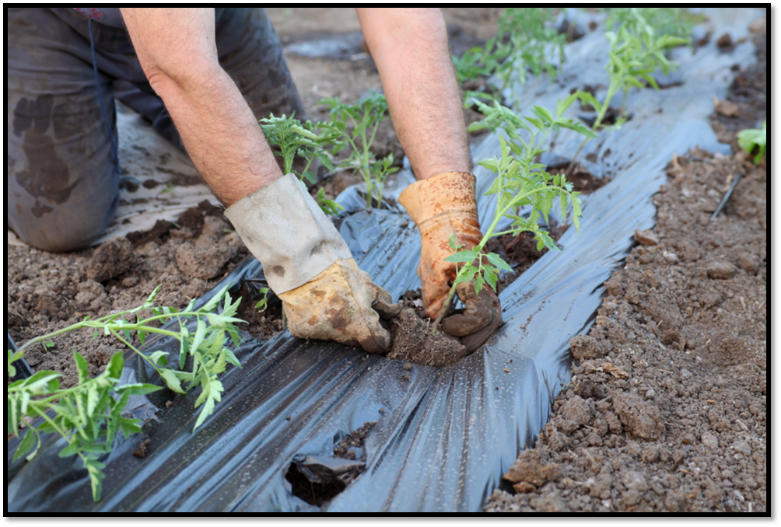





April 18, 2014

INTRODUCTION
This Agricultural Outreach Plan sets policies and objectives in providing workforce services to the agricultural community, including agricultural employers and migrant and seasonal farm workers (MSFWs). Maryland provides equitable services through its network of workforce providers--Maryland Jobs Now, A proud partner of the American Job Center network--offering the full range of employment, training, and educational services qualitatively equivalent and quantitatively proportionate to services provided to non-MSFWs.
The Maryland State Monitor Advocate works continuously reviewing state-wide agricultural activities and the provision of labor exchange and training services to employers and employees within agricultural communities. Consistent with historical trends, agriculture in Maryland continues to be a multi-billion dollar enterprise. However, as is illustrated in the table below, agricultural jobs in Maryland as of February 2014 did not rank within the top ten industries with advertised job openings in the Maryland Workforce Exchange-Virtual One Stop (MWE-VOS).

 | Industry | Job Openings (February 2014)
1 | Accommodation and Food Services | 6,422
2 | Administrative and Support and Waste Management and Remediation Services | 12,590
3 | Agriculture, Forestry, Fishing and Hunting | 119
4 | Arts, Entertainment, and Recreation | 799
5 | Construction | 1,066
6 | Educational Services | 4,709
7 | Finance and Insurance | 6,058
8 | Health Care and Social Assistance | 16,220
9 | Information | 3,866
10 | Management of Companies and Enterprises | 341
 | Agricultural Jobs Advertised In Maryland By County
1 | Montgomery County | 19
2 | Baltimore County | 12
3 | Queen Anne's County | 7
4 | Prince George's County | 6
5 | Howard County | 6
6 | Frederick County | 6
7 | Carroll County | 6
8 | Harford County | 5
9 | Anne Arundel County | 5
10 | Washington County | 4

Occupational projections in Farming, Fishing, and Forestry Occupations are illustrated in the following table.
2012 Estimated Employment | 2014 Projected Employment | Annual Avg. Percent Change | Total 2012-2014 Employment Change | Action
5,742 | 5,923 | 1.56% | 181 | Profile
State of Maryland Department of Labor, Licensing and Regulation • PY14 Agricultural Outreach Plan 3

The table above indicates that human labor needs in Farming, Fishing, and Forestry occupations demonstrate no significant change in demand. The majority of agricultural labor in Maryland is accomplished by family members on family-run farms. Those migrant and seasonal farm worker individuals working in the agricultural labor pool admit overwhelmingly to having an undocumented status and therefore are ineligible for services by statute, thus explaining why Maryland’s reporting numbers for use of workforce services have declined. Telamon Corporation, Maryland’s WIA 167 partner, shares concern about the lack of eligible agricultural workers across the state. Seeking eligible agricultural workers and offering a full array of workforce services to them, Maryland continues to collaborate with Telamon Corp. in its efforts. Maryland’s trend of increasing use of the foreign worker (H2A) program and simultaneous stagnation or disappearance of jobs in remaining crop activities is expected to continue in PY 2014. Farmers using the H2A program report a stable workforce; the same H2A Visa holders have been returning to work at the same farms for numerous years.

ASSESSMENT OF NEED
The three major crop activities across Maryland continue to employ a declining number of migrant and seasonal farmworkers:
- Nursery stock generally employs workers across the state from March through November. The severity of winter 2013-2014 resulted in damage to stock, reducing the needed workforce for the 2014 growing season.
- Vegetable farms, including mostly tomatoes, melons, corn, and fresh produce for wholesale and retail outlets, employ workers mostly on the Eastern Shore for a short period mainly in July and August.
- Fruit orchards, consisting mostly of apple growers but including some peaches and occasionally other fruit, employ workers generally along Maryland’s northern border, i.e. the Mason-Dixon Line, from July through October, depending on the varieties of fruits grown at the particular orchard. Due to the severe winter, it is anticipated that the peach crop may not be as productive in 2014.
These three crop activities may employ approximately 1,200 workers across the state from March through November. The levels of employment are largely dependent upon weather conditions and the availability of worker crews who have traditionally passed through Maryland. These traditional worker crews have diminished in number and size. Historically, Maryland was the destination for labor crews numbering in the low twenties, and each crew consisted of between twenty and thirty members, as that number was easily accommodated on buses that traveled for agricultural migratory labor. Records indicate the following:
- Maryland has historically issued its own permits to agricultural crew leaders.
- The number of permits issued annually continues to decline to a level now representing only a handful of crew leaders.
- Crew members usually number in the single digits.
- Fruit orchards across Maryland appear to employ an ever-increasing number of independent workers who are relatives or associates of workers who have worked previously in individual orchards; however, the number of these workers also continues to decline.
While productive acreage in nursery stock climbs slightly from year to year, due mostly to increases in family-owned operations, the productive acreage in vegetables and fruits continues to decline slightly each year. However, It would appear that the net change in the levels of production remain relatively consistent, again dependent on weather and growing conditions.

OUTREACH ACTIVITIES
Maryland’s Wagner-Peyser staff has consistently out-performed their annual goal of reaching over 50 percent (a historical average) of the migrant and seasonal farm workers who live and work in Maryland. Consistent with this performance and the resources available, staff and partners will endeavor to provide outreach services to at least 700 farm workers of the estimated 1,200 general MSFW population, or approximately 60 percent, for PY2014. The majority of MSFW outreach contacts among the state total will occur on the Eastern Shore of Maryland.
The number of state agency staff who conduct outreach to migrant and seasonal farm workers has remained consistent in past years at 2.5 full-time equivalent positions. Those positions include the State Monitor Advocate, State Rural Services Coordinator, and several local office staff. Salisbury’s Job Center does not meet the federal regulatory requirements or definition of a significant bilingual office, though the Center operates significant outreach to migrant and seasonal farm workers and Spanish speakers, as well as a small amount of service provision to Creole speakers. Services are provided in this Center in cooperation with the state WIA 167 grantee, Telamon Corporation. All Centers across the state are included in a three-tier system for provision of translation services accessible through Maryland State Department of Budget and Management blanket orders.
These contracts provide Maryland State agencies (as well as Maryland's other non-State government entities such as the local governments, counties, municipalities, etc.) with competent, continuously-available language translation services to minimize or eliminate any language barrier in three Service Category Areas:

- By telephone (Language Line Services)
- By agency on-site with pre-arrangement (Ad Astra, Inc.)
- By written document translation (Schreiber Translations, Inc.)

These services provide an on-demand, easy-to-use, cost-effective sources of language interpretation to state government personnel and other entities. All interpreting services included in these contracts are available twenty-four hours per day, seven days per week.

MSFW Proposed Outreach Activities 2014-2015
 | Eastern Shore* | Mason-Dixon Bordering Areas** | Balance of State***
# of MSFW’s to be contacted by Wagner-Peyser staff | 350 | 35 | 15
# of MSFW’s to be contacted by partners | 300 | 0 | 0
Total # of MSFW | 650 | 35 | 15
# of staff (FTE) | 1.3 | 1 | .2

Chart Headings Identifying County List:
*Kent, Queen Anne’s, Caroline, Dorchester, Worcester, Somerset
**Garrett, Alleghany, Washington, Frederick, Carroll, Baltimore, Harford, Cecil
***Howard, Montgomery, Anne Arundel, Prince George’s, Calvert, Charles, St. Mary’s

The majority of outreach and marketing of American Job Center services to the agricultural community in Maryland is accomplished through personal contact. Agricultural workers rarely frequent any of the 34 Job Centers, with the exception of the Salisbury Center, in which Telamon Corporation is a co-located partner and is a discernable attraction for employers and job seekers to that particular Center. Agricultural employers even more rarely access Job Center services. However, it must be noted that Maryland provides assistance to 65 percent of the employers who utilize the agricultural foreign worker program (H2A). The Division of Workforce Development and Adult Learning endeavors to provide informational media, mostly brochures and other printed items. For example, one specific brochure available to workers is available in Spanish/English and French/English. All Job Center staff are trained and kept up-to-date with current information regarding MSFW services and ways to identify individuals. Agricultural employer groups are invited to informational sessions and technical assistance forums in union with affiliated groups and organizations. A variety of resources can be accessed through MWE-VOS, Maryland’s workforce data system, including multi-media and multi-lingual resources relevant to Maryland’s agricultural community.
In spite of continued efforts by state and cooperating agency staff to provide outreach services, most recent quarterly reports to USDOL regarding Service to Migrant and Seasonal Farm Workers (ETA 5148) reflect no MSFWs being recorded in the state data system (MWE-VOS), and therefore Equity Ratio Indicators cannot mathematically be computed. The conclusions of experienced outreach staff and the State Monitor Advocate suggest the reason for non-participation of MSFWs is two-fold: firstly, upwards of 95 percent of MSFWs encountered in the places where they live or work voluntarily self-attest that they are undocumented and therefore ineligible for services; secondly, most MSFWs express they are only “passing through” the state, have established permanent residences elsewhere, and do not desire to participate in workforce services in Maryland. Local staff continually review data system information to ascertain the accuracy of MSFW identification and service provision when appropriate. Outreach continues as described in this plan. Also, the State Monitor Advocate continually reviews the provision of services to the agricultural community ensuring Maryland continues to exceed program goals and requirements.

SERVICE PROVIDED TO MSFWs THROUGH MARYLAND JOBS NOW, A PROUD PARTNER IN THE AMERICAN JOB CENTER NETWORK
The full range of services to MSFWs is provided through Maryland’s American Job Center network. The centers and staff provide services to job seekers such as:
- Job search workshops and resources including internet access
- Veterans services
- Federal, state, and local government information
- Career planning and training programs
- Labor market information
- Bilingual assistance
- Complaint handling
Eligible MSFW customers may access intensive and training services through American Job Center WIA programs. Staff work collaboratively developing individualized employment strategies and training plans for eligible customers. Intensive services may include and are not limited to customized assessments, group counseling, individualized career planning, case management, and short-term pre-vocational services. Training services may include occupational skills training, on-the-job training, skill upgrading and re-training, adult education and literacy activities in combination with other training services.
Outreach, occurring mostly through personal contact in places where MSFWs live or work, usually includes packets of printed information. These packets contain varieties of information, usually in both Spanish and English, regarding DLLR’s Apprenticeship program, youth services, ESL class, hot jobs, health care resources, unemployment compensation, and listings for contacting all American Job Centers within Maryland. Outreach workers consistently provide information on seasonal or short-term non-agricultural job openings where workers may wish to transition when agricultural work opportunities have concluded.
Partnerships with other state and local agencies--most notably, Telamon Corporation, the county Health Departments, the Maryland Farm Bureau, Maryland Legal Air Bureau, and agencies in rural Eastern Shore-- enhance the agency’s ability to achieve maximum penetration into the MSFW population by reaching local workers as well as MSFWs. In addition, the State Monitor Advocate has developed strategic partnerships with community-based organizations such as those mentioned to maximize resources and provide support services to the agricultural community. These partnerships provide the State Monitor Advocate with an opportunity to share knowledge of farm worker needs, characteristics, and concerns with other organizations and cooperatively develop solutions to any deficiencies in the delivery of services to MSFWs. As history demonstrates in Maryland, many agency staff continue to work through challenges of declining resources and declining populations.

SERVICES PROVIDED TO AGRICULTURAL EMPLOYERS THROUGH MARYLAND JOBS NOW, A PROUD PARTNER IN THE AMERICAN JOB CENTER NETWORK
Maryland’s American Job Center business services teams make every effort to assure provision of the highest quality of services to agricultural employers. Local staff maintain close positive relationships with agricultural employers, especially employers who participate in the Foreign Labor program, H2A, and employers who participate annually in Maryland’s agricultural wage surveys. Typical business services provided by Job Center staff may include the following:
- Access to top workforce talent and staff
- Current labor market information
- Continuous exposure for job openings posted through the Maryland Workforce Exchange
- Assistance with occupational and professional licensing, including crew leaders
- Resources and assistance for occupational safety and health
- Access to tax credit programs
- Services related to unemployment insurance
Maryland also employs a full-time Rural Services Coordinator who provides guidance and technical assistance to local staff and works closely with individual agricultural employers across the state. The Rural Services Coordinator is a seasoned veteran in his position whose long-standing relationship with agricultural employers assists the state agency to provide high quality services. Services of particular interest to agricultural employers include housing inspections, assistance with foreign worker Visa programs, wage survey data collection and information, and crew leader registration. Employers in the agricultural community report a historic and on-going challenge of finding adequate workers to meet local needs. Most employers report scant referrals of persons who are relatives or friends of current or past workers, but these few referrals generally do not meet labor needs. However, these same employers generally have long-standing relationships with local and state agency staff and maintain their cooperation with the state agency. The economic challenges of the most recent years have been visible within the agricultural community. A few employers have been lost or temporarily disengaged due to these challenges. However, as recovery continues moving forward, business services within the agricultural community will steadily increase.

DATA ANALYSIS

PY2012 Data
Number of agricultural job orders received – 53
Number of agricultural job orders filled – 0
Percent filled – 0
Number of interstate clearance orders received – 0
Number of interstate clearance orders initiated – 53

PY2014 Data
Number of agricultural job orders expected to be received – 65
Number of agricultural job orders projected to be filled – 0
Percent to be filled – 0
Estimated number of interstate clearance orders to state will receive – 0
Estimated number of interstate clearance orders the state will initiate – 65

Maryland is not designated by the United States Department of Labor as a labor supply state for migrant and seasonal farm workers. Under these current guidelines, Maryland does not receive interstate clearance orders from any other states. Following the current matrix in use by USDOL, Maryland circulates all its foreign labor orders as clearance orders to three labor supply states: Florida, Texas and Virginia.

OTHER REQUIREMENTS
The Maryland State Monitor Advocate has been afforded the opportunity to review and comment on the PY2014 Agricultural Outreach Plan. As is customary, the State Monitor Advocate was instrumental in the assembly of the Plan.
The PY 2014 Agricultural Outreach Plan has been posted on the Maryland Department of Labor Licensing and Regulation web site for public review and comment. No comments were received by the state agency.
The Maryland WIA 167 National Farmworker Jobs Program grantee, Telamon Corporation, has also been provided a copy of the PY2014 Agricultural Outreach Plan for review and comment. Discussion between the Director of Telamon Corporation and the State Monitor Advocate resulted in some statements within this plan.

