STATE OF MARYLAND
BOARD OF PUBLIC ACCOUNTANCY
December 1, 2015

LOCATION: 500 North Calvert Street
Baltimore, Maryland 21202
Third Floor Conference Room
MEMBERS
IN ATTENDANCE: Arthur Flach
Elizabeth Gantnier
Clifton B. Jeter
Ross Ehudin
Phillip J. Korb

MEMBERS ABSENT: Mac Claxton
Naomi Powell

DLLR OFFICIALS/STAFF: Dennis L. Gring, Executive Director
Linda L. Rhew, Administrative Officer
Norbert Fenwick, CPE Consultant
Tiffany Black, Office Secretary
Sloane Kinstler, Counsel
Kris King, AAG

OTHERS PRESENT: Mary Beth Halpern, MACPA
Tom Bray, MSATP
John C. Meyers

The December 1, 2015, meeting of the Maryland Board of Public Accountancy was called to order at 9:06 AM by Arthur Flach, Chair.

Upon a motion (I) by Mr. Korb, and seconded by Mr. Jeter, the minutes of the November 3, 2015, meeting were approved without corrections.

Chairman’s Report

Mr. Flach thanked the MACPA for the event that they held.

Executive Director’s Report

Mr. Gring made the Board aware that the deadline for the comments regarding the exposure draft on future changes to the Uniform CPA Examination projected to be implemented is 2017. Mr. Gring thanked Mr. Korb for his assistance in drafting the Board’s response and comments. The comments on the exposure draft were sent on November 30, 2015.

Exam Appeals

None

Education Report

Mr. Korb presented the Education Report. There was one (1) Transfer of Grades application approved. There were zero (0) Transfer of Grades denials. Upon a motion (II) by Mr. Ehudin, and seconded by Ms. Gantnier, the Board unanimously approved the Education Report.

Experience Report

Ms. Gantnier presented the Experience Report. There were ten (10) reciprocal applications approved, no reciprocal application denials; and thirty (30) Maryland candidate license application approvals and no Maryland candidate application denials. There was one (1) administrative closure for an incomplete application.

Upon a motion (III) by Mr. Ehudin and seconded by Mr. Korb, the Board unanimously approved the Experience Report.

Firm Permit Report

Ms. Gantnier presented the Firm Permit Report. There were eight (8) firm permit applications approved. There were no firm application denials.

Upon a motion (IV) by Mr. Jeter, and seconded by Ms. Gantnier, the Board unanimously approved the Firm Permit Report.

Peer Review Oversight Committee Report

Mr. Flach presented the Peer Review Committee Report. He reported that a conference call was held on November 16, 2015, to discuss the recommended changes to the administration of the PROC. The conference call was attended by Mary Beth Halpern (MACPA), Mike Manspeaker (Chairman Peer Review Committee) and Sandy Steinwedel (MSA executive director). A follow up conference call will take place in early December to follow up on certain matters including:

- Identification of additional PROC members
- Discussion as to whether or not a PROC member can be a member of the Peer Review Committee and administer peer reviews. Trade-off between experience and independence.
- Administration support for the PROC.

Mr. Flach also reported that the ACIPA recently posted the following table about the deficiency rates among firms. Please note the high rate of deficiency among firms that perform fewer than 25 employee benefit plan audits.

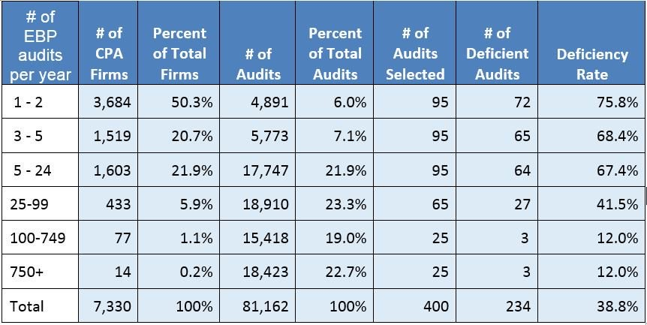

Upon a motion (V) by Mr. Ehudin, and seconded by Ms. Gantnier, the Board approved the Peer Review Committee Report.

New Business

The Board discussed the issue to formally publicize Board meetings on the Board’s website. The Board agreed that all future publications be posted on the website, beginning February 2016.
Upon a motion (VI) by Mr. Korb, and seconded by Ms. Gantnier the Board approved unanimously.

The Board considered the formal request from Mr. Harold Hodges for an extension of his Notice to Schedule (NTS) for the Financial Accounting and Reporting Section of the Uniform CPA Examination which was scheduled to expire on December 16, 2015. Mr. Hodges was issued the NTS on or about June 19, 2015. Pursuant to COMAR 09.24.05.04 (F) (2), a NTS is valid for 180 days from the date it was issued to a candidate. Upon a motion (VII) by Ms. Gantnier, and seconded by Mr. Ehudin the Board denied Mr. Hodges request, unanimously.

Old Business

None

Executive Session

Upon a motion (VIII) by Ms. Gantnier, and seconded by Mr. Jeter, the Board went into Executive Session in the 3rd Floor Conference Room, 500 N. Calvert Street, Baltimore, Maryland 21202 at 9:36 AM. The purpose of this session was to consult with counsel. This session is permitted to be closed pursuant to State Government Title Section 10-508 (a), (7). It returned to the regular business meeting at 9:56 AM upon a motion (IX) by Ms. Gantnier, and seconded by Mr. Ehudin

The Board recessed it’s business meeting at 10:00 AM in order to conduct a hearing in matter of John C. Meyers.

Executive Session

Upon a motion (X) by Ms. Gantnier, and seconded by Mr. Ehudin, the Board again went into Executive Session in the 3rd Floor Conference Room, 500 N. Calvert Street, Baltimore, Maryland 21202 at 11:00 AM. The purpose of this session was to consult with counsel. This session is permitted to be closed pursuant to State Government Title Section 10-508 (a), (7). It returned to the regular business meeting at 11:10 AM upon a motion (XI) by Ms. Gantnier, and seconded by Mr. Ehudin.

Complaint Committee Report

Mr. Jeter presented the Complaint Committee Report. Mr. Jeter reported that the Board received two new (2) consumer complaints and closed three (3) complaints.

Upon a motion (XII) by Mr. Korb, and seconded by Mr. Ehudin, the Board approved the Complaint Committee Report.

In EX-A1215, upon a motion (XIII) by Ms. Gantnier, and seconded by Mr. Korb, the Board approved the license renewal application of licensee who answered “Yes” to a conduct question on the application.

In EX-B1215, upon a motion (XIV) by Ms. Gantnier, and seconded by Mr. Ehudin, the Board approved the Transfer of Grades license application of an applicant who answered “Yes” to a conduct question on the application.

In EX-C1215, upon a motion (XV) by Ms. Gantnier, and seconded by Mr. Ehudin, the Board approved the license application of an applicant who answered “Yes” to a conduct question on the application. Mr. Korb recused himself in this matter.

In EX-A1115, upon a motion (XVI) by Ms. Gantnier and seconded by Mr. Ehudin, to reconsider the Board’s action at the November 3, 2015 meeting, the Board formally withdrew its approval of an extension of a Notice to Schedule due to the Board’s receipt of additional information.

Upon a motion (XVII), by Mr. Ehudin, and seconded by Ms. Gantnier, the Board adjourned at 11:13 AM.

NEXT MEETING

January 5, 2016, 500 North Calvert Street, Third Floor, 9:00 AM

__X__ With corrections ____ Without corrections

_____________________________________ ____________________
Chairman Date

