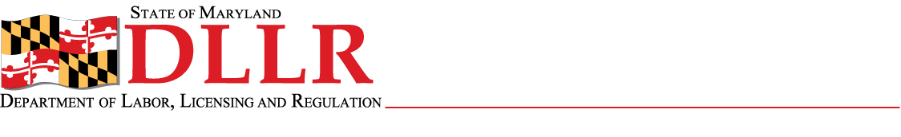
DIVISION OF LABOR AND INDUSTRY
J. RONALD DEJULIIS, COMMISSIONER
MARYLAND OCCUPATIONAL SAFETY AND HEALTH
ERIC M. UTTENREITHER, ASSISTANT COMMISSIONER
10946 GOLDEN WEST DRIVE, SUITE 160
HUNT VALLEY, MD 21031-8212

MOSH STANDARDS NOTICE
MOSH STANDARDS NOTICE: 12-5 | EFFECTIVE DATE: March 5, 2012
SUBJECT: Revising Standards Referenced in the Acetylene Standard | ISSUANCE DATE: May 21, 2012
REFERENCE: OSHA Standard Log Entry Memo for 29 CFR PART -, 1910,1910.102,1911

Purpose: The purpose of this action is to withdraw the companion proposed rule that was issued (and adopted by MOSH) when Federal OSHA issued its Direct Final Rule for the Acetylene Standard in 2009.

Scope: This Instruction applies MOSH-wide.

Contact: Chief of MOSH Compliance Services
See MOSH Website for Current Information
http://www.dllr.maryland.gov/labor/mosh

By and Under the Authority of

Eric M. Uttenreither
Assistant Commissioner

Background:

In 2007 the Commissioner of Labor and Industry adopted the 'as amended' provision for MOSH standards notices. This allows MOSH to adopt revisions of OSHA/MOSH standards without needing the MOSH Advisory Board's consensus. This provision takes affect only if the revision deals with a previous standard already amended by MOSH and the language reads 'as amended'. On October 14, 2010, the Commissioner of Labor and Industry adopted “Acetylene – Direct Final Rule for General Industry” and added the ‘as amended’ provision. That being the case this memo is adopted as is (please reference the above listed OSHA memo for further details).

Actions:

MOSH Compliance and Consultation Supervisors shall ensure that all Compliance Officers are trained on the contents of this notice.

_________________________________________ ___/____/_____
Eric M. Uttenreither, Assistant Commissioner Date

cc: J. Ronald DeJuliis, Commissioner, Division of Labor and Industry
Craig D. Lowry, Deputy Commissioner, Division of Labor and Industry
Jonathan Krasnoff, Assistant Attorney General
Office of Administrative Hearings

