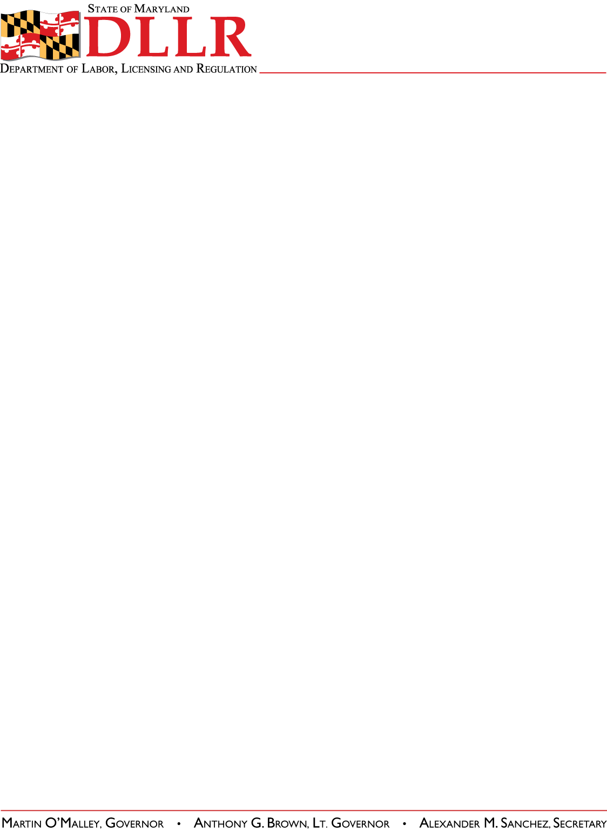
DIVISION OF LABOR AND INDUSTRY
J. RONALD DEJULIIS, COMMISSIONER
MARYLAND OCCUPATIONAL SAFETY AND HEALTH
ERIC M. UTTENREITHER, ASSISTANT COMMISSIONER
10946 GOLDEN WEST DRIVE, SUITE 160
HUNT VALLEY, MD 21031-8212

MOSH STANDARDS NOTICE
MOSH STANDARDS NOTICE: 12-2 | EFFECTIVE DATE: February 20, 2012
SUBJECT: Standard Improvement Project, Phase III | ISSUANCE DATE: March 12, 2012
REFERENCE: OSHA Standard Log Entry Memo for 29 CFR PART -, 1910, 15, 18, 19, 26, 28

Purpose: The purpose of this action is to remove or revise individual requirements within OSHA standards that are confusing, outdated, duplicative, or inconsistent. Revisions include changes to the respiratory protection and lead standards, changes to definitions in the sanitation and bloodborne pathogens standards, and a host of other miscellaneous revisions. Phase III of the Standards Improvement Project is the third in a series of rule-making actions to improve and streamline OSHA standards.

Scope: This Instruction applies MOSH-wide.

Contact: Chief of MOSH Compliance Services
See MOSH Website for Current Information
http://www.dllr.maryland.gov/labor/mosh

By and Under the Authority of

Eric M. Uttenreither
Assistant Commissioner
MOSH Standard 12-1
Page Two

Background:

- On January 25, 2012, the Commissioner of Labor and Industry adopted through incorporation by reference under COMAR 09.12.31 Maryland Occupational Safety and Health Act – Incorporation by Reference of Federal Standards amendments and revisions relating to Standards Improvement Project – Phase III, 29 CFR Parts 1910, 1926, and 1928, excluding Parts 1915, 1917, 1918, and 1919 published in 76 FR 33590—33612 (June 9, 2011). This action, which was proposed for adoption in 38:25 Md. R. 1602—1603 (December 2, 2011), has been adopted as proposed.

- This action was considered by the Maryland Occupational Safety and Health Advisory Board pursuant to a meeting held on August 3, 2011, notice of which was given in accordance with State Government Article §10-506(c), Annotated Code of Maryland.

Actions:

- MOSH compliance personnel shall take note, and enforce where applicable, the revisions relating to the Standards Improvement Project, Phase III– Direct Final Rule 29 CFR part 1910, 1926, and 1928.

- MOSH Compliance and Consultation Supervisors shall ensure that all Compliance Officers are trained on the contents of this notice.

__________________________________________ ___/____/_____
Eric M. Uttenreither, Assistant Commissioner Date

cc: J. Ronald DeJuliis, Commissioner, Division of Labor and Industry
Craig D. Lowry, Deputy Commissioner, Division of Labor and Industry
Jonathan Krasnoff, Assistant Attorney General
Office of Administrative Hearings

