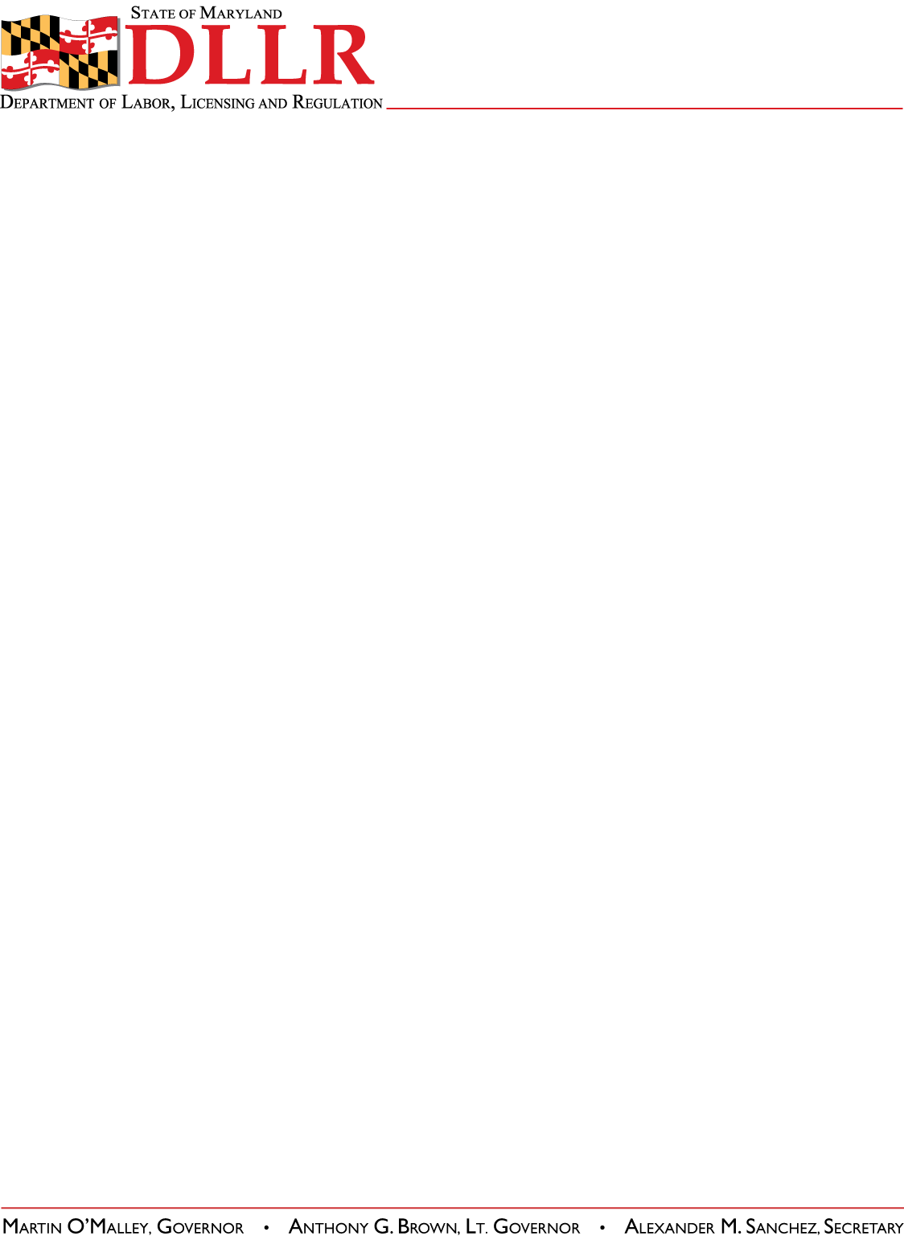
DIVISION OF LABOR AND INDUSTRY
J. RONALD DEJULIIS, COMMISSIONER
MARYLAND OCCUPATIONAL SAFETY AND HEALTH
ERIC M. UTTENREITHER, ASSISTANT COMMISSIONER
10946 GOLDEN WEST DRIVE, SUITE 160
HUNT VALLEY, MD 21031-8212

MOSH STANDARDS NOTICE
MOSH STANDARDS NOTICE: 11-2 | EFFECTIVE DATE: January 1, 2011
SUBJECT: Safety Standards for Steel Erection – Technical Amendment | ISSUANCE DATE: April 1, 2011
REFERENCE: OSHA Standard Log Entry Memo for 29 CFR PART 1926.754

Purpose: This notice is for the purpose of adding a non-mandatory note to the steel erection standard that provides information regarding existing State and Federal Highway Administration regulations that may apply to employers engaged in activities covered by the standards. MOSH believes that knowledge of these requirements will enhance the safety of employees on or near structural steel elements used in highway construction.

Scope: This Instruction applies MOSH-wide.

Contact: Chief of MOSH Compliance Services
See MOSH Website for Current Information
http://www.dllr.maryland.gov/labor/mosh

By and Under the Authority of

Eric M. Uttenreither
Assistant Commissioner

Background:

In 2007 the Commissioner of Labor and Industry adopted the ‘as amended’ provision for MOSH standards notices. This allows MOSH to adopt revisions of OSHA/MOSH standards without needing the MOSH Advisory Board’s consensus. This provision takes affect only if the revision deals with a previous standard already amended by MOSH and the language reads ‘as amended’. On January 1, 2007 the Commissioner of Labor and Industry adopted a “Provision Relating to Steel Erection; Slip Resistance of Skeletal Structural Steel” and added the ‘as amended’ provision. That being the case, this memo from OSHA is adopted as is (please reference the above listed OSHA memo for details).

MOSH Standard 11-2
Page Two

Actions:

MOSH Compliance and Consultation Supervisors shall ensure that all Compliance Officers are trained on the contents of this notice.

__________________________________________ ___/____/_____
Eric M. Uttenreither, Assistant Commissioner Date

cc: J. Ronald DeJuliis, Commissioner, Division of Labor and Industry
Craig D. Lowry, Deputy Commissioner, Division of Labor and Industry
Jonathan Krasnoff, Assistant Attorney General
Office of Administrative Hearings

