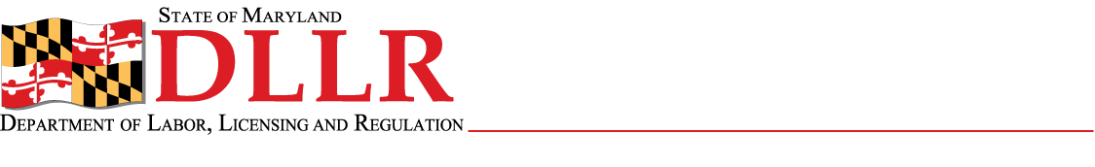
DIVISION OF LABOR AND INDUSTRY
J. RONALD DEJULIIS, COMMISSIONER
MARYLAND OCCUPATIONAL SAFETY AND HEALTH
ERIC M. UTTENREITHER, ASSISTANT COMMISSIONER
10946 GOLDEN WEST DRIVE, SUITE 160
HUNT VALLEY, MD 21031-8212

MOSH STANDARDS NOTICE
MOSH STANDARDS NOTICE: 10-2 | EFFECTIVE DATE: November 29, 2010
SUBJECT: Acetylene – Direct Final Rule for General Industry | ISSUANCE DATE: February 24, 2011
REFERENCE:

Purpose: The purpose of this action is to revise the Acetylene Standard for general industry by updating references to standards published by the standards developing organization (i.e., “SDO Standards”). This rulemaking is part of OSHA’s ongoing effort to update references to outdated SDO standards used throughout its rules.

Scope: This Standard is MOSH-wide.

Contact: Chief of MOSH Compliance Services
See MOSH Website for Current Information
http://www.dllr.maryland.gov/labor/mosh

Background

- On October 14, 2010, the Commissioner of Labor and Industry adopted, through incorporation by reference under COMAR 09.12.31 Maryland Occupational Safety and Health Act – Incorporated by Reference of Federal Standards, revisions relating to the Acetylene Standard, 29 CFR Part 1910, published in 74 FR 40441 – 40447 (August 11, 2009), as amended. The direct final rule originally published on August 11, 2009, and became effective on November 9, 2009. This action, which was proposed for adoption in 37:17 Md. R. 1191 (August 13, 2010) has been adopted as proposed. Effective Date November 29, 2010.

- This action was considered by the Maryland Occupational Safety and Health Advisory Board pursuant to a meeting held on October 7, 2009, notice of which was given in accordance with State Government Article §10-506(c), Annotated code of Maryland.

Actions

- MOSH compliance personnel shall enforce the revisions relating to the Acetylene Standard – Direct Final Rule, 29 CFR Part 1910.

- MOSH Compliance and Consultation Supervisors shall ensure that training sessions are conducted on the contents of this notice.

By and Under the Authority of

__________________________________________ ___/____/_____
Eric M. Uttenreither, Assistant Commissioner Date

cc: J. Ronald DeJuliis, Commissioner, Division of Labor and Industry
Craig D. Lowry, Deputy Commissioner, Division of Labor and Industry
Jonathan Krasnoff, Assistant Attorney General
Office of Administrative Hearings

