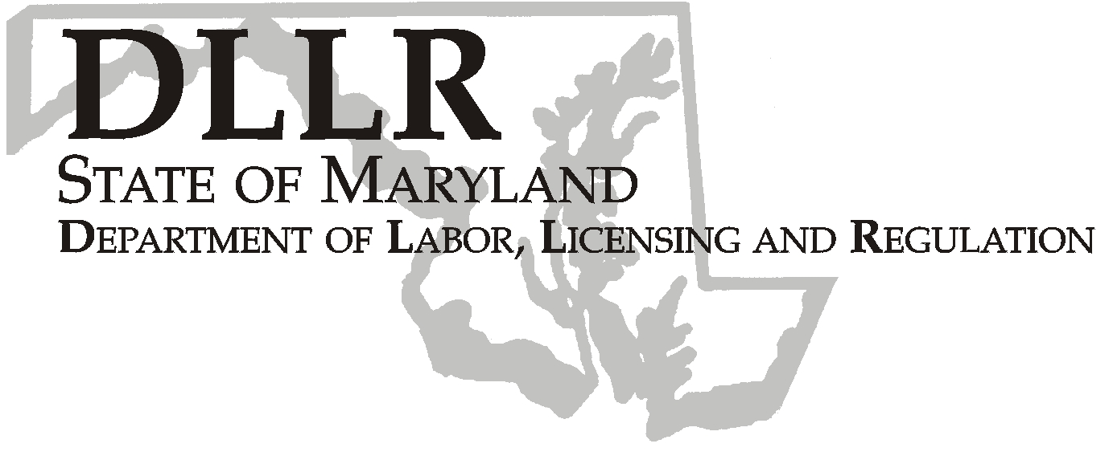
MARTIN O’MALLEY, Governor
ANTHONY G. BROWN, Lt. Governor
THOMAS E. PEREZ, Secretary

Division of Labor and Industry

J. Ronald DeJuliis, Commissioner

DLLR Home Page • http://www.dllr.state.md.us
DLLR E-mail • dli@dllr.state.md.us

MOSH STANDARDS NOTICE 07-4

TO: All MOSH Personnel

FROM: Roger Campbell
Assistant Commissioner

SUBJECT: Adoption and Enforcement of Revisions to the General Industry Electrical Installation Standard,
Subpart S of 29 CFR Part 1910

Effective Date: September 24, 2007

Issuance Date: February 20, 2008

- Background

  - On February 14, 2007, OSHA issued a final rule revising the general industry electrical installation standard. This final rule revises OSHA’s existing standard for electrical installations, which is contained in Section 1910.302 through Section 1910.308 of Subpart S, with relevant definitions in Section 1910.399. It applies, as the existing standard does, to employers in general industry.
  - On August 21, 2007, the Commissioner of Labor and Industry adopted through incorporation by reference under COMAR 09.12.31 Maryland Occupational Safety and Health Act – Incorporated by Reference of Federal Standards, the revisions relating to the general industry electrical installation standard found in Subpart S of 29 CFR 1910.
B. Action

1. MOSH compliance personnel will enforce the adopted revisions as provided in the Electrical Standard; Final Rule-72:7135-7221.

2. MOSH Supervisors will hold appropriate training sessions in each region to review the requirements of this action.

________________________________________ ____________
Roger Campbell, Assistant Commissioner MOSH Date

Attachment

cc: J. Ronald DeJuliis, Commissioner, Labor and Industry
Craig D. Lowry, Deputy Commissioner, Labor and Industry
John Krasnoff, Assistant Attorney General
Office of Administrative Hearings
TEL: 410-767-2215 ⋅ FAX: 410-767-2003
TTY USERS, CALL VIA THE MARYLAND RELAY SERVICE
1100 N. EUTAW STREET
BALTIMORE, MD 21201
Keeping Maryland Working and Safe

