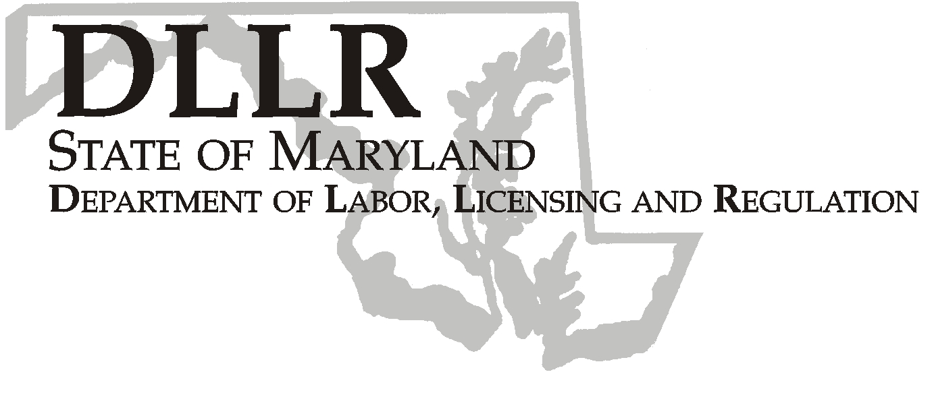
MARTIN O’MALLEY, Governor
ANTHONY G. BROWN, Lt. Governor
THOMAS E. PEREZ, Secretary

Division of Labor and Industry

J. Ronald DeJuliis, Commissioner

DLLR Home Page • http://www.dllr.state.md.us
DLLR E-mail • dli@dllr.state.md.us

MOSH STANDARDS NOTICE 07-2

TO: All MOSH Personnel

FROM: Roger Campbell
Assistant Commissioner

SUBJECT: Revisions relating to Assigned Protection Factors, 29 CFR Parts 1910 and 1926.

PURPOSE: To revise the existing Respiratory Protection Standard to add definitions and requirements for Assigned Protection Factors (APFs) and Maximum Use Concentrations (MUCs). The revisions also supersede the current respirator selection provisions of existing substance-specific standards with new APFs, except for the respirator selection provisions of the 1.3 Butadiene Standard.

The final APFs provide employers with critical information to use when selecting respirators for employees exposed to atmospheric contaminants in construction and general industry workplaces. Proper respirator selection using APFs is an important component of an effective respiratory protection program.

Employers also use MUCs to select appropriate respirators, especially for protection against organic vapors and gases. MUCs specify the maximum atmospheric concentrations that an employee can experience while wearing a specific respirator or class of respirator.

EFFECTIVE DATE: April 9, 2007

ISSUANCE DATE: February 20, 2008

- Background

- On February 6, 2007, the Commissioner of Labor and Industry adopted through incorporation by reference under COMAR 09.12.31 Maryland Occupational Safety and Health Act – Incorporation by Reference of Federal Standards, the revisions relating to Assigned Protection Factors, 29 CFR Parts 1910 and 1926, excluding Part 1915, published in 71 FR 50122 – 50192 (August 24, 2006). This action, which was proposed for adoption in 33:26 Md. R. 2002 – 2003 (December 22, 2006), has been adopted as proposed. This action was recommended to the Commissioner of Labor and Industry by the Maryland Occupational Safety and Health Advisory Board pursuant to meeting held on September 6, 2006, notice of which was given in accordance with State Government Article, §10-506(c), Annotated Code of Maryland.

- Action

1. MOSH Compliance and Consultation Supervisors shall ensure that all Compliance Officers are trained on the
contents of this notice.

_______________________________________ ________
Roger Campbell, Assistant Commissioner MOSH Date

Attachment

cc: J. Ronald DeJuliis, Commissioner, Division of Labor and Industry
Craig D. Lowry, Deputy Commissioner, Division of Labor and Industry
General Jon Krasnoff, Assistant Attorney
Office of Administrative Hearings
Keeping Maryland Working and Safe
TEL: 410-767-2215 ⋅ FAX: 410-767-2003
TTY USERS, CALL VIA THE MARYLAND RELAY SERVICE
1100 N. EUTAW STREET
BALTIMORE, MD 21201

