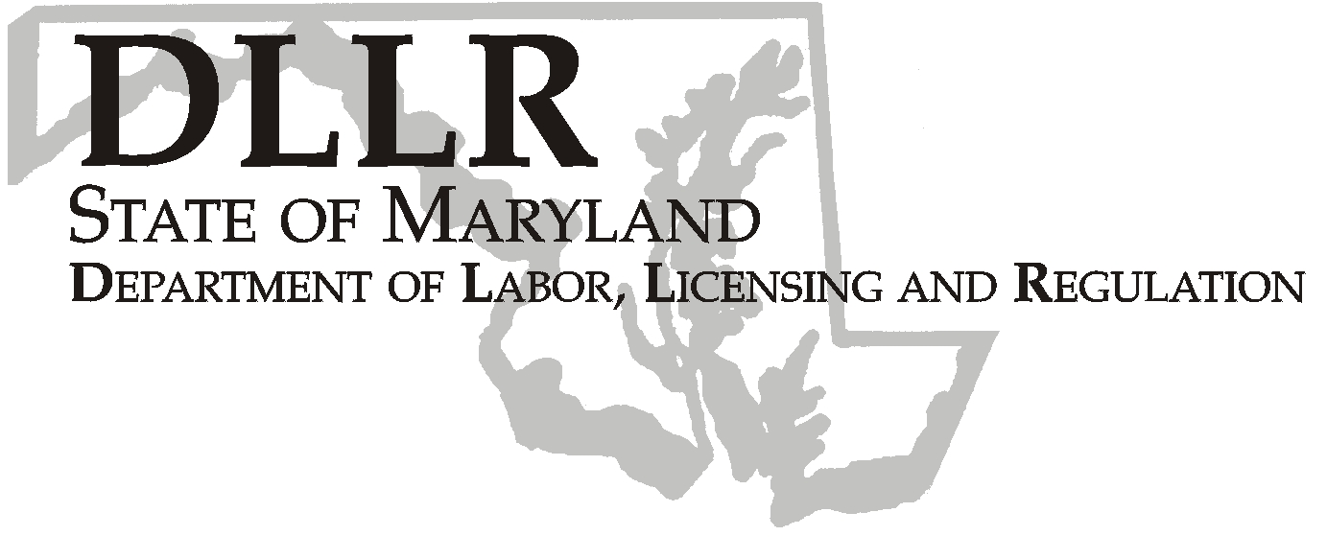
MARTIN O’MALLEY, Governor
ANTHONY G. BROWN, Lt. Governor
THOMAS E. PEREZ, Secretary

Division of Labor and Industry

J. Ronald DeJuliis, Commissioner

DLLR Home Page • http://www.dllr.state.md.us
DLLR E-mail • dli@dllr.state.md.us

MOSH STANDARDS NOTICE 07-1

TO: All MOSH Personnel

FROM: Roger Campbell
Assistant Commissioner

PURPOSE: To revoke a provision within the Steel Erection Standard that addresses slip resistance of
skeletal steel. OSHA received comments suggesting there had been no significant progress concerning the suitability of the test method referenced in the provision for testing slip resistance or the availability of coatings that would meet the slip resistant requirements of the provision. Additionally there was a high probability that the test methods would not be validated by the effective date and that ASTM, an industry standards association, was likely to withdraw them shortly thereafter. As a result, employers would not be able to comply with the provision and for these reasons, OSHA has revoked the provision.

Effective Date: January 1, 2007

Issuance Date: February 20, 2008

- Background

- On November 28, 2006, the Commissioner of Labor and Industry adopted through incorporation by reference under COMAR 09.12.31 Maryland Occupational Safety and Health Act – Incorporation by Reference of Federal Standards, the revocation of a provision relating to Steel Erection; Slip Resistance of Skeletal Structural Steel, published in 71 FR 2879 – 2885 (January 5, 2006), as amended. This action, which was proposed for adoption in 33:21 Md. R. 1683 (October13, 2006), has been adopted as proposed. This action was recommended to the Commissioner of Labor and Industry by the Maryland Occupational Safety and Health Advisory Board pursuant to meeting held on April 5, 2006, notice of which was given in accordance with State Government Article, §10-506(c), Annotated Code of Maryland.

- Action

1. MOSH Compliance and Consultation Supervisors shall ensure that all Compliance Officers are trained on the
contents of this notice.

_______________________________________ ________
Roger Campbell, Assistant Commissioner MOSH Date

Attachment

cc: J. Ronald DeJuliis, Commissioner, Division of Labor and Industry
Craig D. Lowry, Deputy Commissioner, Division of Labor and Industry
General Jon Krasnoff, Assistant Attorney
Office of Administrative Hearings

TEL: 410-767-2215 ⋅ FAX: 410-767-2003
TTY USERS, CALL VIA THE MARYLAND RELAY SERVICE
Keeping Maryland Working and Safe
1100 N. EUTAW STREET
BALTIMORE, MD 21201
Keeping Maryland Working and Safe

