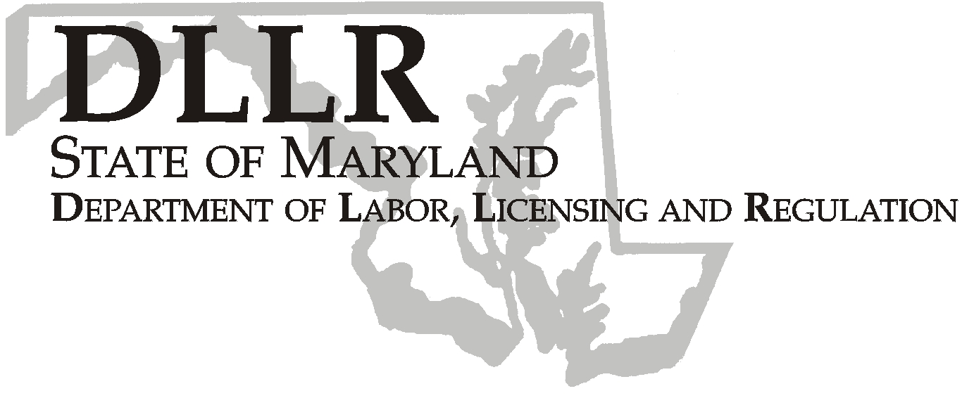
MARTIN O’MALLEY, Governor
ANTHONY G. BROWN, Lt. Governor
THOMAS E. PEREZ, Secretary

Division of Labor and Industry

J. Ronald DeJuliis, Commissioner

DLLR Home Page • http://www.dllr.state.md.us
DLLR E-mail • dli@dllr.state.md.us

MOSH STANDARDS NOTICE 06-5

TO: All MOSH Personnel

FROM: Roger Campbell
Assistant Commissioner

SUBJECT: Corrections and technical amendments relating to the Department of Labor Regulatory Review and Update, Occupational Safety and Health Administration, 29 CFR Parts 1910 and 1926.

PURPOSE: To update references and remove obsolete effective dates and startup dates from existing standards.

Effective Date: November 23, 2006

Issuance Date: February 20, 2008

- Background

- On November 17, 2006, the Commissioner of Labor and Industry adopted through incorporation by reference under COMAR 09.12.31 Maryland Occupational Safety and Health Act – Incorporation by Reference of Federal Standards, the corrections and technical amendments relating to the Department of Labor Regulatory Review and Update, Occupational Safety and Health Administration, 29 CFR Parts 1910 and 1926, excluding
Parts 1913 and1915, published in 71 FR 16669 – 16675 (April 3, 2006). This action, which was proposed for adoption in 33:18 Md. R. 1513 – 1514 (September 1, 2006), has been adopted as proposed. This action was recommended to the Commissioner of Labor and Industry by the Maryland Occupational Safety and Health Advisory Board pursuant to meeting held on May 3, 2006, notice of which was given in accordance with State Government Article, §10-506(c), Annotated Code of Maryland.

- Action

1. MOSH Compliance and Consultation Supervisors shall ensure that all Compliance Officers are trained on the
contents of this notice.

________________________________________ ________
Roger Campbell, Assistant Commissioner MOSH Date

Attachment

cc: Roger Campbell, Commissioner, Division of Labor and Industry
Craig D. Lowry, Deputy Commissioner, Division of Labor and Industry
General Jon Krasnoff, Assistant Attorney
Office of Administrative Hearings
Keeping Maryland Working and Safe
TEL: 410-767-2215 ⋅ FAX: 410-767-2003
TTY USERS, CALL VIA THE MARYLAND RELAY SERVICE
1100 N. EUTAW STREET
BALTIMORE, MD 21201

