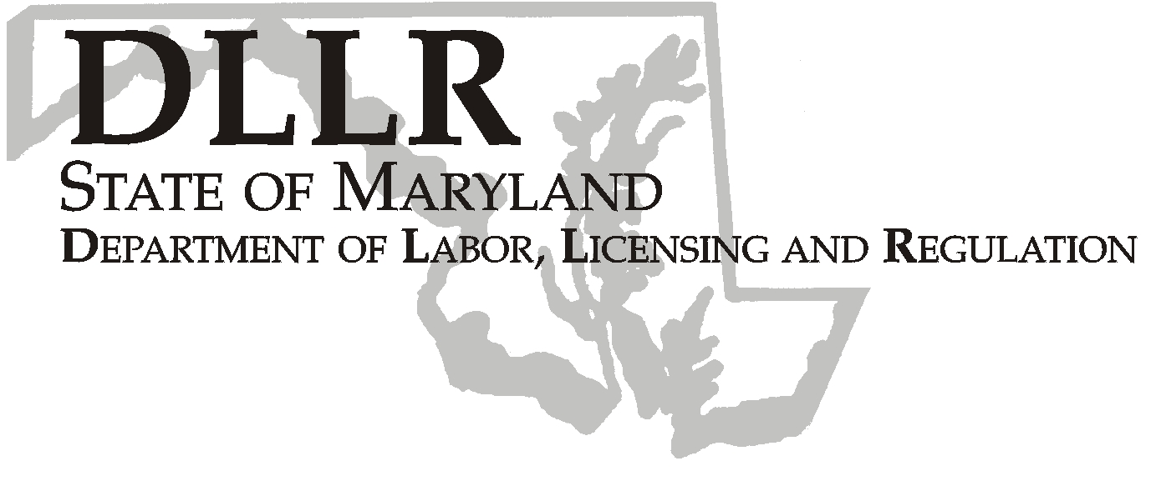
MARTIN O’MALLEY, Governor
ANTHONY G. BROWN, Lt. Governor
THOMAS E. PEREZ, Secretary

Division of Labor and Industry

J. Ronald DeJuliis, Commissioner

DLLR Home Page • http://www.dllr.state.md.us
DLLR E-mail • dli@dllr.state.md.us

MOSH STANDARDS NOTICE 06-3

TO: All MOSH Personnel

FROM: Roger Campbell
Assistant Commissioner

SUBJECT: Revisions relating to Roll-Over Protective Structures.

PURPOSE: To reinstate OSHA’s original construction and agriculture standards that regulate the testing of roll-over protective structures (“ROPS”) used to protect employees who operate wheel-type tractors.

Effective Date: September 25, 2006

Issuance Date: February 20, 2008

- Background

- On September 5, 2006, the Commissioner of Labor and Industry adopted through incorporation by reference under COMAR 09.12.31 Maryland Occupational Safety and Health Act – Incorporation by Reference of Federal Standards, the revisions relating to Roll-Over Protective Structures, published in 70 FR 76979 – 77025 (December 29, 2005), as amended. This final rule was originally published as a direct final rule on December 29, 2005. Confirmation of the effective date of the final rule was published in 71 FR 9909 (February 28, 2006). This action, which was proposed for adoption in 33:15 Md. R. 1288 (July 21, 2006), has been adopted as proposed. This action was recommended to the Commissioner of Labor and Industry by the Maryland Occupational Safety and Health Advisory Board pursuant to meeting held on April 5, 2006, notice of which was given in accordance with State Government Article, §10-506(c), Annotated Code of Maryland.

- In 1996, OSHA issued a technical amendment which removed the original detailed ROPS-testing standards and
referred instead to national consensus standards for substantive ROPS-testing requirements. Later, OSHA
determined that differences existed between its original construction and agriculture ROPS standard and the ROPS
standards adopted under the 1996 technical amendment, and that these differences had a substantial impact on the
affected industries. As a result, OSHA reinstated its original standard.

Although this final rule applies to employers in construction and agriculture so that their employees may operate
safe equipment (i.e., wheel-type tractors), it more directly affects equipment manufacturers. Equipment
manufacturers design and build machines that have ROPS to meet the testing criteria specified in OSHA’s ROPS
standards. Employers in the construction and agriculture industries who purchase and use wheel-type tractors are
in violation of OSHA’s ROPS standards when the tractors do not have protective structures meeting the standards.

TEL: 410-767-2215 ⋅ FAX: 410-767-2003
TTY USERS, CALL VIA THE MARYLAND RELAY SERVICE
1100 N. EUTAW STREET
BALTIMORE, MD 21201

Keeping Maryland Working and Safe

- Action

1. MOSH Compliance and Consultation Supervisors shall ensure that all Compliance Officers are trained on the
contents of this notice.

________________________________________ ________
Roger Campbell, Assistant Commissioner MOSH Date

Attachment

cc: J. Ronald DeJuliis, Division of Labor and Industry
Craig D. Lowry, Deputy Commissioner, Division of Labor and Industry
Jonathan Krasnoff, Assistant Attorney General
Office of Administrative Hearings

