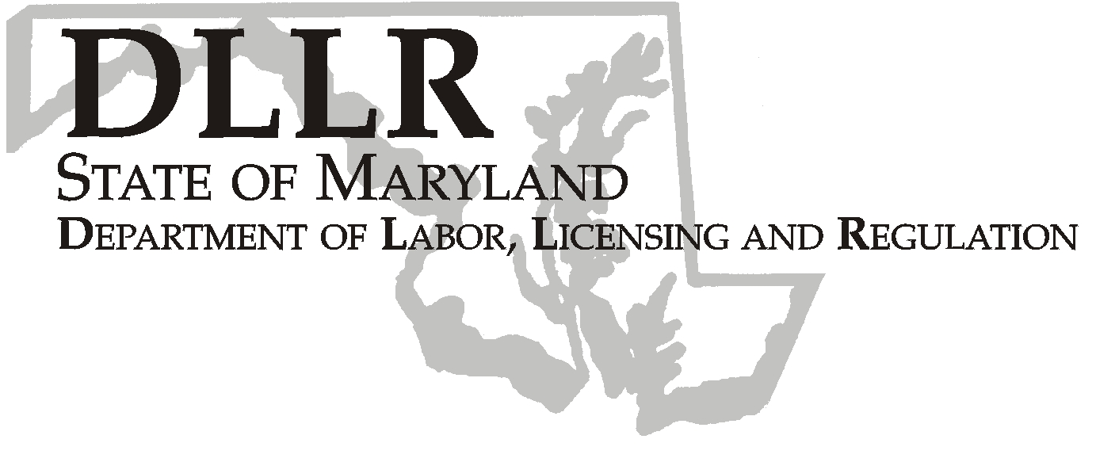
MARTIN O’MALLEY, Governor
ANTHONY G. BROWN, Lt. Governor
THOMAS E. PEREZ, Secretary

Division of Labor and Industry

J. Ronald DeJuliis, Commissioner

DLLR Home Page • http://www.dllr.state.md.us
DLLR E-mail • dli@dllr.state.md.us

MOSH STANDARDS NOTICE 05-3

TO: All MOSH Personnel

FROM: Roger Campbell
Assistant Commissioner

SUBJECT: Revisions of the regulatory text of the Methylenedianiline (MDA) Standard for Construction,
29 CFR §1926.60

PURPOSE: To incorporate by reference a recent revision of the regulatory text of the Methylenedianiline (MDA) Standard for Construction, (29 CFR §1926.60) to correct a cross reference to the Occupational Safety and Health Administration (OSHA) standard on emergency action plans and fire preventions plans.

Effective Date: August 1, 2005

Issuance Date: February 20, 2008

- Background

- On July 12, 2005, the Commissioner of Labor and Industry adopted through incorporation by reference under COMAR 09.12.31 Maryland Occupational Safety and Health Act – Incorporation by Reference of Federal Standards, a revision of the regulatory text of the Methylenedianiline (MDA) Standard for Construction, 29 CFR §1926.60 published in 69 FR 70373 (December, 6 2004). This action, which was proposed for adoption in 32:11 Md. R. 988 (May 27, 2005), has been adopted as proposed. This action was recommended to the Commissioner of Labor and Industry by the Maryland Occupational Safety and Health Advisory Board pursuant to a meeting held on January 5, 2005, notice of which was given in accordance with State Government Article, §10-506(c), Annotated Code of Maryland.

- In November 2002, OSHA published a final rule entitled “Exit Routes, Emergency Action Plans, and Fire Prevention Plans”, 67 FR 67949 (2002). The action was taken, in part, to clarify and make consistent provisions regarding emergency action plans and fire prevention plans in several general industry standards. At that time, OSHA separated the requirements for emergency action plans and fire protection plans into two separate sections, 29 CFR §§1910.38 and 1910.39, respectively.

Several general industry health standards were revised at that time to reflect the change, including the general industry standard for MDA. The same provision in the MDA Standard for Construction (29 CFR §1926.60) was not similarly revised at that time. Since OSHA intended to revise all health standards to reflect the change, OSHA is accordingly correcting the MDA Construction Standard to make it consistent with the revised language in the other health standards.

B. Action

  - MOSH Compliance and Consultation Supervisors shall ensure that Compliance Officers are provided training on the contents of this notice.

________________________________________ ________
Roger Campbell, Assistant Commissioner MOSH Date

Attachment

cc: J. Ronald DeJuliis, Commissioner, Division of Labor and Industry
Craig D. Lowry, Deputy Commissioner, Division of Labor and Industry
General Jon Krasnoff, Assistant Attorney
Office of Administrative Hearings
TEL: 410-767-2215 ⋅ FAX: 410-767-2003
TTY USERS, CALL VIA THE MARYLAND RELAY SERVICE
1100 N. EUTAW STREET
BALTIMORE, MD 21201
Keeping Maryland Working and Safe

