Nonfatal Occupational Injuries and Illnesses in Maryland for 2014

Over 68 thousand new cases of occupational injury and illness were reported by Maryland’s private and public sector employers in 2014 according to the latest results of the Survey of Occupational Injuries and Illnesses or (SOII) program. SOII is a cooperative program between the Maryland Department of Labor, Licensing and Regulation, Division of Labor and Industry and the U.S. Department of Labor, Bureau of Labor Statistics. In 2014 there were approximately 2.4 million workers in the State under the Maryland Occupational Safety and Health (MOSH) agency’s regulatory oversight.

The number of injuries and illnesses for the private and public sectors combined increased by 1,600 cases when compared with 2013’s results. The number converts to a total recordable case (TRC) incidence rate of 3.5 injuries and illnesses per 100 equivalent full-time workers. This rate represents a 3 percent increase over 2013.

Summary Results for Maryland’s Private Sector, 2014

Occupational injuries and illnesses among Maryland’s private sector workers occurred at a rate of 3.1 cases per 100 equivalent full-time workers. The TRC rate represented a slight increase over the previous year’s rate of 3.0. The injury and illness incidence rate for cases of a more serious nature involving days away from work, job transfers, or restrictions, commonly referred to as the DART rate, also increased slightly from 1.5 cases per 100 full-time equivalent workers the previous year to 1.7 in 2014. Of the 52,400 cases reported by private industry, 97 percent were injuries with the remaining 1,500 being cases of occupational illness.

Industries in the private sector showing declines in their workplace injury and illness rates were Construction; Wholesale trade; Retail trade; Information; Finance and insurance; Professional, scientific, and technical services. Industry sectors showing increases were Transportation and warehousing; Real estate and rental and leasing; Management of companies and enterprises, Administrative and support and waste management and remediation services; Health care and social assistance; Arts, entertainment and recreation and Accommodation and food services. Manufacturing and Professional business services remained unchanged from the previous year. These 2014 BLS private sector injury and illness estimates cover just over 2 million workers in the State.

Chart 1, Total recordable case incidence rates for Maryland and all United States, 1998 - 2014

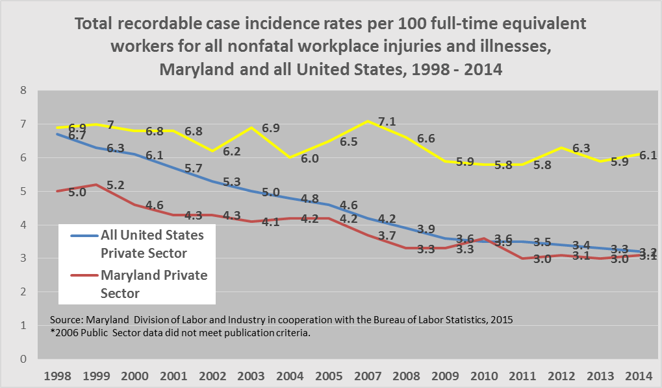

Maryland’s Private Sector

- Private sector construction’s total recordable case incidence rate showed a marked decline of 19 percent to a TRC rate of 2.9, down from 2013’s 3.6. This is the first time that construction’s rate has dipped below the State private sector average. Maryland’s private sector construction is currently 19 percent below this sector’s national average.

- For the third year in a row, manufacturing’s rate of 3.0 injuries and illnesses per 100 full-time equivalent workers, remained unchanged. This rate is almost half 2004’s reported rate of 5.5. Manufacturing’s rate continues to remain well below the national average. Wide variation exists, however, with rates reported by subsector industries within manufacturing. For example, Beverage manufacturing reported the highest incidence rate in manufacturing at 9.3 while Computer and electronic product manufacturing reported the lowest rate at 0.4. For the second year in a row, Maryland manufacturing’s TRC rate was 25-percent below the U.S average for this sector.

- Collectively, Goods-producing industries, which include Manufacturing, Construction, Agriculture and Mining, experienced a decline in the total recordable case incidence rate from 3.4 to 2.9 while Service-providing industries, which include Transportation and warehousing, Utilities, Leisure, entertainment and hospitality and Health care and social assistance showed a slight increase.

- With 7,300 reported cases, Goods-producing industries accounted for 14 percent of the injuries and illnesses in the private sector and 12 ½ percent of private sector employment with just under 260,000 workers.

- With 45,100 reported cases, Service- providing industries accounted 86 percent of the injuries and illnesses and 87 ½ percent of the total private sector employment.

Maryland’s State and Local Government

Occupational injury and illness estimates have been published for State and local government in Maryland every year since 1979. Representing some 343,000 workers, the public sector representing all State and local government entities reported 16,200 new cases of occupational injury and illness in 2014, an increase of 700 cases over the previous year. The total recordable case (TRC) incidence rate was 6.1 cases per 100 full-time equivalent employees. This represented a three-percent increase from 2013 and can be attributed primarily to the increase in Local government’s rates. The public sector continues to report some of the highest injury and illness rates in Maryland. For the seventh consecutive year Maryland’s public sector has remained above the national average. Currently the national public sector average is 5.0 injuries and illnesses per 100 full-time equivalent workers.

State Government’s overall total recordable case rate declined.

With 4,400 reported cases (400 fewer than 2013), and occurring at a rate of 4.8 injuries and illnesses per 100 full-time equivalent workers, Maryland State government recorded the lowest TRC rate since 2006. State government’s rate declined 6 percent from 2013’s rate of 5.1. Of the cases reported 1,900 were severe enough to require the injured or ill worker to take at least one day off from work to recuperate. In spite of a top-line rate decline, certain industry rates within State government remain high.
Some notable examples:
- State hospitals’ reported a TRC rate of 16.1, up 12 percent from 2013’s reported rate of 14.4. Nationally, state hospitals reported a collective rate of 8.7.

- State government’s correctional institutions TRC rate increased by 3 percent from 12.2 to 12.6 injuries and illnesses per 100 full-time equivalent workers for 2014. Nationally, State corrections’ rate was 8.2.

- State government’s nursing and residential care facilities reported the highest total recordable case incidence rate (TRC) rate of any industry in the State with 17.7 cases per 100 full-time equivalent workers. This industry has reported the highest TRC rate in Maryland every year since 2009.

Local Government’s overall total recordable case rate increased.

An estimated 11,800 injury and illness cases were reported by Maryland’s county governments and local municipalities in 2014. At 6.7 injuries and illnesses per 100 full-time equivalent workers, local government experienced a 5 percent increase over 2013’s rate of 6.4. For 2014, Local government’s TRC rate remains above the national average by 24 percent. Maryland local government has recorded TRC rates above the national average every year since 2009. Of the cases reported for 2014, 5,300 were severe enough to require the injured or ill worker to take either days off for recuperation, a job transfer, or be assigned some type of work restriction. In 2014, over 243,000 workers were employed by the State’s counties, local governments and municipalities. Some notably high industry rates in Local government were:

- Fire protection reported the highest TRC rate for local government in the State with 15.2 injuries and illnesses per 100 full-time equivalent workers. The reported rate was 13.7 in 2013. Nationally local government fire protection reported 12.1 injuries and illnesses per 100 equivalent full-time workers.

- Justice, public order, and safety activities reported a 19 percent increase from a TRC rate of 9.3 in 2013 to 11.1 for 2014.

- Transit and ground passenger transportation reported a TRC rate or 6.9, down 15 percent from 2013’s rate of 8.1.

- Elementary and secondary schools’ TRC rate increased to 5.6 in 2014 from 2013’s rate of 5.0. Nationally, Local government’s elementary and secondary schools’ reported rate was 4.2.

Chart 2, Industries with the highest incidence rates of total nonfatal occupational injuries and illnesses, Maryland, 2014

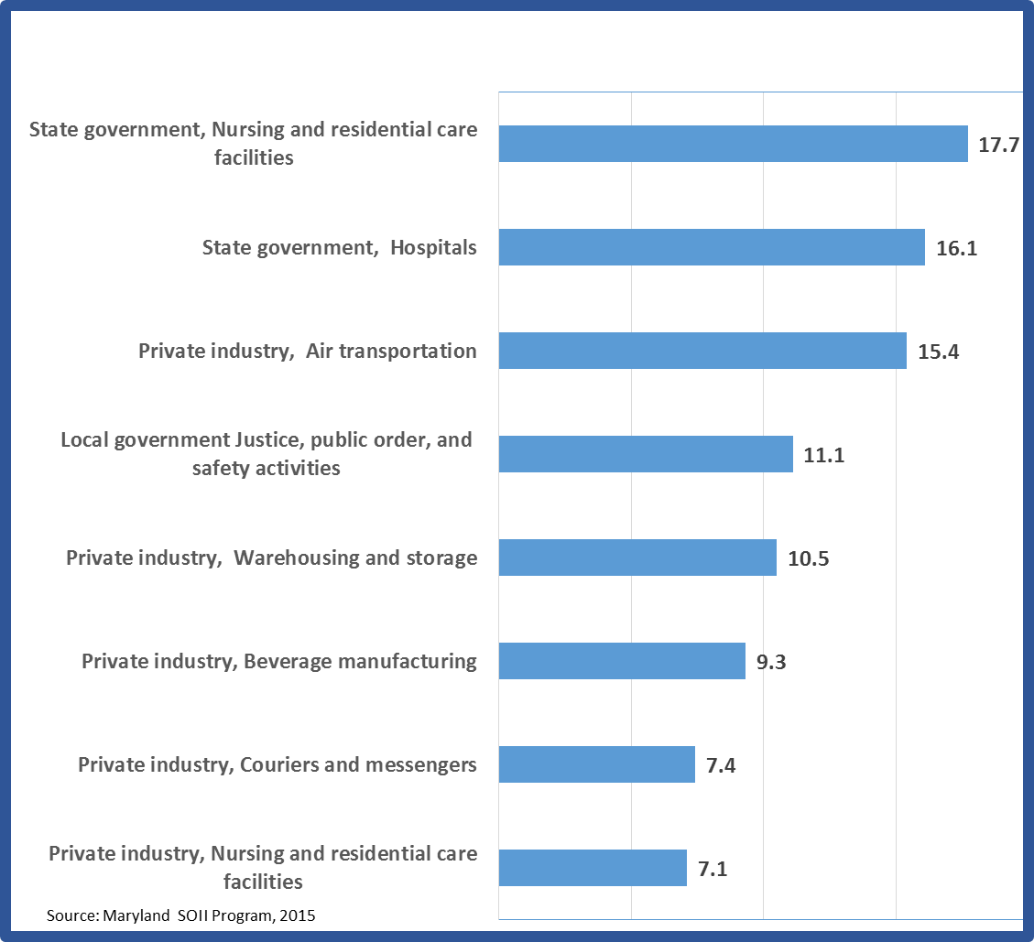

Chart 3, Incidence rates per 100 equivalent full-time workers for total nonfatal occupations injuries and illnesses by major industry sector, Maryland, 2013 and 2014

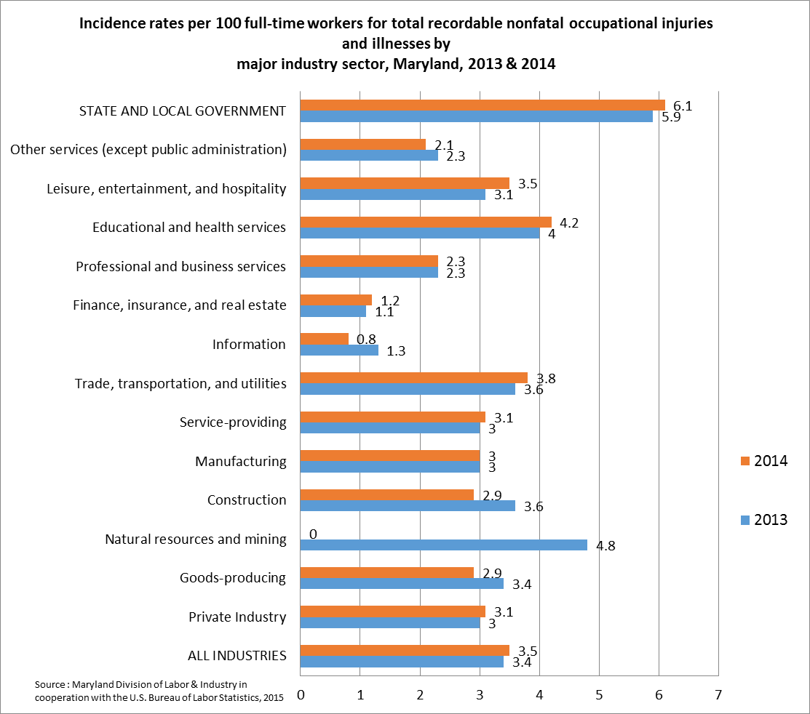

Background of the Survey

The Survey of Occupational Injuries and Illnesses (SOII) is a cooperative program between the State of Maryland’s Department of Labor, Licensing and Regulation, Division of Labor and Industry and the U.S. Department of Labor, Bureau of Labor Statistics. SOII provides estimates of the number and frequency (incidence rates) of nonfatal occupational injuries and illnesses by industry code as defined by the 2007 North American Industry Classification System (NAICS) manual. The SOII program also provides details on the circumstances and characteristics of the more seriously injured and ill workers. These injury and illness estimates are based on safety and health logs that, by law, employers are required to keep. Occupational injury and illness statistics have been published for Maryland’s private sector every year since 1972 and for State and local government from 1979 forward.
The SOII program utilizes an employer-based questionnaire to collect occupational injury and illness data. Questionnaires are mailed to a scientifically selected random sampling of businesses in Maryland. The responses are compiled, tabulated and published annually.

Statistical sampling techniques are used to produce the estimates. Because the results are based on a random sampling of establishments in the universe file (the universe is all operating in-scope establishments in Maryland’s unemployment insurance tax file), the estimates probably differ from the figures that would be obtained if every establishment in the State had participated. To determine the precision of each data estimate, a standard error is calculated. The standard error defines a range (confidence interval) around each estimate. Relative standard errors are calculated for every SOII estimate produced.

The quality of the data is dependent on the employer’s understanding of which cases are recordable under the Occupational Safety and Health Administration’s recordkeeping regulation. Maryland State agencies and all local government municipalities and jurisdictions are required by law to keep records of occupational injuries and illnesses. Additionally, many private sector establishments are required to keep injury and illness records. In order to have a complete picture of the occupational injury and illness experience for the economy, many establishments normally exempt from OSHA’s recordkeeping requirements are included in the survey. The OSHA recordkeeping system is designed to measure the incidence, rather than the prevalence, of occupational injury and illness. Prevalence measures capture all injuries and illnesses that occur in a given year including ongoing or unresolved cases from previous years. The intent of the OSHA recordkeeping system is to measure each occupational injury and illness only once. The SOII, therefore, provides estimates of the number and rate of only new injuries and illnesses in a given year.

Excluded from the SOII are the self-employed, farming operations with fewer than 11 employees, private households and federal government agencies. Occupational injury and illness data for coal, metal and nonmetal mining, and for railroad activities were provided by the U.S. Department of Labor’s Mine Safety and Health Administration and the U.S. Department of Transportation’s Federal Railroad Administration, respectively.

Collecting occupational illness statistics remains a challenge with the true number and rate difficult to measure. Unlike injuries, which result from sudden, acute events that are easily observed, reported and documented, many types of occupational disease are not diagnosed until long after the initial exposure to workplace carcinogens and other toxins have taken place. It may be years before the cumulative effects of these exposures present as occupational disease and the ill employee may no longer be in the workforce. Because of this, it is believed the incidence of certain long-term, latent forms of occupational disease is understated by the SOII. The overwhelming majority of the reported illness cases are those that are easier to directly relate to the workplace such as contact dermatitis or carpal tunnel syndrome.
The Bureau of Labor Statistics’ Survey of Occupational Injuries and Illnesses is the U.S government’s primary source for charting the nature and magnitude of the occupational injury and illness problem across the country.
Maryland Nonfatal Incidence Rates
Survey of Occupational Injuries and Illnesses, 2003-2014
 | Total Recordable Cases (TRC) | Cases with Days  Away, Restriction, or Transfer (DART) | Other Recordable Cases (ORC)
Private industry
2014 | 3.1 | 1.7 | 1.4
2013 | 3.0 | 1.5 | 1.5
2012 | 3.1 | 1.6 | 1.5
2011 | 3.0 | 1.6 | 1.4
2010 | 3.6 | 1.9 | 1.7
2009 | 3.3 | 1.7 | 1.6
2008 | 3.3 | 1.7 | 1.6
2007 | 3.7 | 1.9 | 1.8
2006 | 3.8 | 2.0 | 1.8
2005 | 4.2 | 2.2 | 2.0
2004 | 4.2 | 2.3 | 1.9
2003 | 4.1 | 2.3 | 1.8
State and local govt.
2014 | 6.1 | 2.9 | 3.1
2013 | 5.9 | 2.8 | 3.1
2012 | 6.3 | 2.8 | 3.6
2011 | 5.8 | 2.9 | 3.0
2010 | 5.8 | 3.1 | 2.7
2009 | 5.9 | 3.0 | 2.9
2008 | 6.6 | 3.3 | 3.3
2007 | 7.1 | 3.5 | 3.6
2006* | - | - | -
2005 | 6.5 | 2.9 | 3.6
2004 | 6.0 | 3.2 | 2.9
2003 | 6.9 | 3.9 | 3.0
All industries including State & local govt.
2014 | 3.5 | 1.8 | 1.6
2013 | 3.4 | 1.7 | 1.7
2012 | 3.5 | 1.7 | 1.8
2011 | 3.4 | 1.8 | 1.6
2010 | 3.9 | 2.1 | 1.8
2009 | 3.7 | 1.9 | 1.8
2008 | 3.7 | 1.9 | 1.8
2007 | 4.1 | 2.1 | 2.1
2006* | - | - | -
2005 | 4.5 | 2.3 | 2.2
2004 | 4.5 | 2.4 | 2.1
2003 | 4.5 | 2.5 | 1.9

SOURCE: Maryland Department of Labor, Licensing and Regulation, Division of Labor and Industry in cooperation with the U.S. Department of Labor, Bureau of Labor Statistics, Survey of Occupational Injuries and Illnesses, 2014. Incidence rates represent the number of injuries and illnesses per 100 full-time workers.
*2006 occupational injury and Illness data for State and local government did not meet publication criteria.

All employment data derived from the Maryland Department of Labor, Licensing and Regulation, Office of Workforce Information and Performance, Employment and Payrolls, Industry Series, 2014.
Incidence rates represented the number of injuries and illnesses per 100 full-time equivalent workers and are calculated as (N/EH) x 200,000 where: N = number of injuries and illnesses EH = total hours worked by all employees during the calendar year 200,000 = base for 100 equivalent full-time workers.

