Nonfatal Workplace Injuries and Illnesses in Maryland for 2012

More than 68 thousand nonfatal work-related injuries and illnesses were reported by Maryland’s public and private sector employers in 2012 according to the latest results of the Bureau of Labor Statistics’ Survey of Occupational Injuries and Illnesses (SOII) program. For 2012 there were approximately 2.3 million workers in the State under the Maryland Occupational Safety and Health agency’s regulatory oversight, based on data derived from the Maryland Department of Labor, Licensing and Regulation’s Quarterly Census of Employment and Wages program. The total number of injuries and illnesses reported represented an increase of 3,800 new cases when compared to the 2011 survey results. The number of injuries and illnesses converts to a total recordable case (TRC) incidence rate of 3.5 injuries and illnesses per 100 equivalent full-time workers. For 2012, Maryland’s TRC rate for all industries, including State and local government was 5 percent below the 2012 national average of 3.7.

Occupational Injury and Illness Summary Results for Maryland’s Private Sector, 2012

Occupational injuries and illnesses among Maryland’s private sector employers occurred at a rate of 3.1 cases per 100 equivalent full-time workers. The private sector's TRC incidence rate represented a slight increase over the previous year’s rate of 3.0.

Ninety-six percent of the total 51,900 cases reported by private sector employers were injuries with the remaining 2,100, occupational illnesses. The rate for cases of a more serious nature involving days away from work, job transfers, or restrictions, commonly referred to as the DART rate, remained unchanged from the previous year at 1.6 injuries and illnesses per 100 full-time equivalent workers. Maryland’s private sector injury and illness estimates cover almost 2 million workers.

Occupational Injury and Illness Summary Results for Maryland’s Public Sector, 2012

Public sector injury and illness estimates for Maryland State and local government have been published every year since 1979. Representing some 342,000 employees, State and local government employers reported 16,500 injuries and illnesses in 2012. The total recordable case incidence rate for all injuries and illnesses was 6.3 cases per 100 full-time equivalent employees. This represented a 9-percent increase over 2011.
For the fifth consecutive year, Maryland State and local government’s TRC incidence rate has remained above the national average reported rate of 5.6 injuries and illnesses for all public sector employees. Maryland’s 2012 rate was 13 percent above the U.S. average.
Maryland State Government

With 4,600 reported cases converting to a TRC incidence rate of 4.9 injuries and illnesses per 100 full-time equivalent workers, Maryland State government’s incidence rate declined 2 percent from the previous year. Of the total cases reported, 2,100 were severe enough to require the injured or ill worker to take at least one day off from work to recuperate.

Maryland Local Government

An estimated 11,900 new injury and illness cases were reported by Maryland’s county governments and local municipalities. Local government experienced a 13-percent increase from the previous year’s recorded rate of 6.3 cases per 100 equivalent fulltime workers to 7.1 in 2012. Maryland local government’s rate was 16 percent above the national average for this sector. Of the total cases reported, 4,500 were severe enough to require the injured or ill worker to take days away from work, job transfers, or restrictions. In 2012, approximately 241,000 workers were employed by the State’s counties and local municipalities.

Key Findings for the Maryland Survey of Occupational Injuries and Illnesses, 2012

Private Industry Estimates

- Reporting 3.1 workplace injuries and illnesses per 100 equivalent full-time workers for 2012, Maryland’s private sector TRC incidence rate has declined 28 percent since 2002.

- Reporting three consecutive years of declining rates, private construction’s TRC incidence rate was down an additional 16 percent from 2010.

- At a rate of 3.0 injuries and illnesses per 100 full-time equivalent workers manufacturing's TRC rate was down 14 percent from the previous year and 45-percent below this sector’s 2004 rate of 5.5. Maryland manufacturing’s rate continues to remain well below the national average. For 2012 Maryland manufacturing was 30-percent below the U.S average.

- With 8,600 reported cases, the goods-producing industries accounted for 17 percent of the total injury and illness cases reported by Maryland’s private sector. Based on employment data from the Maryland Department of Labor, Licensing and Regulation, this sector accounted for slightly more than 259,000 workers or 13 percent of private sector employment in 2012. For three consecutive years goods-producing industries’ rate has declined and in 2012 reported a TRC rate of 3.4 injury and illness cases, a rate that was 17-percent below the national average of 4.1 for the sector.

State Government Estimates

Beginning in 2009, Maryland State government has reported four consecutive years of decline in TRC incidence rates with a reported 4.9 injuries and illnesses per 100 full-time equivalent workers in 2012. However, certain sectors within State government remain high. Some notable examples:

- The TRC rate for State hospitals’ was 13.4; although, this represented a significant decrease from 2011’s rate of 17.8.

- State nursing and residential care facilities’ remains very high at 19.1 but declined slightly from the previous year’s rate of 21.3. This industry has reported the highest TRC incidence rate in Maryland every year since 2009.

State correctional institutions’ rate has increased for the third consecutive year from 2010’s, 10.6; to 2011’s, 12.0; to 2012’s, 14.2.

Local Government Estimates

For the third consecutive year Maryland’s local government TRC incidence rate has increased and was up 13 percent from 2011 to 2012 with a reported rate of 7.1.

- Local government, public elementary and secondary schools’ TRC rate has increased each year since 2010 and was up 7 percent from 2011 to 5.9 cases in 2012.

- Local government, water, sewage and other systems (NAICS 2213) reported a TRC rate increase from 8.2 cases in 2011 to 10.0 cases in 2012.

Background of the Survey

The Survey of Occupational Injuries and Illnesses (SOII) is a cooperative program between the State of Maryland’s Department of Labor, Licensing and Regulation, Division of Labor and Industry and the U.S. Department of Labor, Bureau of Labor Statistics. SOII provides estimates of the number and frequency (incidence rates) of nonfatal occupational injuries and illnesses by industry code as defined by the 2007 North American Industry Classification System (NAICS) manual. The SOII program also provides details on the circumstances and characteristics of the more seriously injured and ill workers. These injury and illness estimates are based on safety and health logs that, by law, employers are required to keep. Occupational injury and illness statistics have been published for Maryland’s private sector every year since 1972 and for State and local government from 1979 forward.

The SOII program utilizes an employer-based questionnaire to collect occupational injury and illness data. Questionnaires are mailed to a scientifically selected random sampling of businesses in Maryland. The responses are compiled, tabulated and published annually.

Statistical sampling techniques are used to produce the estimates. Because the results are based on a random sampling of establishments in the universe file (the universe is all operating in-scope establishments in Maryland’s unemployment insurance tax file), the estimates probably differ from the figures that would be obtained if every establishment in the State had participated. To determine the precision of each data estimate, a standard error is calculated. The standard error defines a range (confidence interval) around each estimate. Relative standard errors are calculated for every SOII estimate produced.

The quality of the data are dependent on the employer’s understanding of which cases are recordable under the Occupational Safety and Health Administration’s recordkeeping regulation. Maryland State agencies and all local government municipalities and jurisdictions are required by law to keep records of occupational injuries and illnesses. Additionally, many private sector establishments are required to keep injury and illness records. In order to have a complete picture of the occupational injury and illness experience for the economy, many establishments normally exempt from OSHA’s recordkeeping requirements are included in the survey. The OSHA recordkeeping system is designed to measure the incidence, rather than the prevalence, of occupational injury and illness. Prevalence measures capture all injuries and illnesses that occur in a given year including ongoing or unresolved cases from previous years. The intent of the OSHA recordkeeping system is to measure each occupational injury and illness only once. The SOII, therefore, provides estimates of the number and rate of only new injuries and illnesses in a given year.

Excluded from the SOII are the self-employed, farming operations with fewer than 11 employees, private households and federal government agencies. Occupational injury and illness data for coal, metal and nonmetal mining, and for railroad activities were provided by the U.S. Department of Labor’s Mine Safety and Health Administration and the U.S. Department of Transportation’s Federal Railroad Administration, respectively.

A note regarding occupational illness statistics

Collecting occupational illness statistics remains a challenge with the true number and rate difficult to measure. Unlike injuries, which result from sudden, acute events that are easily observed, reported and documented, many types of occupational disease are not diagnosed until long after the initial exposure to workplace carcinogens and other toxins have taken place. It may be years before the cumulative effects of these exposures present as occupational disease and the ill employee may no longer be in the workforce. Because of this, it is believed the incidence of certain long-term, latent forms of occupational disease is understated by the SOII. The overwhelming majority of the reported illness cases are those that are easier to directly relate to the workplace such as contact dermatitis or carpal tunnel syndrome.

Maryland Nonfatal Incidence Rates
Survey of Occupational Injuries and Illnesses, 2002-2012
 | Total Recordable Cases (TRC) | Cases with days  Away, restriction, or transfer (DART) | Other recordable cases (ORC)
Private industry
2012 | 3.1 | 1.6 | 1.5
2011 | 3.0 | 1.6 | 1.4
2010 | 3.6 | 1.9 | 1.7
2009 | 3.3 | 1.7 | 1.6
2008 | 3.3 | 1.7 | 1.6
2007 | 3.7 | 1.9 | 1.8
2006 | 3.8 | 2.0 | 1.8
2005 | 4.2 | 2.2 | 2.0
2004 | 4.2 | 2.3 | 1.9
2003 | 4.1 | 2.3 | 1.8
2002 | 4.3 | 2.4 | 1.9
State and local govt.
2012 | 6.3 | 2.8 | 3.6
2011 | 5.8 | 2.9 | 3.0
2010 | 5.8 | 3.1 | 2.7
2009 | 5.9 | 3.0 | 2.9
2008 | 6.6 | 3.3 | 3.3
2007 | 7.1 | 3.5 | 3.6
2006* | - | - | -
2005 | 6.5 | 2.9 | 3.6
2004 | 6.0 | 3.2 | 2.9
2003 | 6.9 | 3.9 | 3.0
2002 | 6.2 | 3.6 | 2.6
All industries including State & local govt.
2012 | 3.5 | 1.7 | 1.8
2011 | 3.4 | 1.8 | 1.6
2010 | 3.9 | 2.1 | 1.8
2009 | 3.7 | 1.9 | 1.8
2008 | 3.7 | 1.9 | 1.8
2007 | 4.1 | 2.1 | 2.1
2006* | - | - | -
2005 | 4.5 | 2.3 | 2.2
2004 | 4.5 | 2.4 | 2.1
2003 | 4.5 | 2.5 | 1.9
2002 | 4.6 | 2.6 | 2.0
SOURCE: Maryland Department of Labor, Licensing and Regulation, Division of Labor and Industry in cooperation with the U.S. Department of Labor, Bureau of Labor Statistics, Survey of Occupational Injuries and Illnesses, 2012. Incidence rates represent the number of injuries and illnesses per 100 full-time workers.
*2006 occupational injury and Illness data for State and local government did not meet publication criteria.

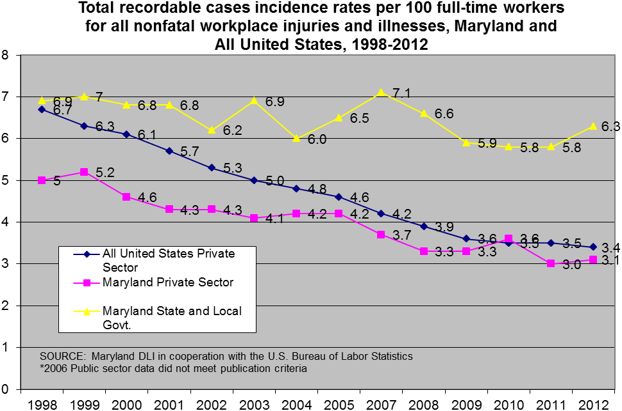
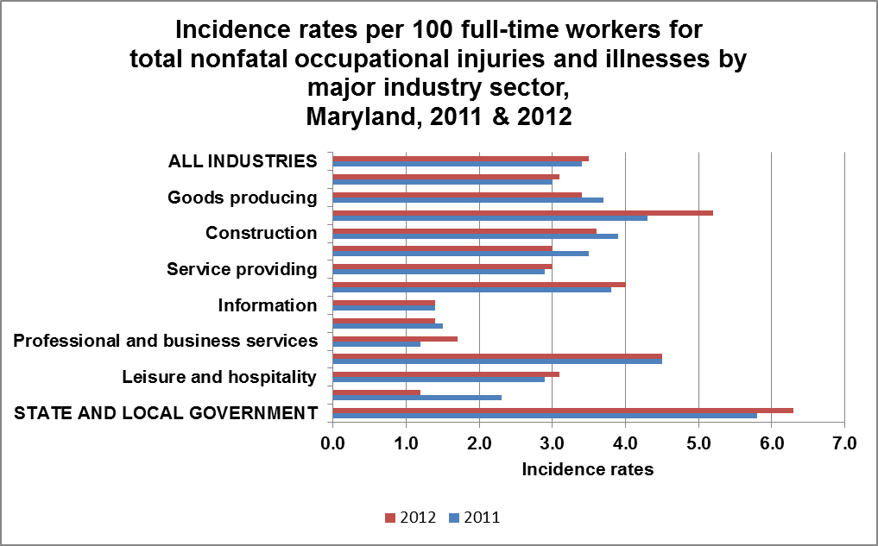
SOURCE: Maryland Division of Labor and Industry in cooperation with the U.S. Bureau of Labor Statistics, Dec. 2013

All employment data derived from the Maryland Department of Labor, Licensing and Regulation, Office of Workforce Information and Performance, Employment and Payrolls, Industry Series, 2012.
Incidence rates represent the number of injuries and illnesses per 100 full-time workers and are calculated as: (N/EH) x 200,000 where N = number of injuries and illnesses EH = total hours worked by all employees during the calendar year 200,000 = base for 100 equivalent full-time workers.

