INSTRUCTION NUMBER: 24-5 | EFFECTIVE DATE: January 26, 2024
SUBJECT: Enforcement Policies and Procedures for MOSH’s Severe Violator Enforcement Program (SVEP) | ISSUANCE DATE: January 26, 2024
CANCELLATION: MOSH Instruction 11-3 | EXPIRATION DATE: Effective until canceled or superseded

Purpose: This instruction establishes enforcement policies and procedures for MOSH’s Severe Violator Enforcement Program, which concentrates resources on employers who have demonstrated indifference to their MOSH Act obligations by committing certain willful, repeated, or failure-to-abate violations.

Scope: This Instruction applies MOSH-wide.

References: A. Current MOSH Field Operations Manual (FOM)
B. OSHA Directive Severe Violator Enforcement Program (SVEP) CPL 02-00-169

Contact: Chief of MOSH Compliance Services
See MOSH Website for Current Information
http://www.dllr.maryland.gov/labor/mosh

Action:

The Chief of Compliance shall ensure that SVEP inspections are conducted in accordance with the policy and procedures set forth in this instruction.

Compliance and Consultation Supervisors shall ensure that field personnel are familiar with the contents of this Instruction, and OSHA Instruction CPL 02-00-169 issued September 15th, 2022.

- Handling SVEP Cases

  - The CSHOs must be familiar with Appendix B of this directive to effectively evaluate employers during any inspection likely to result in a severe violator enforcement case.
  - The regional supervisor, in accordance with the criteria set forth in this directive, will identify severe violator enforcement cases no later than at the time the citations are issued.
  - When an inspection meets the severe violator enforcement case criteria:
    - The inspection will be classified as such.
    - The regional supervisor will notify the Chief and Assistant Chief of MOSH Compliance Services, who will in turn notify the Assistant Commissioner.
    - Appropriate SVEP actions will be determined by the Chief and Assistant Chief of MOSH Compliance Services, and the Assistant Commissioner of MOSH.
  - When a case meets the SVEP case criteria, MOSH must accurately identify the establishment in the OSHA Information System (OIS).

- Criteria for an SVEP Case

Any inspection that meets one or more of the following, at the time that the citations are issued, will be considered a severe violator enforcement case. The regional supervisor will identify severe violator enforcement cases no later than at the time the citations are issued, in accordance with criteria set forth in this instruction (also see Appendix B).

Over time, a severe violator case may extend beyond a single employer location, depending on what further research and follow-up inspections reveal.

  - Fatality/Catastrophe Criterion.

An inspection of a fatality, or the hospitalization of three or more employees in which MOSH finds one or more of the following related to a death or hospitalization of three or more employees.

    - Willful or repeated serious violations or
    - Failure-to-abate notices based on a serious violation.

  - Non-Fatality/Catastrophe Criterion.

An inspection in which MOSH finds two or more willful or repeated serious violations or failure-to-abate notices (or any combination of these violations/notices), based on serious violations with a gravity of eight or higher.

  - Egregious Criterion.

All egregious (e.g., per-instance citations) enforcement actions will be considered SVEP cases.

Note: For SVEP consideration, willful and repeated citations and failure-to-abate notices must be based on serious violations, except for recordkeeping, which must be egregious.

Note: Grouped and combined violations must count as one violation for SVEP purposes. In cases where an inspection’s original violations at issuance initially qualify an employer for SVEP, but later are reclassified to fall outside the program’s eligibility criteria, the employer must be removed from the SVEP log.

Note: Under MOSH’s multi-employer citation policy, a general contractor may be cited for the same violations as other contractors qualifying for SVEP, and therefore may also qualify for the program. An employer can qualify for SVEP even if none of its own employees were exposed to hazards.

- Enforcement Considerations - Two or More Inspections of the Same Employer

For inclusion under SVEP, MOSH must evaluate each individual inspection independently to determine if it meets any of the SVEP criteria. If any of the inspections meet one of the SVEP criteria, MOSH will consider that inspection to be an SVEP case and code it accordingly.

Note: Do not combine two or more inspections of the same employer to fulfill the SVEP criteria.

- SVEP Procedures

  - When MOSH determines that a case meets one of the SVEP criteria, cases will be managed as described below:

    - General:

For any SVEP inspection opened on or after the effective date of this Instruction, MOSH must conduct a follow-up or referral inspection within one year but no longer than two years, after the citation becomes a final order, even if the agency has received abatement verification of the cited violations. The purpose of the follow-up or referral inspection is to assess not only whether the cited violation(s) were abated, but also whether the employer is failing to address similar or related hazards.

    - Justification for Not Conducting a Follow-up:

If there is a compelling reason not to conduct a follow-up inspection, the CSHO or Chief of Compliance must document that justification in the case file. If MOSH cannot initiate a follow-up inspection, it may document and complete a “No Inspection” in OIS. Reasons for not conducting a follow- up inspection may include:

      - worksite/workplace closed,
      - the employer is out of business, or
      - cited operation discontinued at the worksite/workplace.

Note: A corrected-during-inspection determination does not eliminate the required follow-up inspection.

If the Chief of Compliance learns that a cited employer/operation has moved to a different location, MOSH must inspect the new location. If the new location is outside of MOSH’s jurisdiction, a referral must be made to the Area Office with appropriate jurisdiction. Regional Office Enforcement Programs should be consulted to coordinate referrals outside of MOSH’s jurisdiction.

Note: CSHOs must create or open an inspection in OIS for all follow- up or referral attempts. Mark the inspection as “No Inspection” in instances where the employer is no longer located at the originally inspected site. Apply relevant SVEP coding.

    - Construction, Mobile, and Temporary Worksites:

- When MOSH has reason to believe that a construction, mobile, or otherwise temporary worksite is no longer active (or is nearing completion), therefore making a follow-up inspection of the same worksite difficult or impractical, see the provisions in section SVEP Log Removal Criteria and Procedures.

  - Statewide Inspections of Related Workplaces/Worksites

    - General.

Employer indifference to compliance responsibilities under the MOSH Act at one worksite may indicate broader patterns of non-compliance at the employer’s related worksites. When MOSH has reasonable grounds to believe that violations identified in the initial inspection may indicate a broader pattern of non-compliance, the agency must inspect related worksites of the same employer. While MOSH usually initiates inspections of related worksites only after issuing citations to the employer of violations from original worksite, in cases of “imminent danger” hazards or similarly exigent circumstances, MOSH must follow the FOM.

Appendix A, CSHO Guidance – Considerations for Determining Company Structure and Safety and Health Organization, of this Instruction, provides guidance for evaluating whether violative conditions found during the initial SVEP inspection are likely to exist at related facilities. It is essential that information in Appendix A be gathered during the initial SVEP inspection. MOSH may also obtain such information by letter, telephone, or by subpoena. The Chief of Compliance is responsible for assuring that MOSH collects all relevant information and for determining whether it provides reasonable grounds to believe that a broader pattern of non-compliance may exist. The Chief of Compliance should consult with the Attorney General as appropriate. When the Chief of Compliance finds sufficient evidence of potential broader noncompliance, the Chief of Compliance should identify the employer’s related establishments in the same 3-digit NAICS code as the initial SVEP case and select establishments for inspection in accordance with the directive. Establishments outside that 3-digit NAICS code may also be inspected if the evidence establishes reasonable grounds of the presence of potential hazards at those sites.

Note: The Directorate of Enforcement Programs serves as the National Office point of contact for all SVEP nationwide referrals. Address any questions to the Director or Deputy Director in DEP.

    - Office of Statistical Analysis (OSA)

At the request of the DEP Director, DOC Director, RA, or Regional Coordinator, OSA assists in identifying similar and other related worksites nationwide (including those in State Plans) of the same employer. Establishments are related when there is evidence of common ownership. Related establishments include entities in the same corporate family, such as subsidiary, affiliate, or parent corporations with substantial common responsibilities. Similar related establishments are those establishments that are in the same 3-digit NAICS code.

    - Federal Referrals

MOSH will accept referrals as resources permit, which must include all relevant facts, from OSHA regarding any inspections conducted pursuant to the OSHA’s SVEP. The referral will be identified in OIS as a referral from an outside agency.

    - Inspections of Related Workplaces

      - Where and Employer has Three (3) or Fewer Related Workplaces:

Pursuant to Appendix A, when the Chief of Compliance determines that MOSH should inspect additional workplaces, and the employer has three or fewer related workplaces, all such workplaces must be inspected to determine whether those sites have hazardous conditions or violations similar to those in the SVEP case. The Chief of Compliance has overall responsibility for coordinating the inspections and planning investigative strategy.

      - Where an Employer has our (4) or More Related Workplaces:

When the Chief of Compliance determines that additional workplaces must be inspected, and the employer has four or more similar related establishments within the State or in other jurisdictions, the Chief of Compliance has the responsibility for coordinating those inspections and planning investigative strategy. The Chief of Compliance may consult with the Area Office as appropriate.

Note: MOSH must inspect all establishments on the nationwide list to determine whether hazardous conditions or violations similar to those found in the initial SVEP inspection are present as resources permit. Based on the results of these inspections, the Chief of Compliance determines whether MOSH needs to inspect additional establishments. Any inspection conducted from an SVEP nationwide inspection list must be coded as an “unprogrammed referral.” A referral report must be generated when learning of a site where an SVEP nationwide referral employer is working.
In addition to or in lieu of the above, when the Chief of Compliance has reasonable grounds to believe that hazards may exist at specifically related establishments, the Director may select those establishments for inspection if supported by evidence of potential non-compliance.

      - SVEP Nationwide Related Inspections that involve Process Safety Management (PSM) hazards:

For SVEP inspections arising from willful or repeated PSM citations or failure-to-abate PSM notices, related inspections must be limited to requirements under the PSM standard. No inspections of establishments are to be conducted where MOSH has performed a PSM inspection at that establishment in the past two years from the opening conference date.

    - Construction Worksite

      - Regional Office

Whenever a SVEP case involves a construction industry employer, the Chief of Compliance should further investigate that employer’s overall compliance. If the initially inspected worksite closes before MOSH can conduct a follow-up inspection, MOSH must conduct an inspection of at least one of the employer’s other worksites to determine whether the employer is failing to address hazardous conditions similar to those identified in the initial SVEP inspection. Because construction worksites are often difficult to locate, the following means may be useful to identify a cited employer’s other sites.

Note: If a construction related SVEP case is resolved through a settlement, the agreement should require the employer to notify the Chief of Compliance prior to beginning work at any new construction sites during the subsequent three-year period. However, if MOSH conducts a follow-up or referral inspection during that three-year period, then the employer is no longer required to notify the agency regarding other job sites.

- MOSH may issue an administrative subpoena, prior to issuing a citation, to an employer requesting the location of worksites where employees of that employer are presently working or are expected to be working, within the next 12 months.

- MOSH may issue such a subpoena during the early stages of an investigation if it appears that the inspection is likely to result in an SVEP case and the Chief of Compliance determines that the hazards discovered during the inspection, and the inadequacy of the employer’s response to those hazards, indicate that a broader agency response is appropriate.

      - Regional Office Communications

        - If the Chief of Compliance determines that an SVEP construction employer is operating in a different jurisdiction or state, a recommendation for inspection including all relevant facts, should be transmitted to the appropriate Area Office.

        - Code any inspection conducted under an SVEP nationwide referral as an unprogrammed referral from the National Office. Generate a referral report when finding a site where an SVEP nationwide referral employer is operating.

    - Scope of Related Inspections.

The decision to expand the scope of an inspection to related establishments must be determined by the evidence gathered in the original SVEP inspection. The expanded inspection should focus primarily on potential systemic hazards that are the same, or similar, to those found in the original inspection.

    - Priority of SVEP Inspections.

In accordance with inspection priorities listed in the MOSH Field Operations Manual, SVEP inspections will come after imminent danger, fatality, and complaints, but before other scheduled inspections. Refer to the MOSH Field Operations Manual to determine when other inspections may be conducted concurrently.

  - Increase Company Awareness of MOSH Enforcement.

    - Sending Letters, Citations, or Notifications of Penalty to Employer Representatives

Employee representatives (e.g. unions) will also be mailed a copy of the Citations and Notifications of Penalty that is mailed to the employer’s national headquarters as per the direction of the MOSH Field Operations Manual.

    - Sending Citations and Notifications of Penalty to Headquarters

For all employers that are the subject of a SVEP case, a copy of the Citations and Notifications of Penalty must be sent to the employer’s national headquarters including a message explaining that their company is being inspected as part of the Severe Violator Enforcement Program, with follow-up inspections planned for the future. See Appendix C for sample of cover letter.

    - Publication

MOSH may publicize the SVEP list.

  - Enhanced Settlement Agreements

Settlement provisions must follow current MOSH protocol for effective abatement of hazards. The following settlement provisions may be included in agreements to ensure future compliance both at the cited facility and at the employer’s other related facilities:

    - The agreement should apply company-wide.

    - Require interim abatement controls in cases where the employer is unable to implement final abatement in the agreed upon timeframe.

- SVEP Log Removal Criteria and Procedures

  - MOSH will remove an employer from the Severe Violator Enforcement Program Log after at least three years from the date of receiving acceptable abatement verification. To be eligible for removal, the employer must have:
    - Abated all SVEP-related hazards,
    - Paid all final penalties,
    - Where applicable, followed and completed all applicable settlement provisions,
    - Received no additional serious citations related to the hazards identified in the original SVEP inspection or any related establishments, and
    - Have received one follow-up or referral MOSH inspection except for the following:

      - For all temporary worksite locations (i.e. construction, mobile), a follow-up or referral should be attempted. If there is compelling reason not to conduct a follow-up inspection (i.e. worksite closed, the employer is out of business, or cited operation discontinued at the worksite) the employer may be eligible for removal upon approval by the Chief of Compliance.

      - MOSH will take additional measures in the construction industry. During the first year following the effective date of this Instruction, a quarterly list will be generated of all temporary worksite locations coded as SVEP. This list will be made available to all known general contractors and construction managers that operate in Maryland. In subsequent years, the list will be maintained on the MOSH website.
  - If contesting a case, the employer may choose to begin the three-year designation period by providing acceptable abatement verification for all SVEP-related hazards. This policy change is meant to incentivize employers to abate hazards but does not affect any of the employer’s rights under the MOSH Act.
  - Prior to removing an employer from the SVEP, MOSH must conduct at least one follow-up or referral inspection to ensure abatement verification and compliance with the enhanced settlement provisions, if any. If the follow-up inspection results in a serious citation related to the hazards identified in the initial SVEP inspection, then the establishment must not be eligible for removal from the SVEP log, and an additional follow-up inspection must be performed.
  - Only the Chief of Compliance may authorize removing an employer from the SVEP. If a case involves a national Corporate-Wide Settlement Agreement (CSA), MOSH may coordinate with OSHA to determine whether circumstances warrant removing the employer from the state’s SVEP once the CSA expires. The national Corporate Settlement Coordinator will ensure that the employer has both completed the follow-up requirements of the SVEP and fully implemented the terms of the CSA pursuant to OSHA Instruction CPL 02-00-167, Guidelines for Administering Corporate-Wide Settlement Agreements, September 3, 2021.
  - If, after five years from the final order date, MOSH is unable to conduct a follow-up or referral inspection, it can enter the establishment in the “Auxiliary SVEP Log.” Reasons for being unable to conduct a follow-up or referral inspection may include:
- worksite/workplace closed,
- employer is out of business, or
- cited operation discontinued at the worksite/workplace.
However, the employer remains in the “Auxiliary SVEP Log” until MOSH makes contact, verifies abatement, and assures that the employer fulfills all other requirements of the program. MOSH encourages establishments to contact the office to discuss the follow-up or referral requirements in SVEP.

  - After ten years from the case closure date, MOSH may remove an employer from the Severe Violator Enforcement Program if the case meets all the following criteria:
    - State of Maryland Central Collections Unit has returned the case to the office as uncollectible.
    - The case was coded as “abatement not completed; worksite changed” in OIS after documenting such in the case file in accordance with the FOM.
  - MOSH maintains the legal entity name, any associated business titles or “doing business as” names, and ownership of the company in a searchable format for cross reference for future inspections. In cases where MOSH encounters the employer at any time in the future, a search of the employer’s history in OIS will flag the SVEP inclusion and MOSH will reactivate the entire timeline, process, and abatement verification procedures.
- Relationship to Other Programs
  - Unprogrammed Inspections
MOSH may conduct an unprogrammed inspection and an SVEP-related inspection either separately or concurrently. This instruction does not affect in any way MOSH’s ability to conduct unprogrammed inspections.
  - Programmed Inspections
Site-Specific Targeting (SST), High Hazard List, or Local Emphasis Programs (LEP) inspections may occur either separately or concurrently with SVEP inspections.
- Recording and Tracking Inspections
  - Initial SVEP Inspections
Designate only an inspection that meets the criteria of a severe violator enforcement case as an initial SVEP inspection case. Enter that case into OIS using the following procedures.
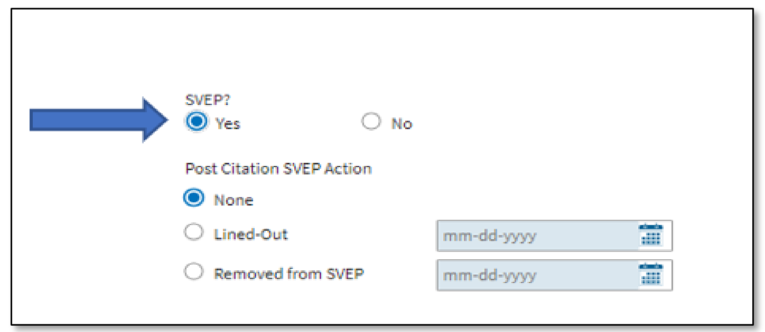
Adding to OIS: Identify initial SVEP inspections by selecting the “Yes” SVEP radio button on the “Inspection Data” tab for that inspection in OIS.

Note: Once a user identifies an inspection as an initial SVEP case, the user cannot change the SVEP radio button to “No.” Identify line-outs and removals from SVEP using the relevant Post Citation SVEP Action field below.

  - Post Citation SVEP Action

Select the relevant radio button under “Post Citation SVEP Action.” If the case remains active on the SVEP log, select the “None” radio button.

If an establishment entered into a settlement agreement (informal or formal) in which MOSH agreed to delete or reclassify the citation that qualified the establishment for SVEP designation; or if an Administrative Law Judge, the Review Commission, or a court decision has vacated such a citation, then select the “Lined Out” radio button to indicate that the entry on the SVEP log will be lined-out.

Note: MOSH or Assistant Attorneys General may not use SVEP removal as a settlement incentive. However, if the final terms of an agreement take an employer out of the SVEP criteria, the employer must be removed from the log.
    - Lined-out from SVEP: Identify initial SVEP inspections that meet the criteria of a line-out by selecting the “Lined-Out” radio button and enter the date when the Chief of MOSH approved the Line-Out. This option is available on the “Inspection Data” tab for that inspection in OIS.
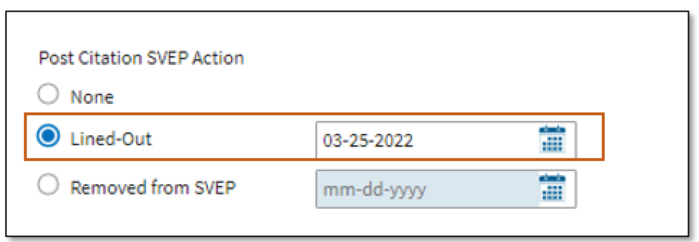
    - Removed from SVEP: Identify initial SVEP inspections that meet the removal criteria by selecting the “Removed from SVEP” radio button and enter the date when the Chief of MOSH approved the removal. This option is available on the “Inspection Data” tab for that inspection in OIS.
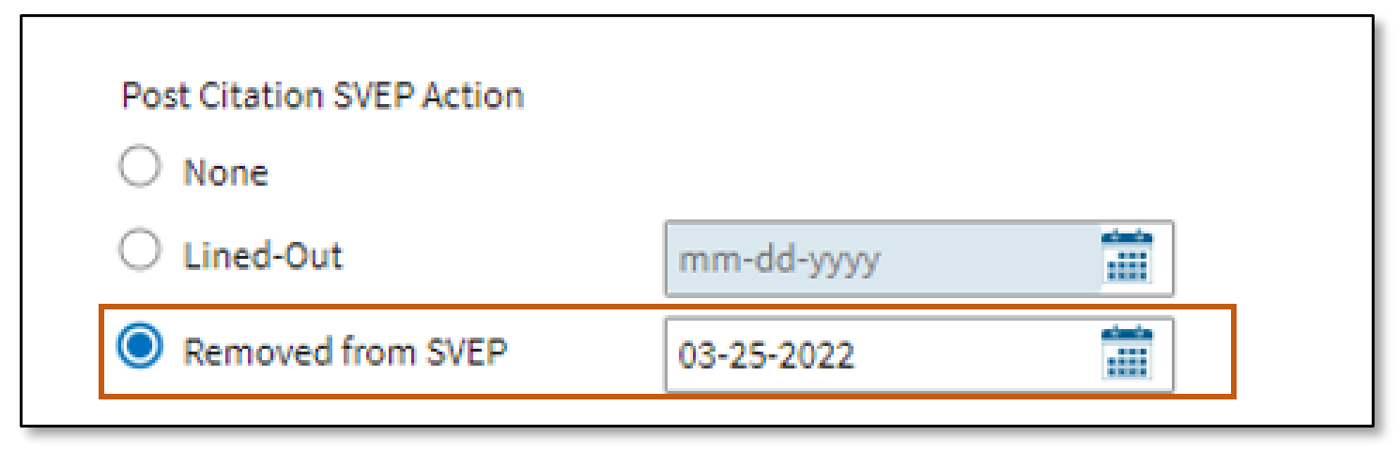

  - Folow-up and Related SVEP Inspection

When identifying an inspection as a follow-up or an inspection otherwise related to an original or previous SVEP inspection, the CSHO must select the “Yes” radio button for “Is this inspection related to a previous SVEP inspection?” If the case is a new SVEP case (not a follow-up inspection or related to a previous SVEP case) then select the “No” radio button.

Note: Follow-up and inspections otherwise related to an initial SVEP case that do not meet the criteria for a new SVEP case must select the “No” SVEP radio button.

The CSHO must link any inspection marked as “Yes” in the previous step to the initial SVEP inspection by entering the relevant “Inspection Number” in the “Previous/Subsequent Inspections” section of the “Related Activities” subtab, under the “Inspection” tab.
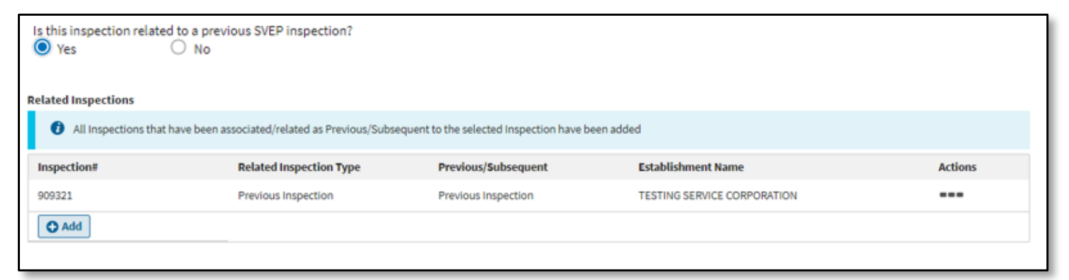

  - Other Program Codes

Remember to enter all applicable emphasis program (LEP, SST, and NEP) codes in the inspection emphasis program section of the inspection type tab when conducting an SVEP inspection and the SVEP inspection also meets the protocol for other program(s).

By and under the Authority of:

Michael A. Penn, CSP, SMS
Acting Assistant Commissioner
Appendix A: Criteria for Investigating an Employer’s Related Establishments

When determining whether to inspect other worksites of a company designated as a severe violator enforcement case, determine whether the compliance issues found during the initial SVEP inspection are likely to exist at any other similar facilities of the employer. If violations at a local workplace appear to be potentially symptomatic of broader non-compliance with OSHA requirements, either generally or with respect to conditions cited under the SVEP inspection, investigate the company structure to help identify other establishments. Employer and employee interviews should be conducted, and subpoenas issued to determine if there is evidence of similar hazards and conditions at other work sites. The Director of the Directorate of Enforcement Programs, an RA, or a Regional Coordinator can request that the Office of Statistical Analysis assist in identifying the employer’s similar or related worksites. The following information
may be solicited in making this determination:

Extent of Compliance Problems.

Question the plant manager, safety and health personnel, and line employees to help determine if local health and safety violations are indicative of a corporate-wide problem. Examples of questions to ask facility personnel include:
- Are the violative conditions the result of a company decision or related to complying with a standard or addressing a hazard? Have corporate safety personnel addressed compliance or the hazard?
- Who made the decision concerning conditions related to the violation: local management or company headquarters? Was the decision meant to apply to other company facilities? If the decision was from company headquarters, what was the explanation?
- Is there a written company-wide safety program? If so, does it address the specific
- hazards present? If so, how does the program address or not address the hazards?
- Is there a company-wide safety department? If so, who are they and where are they located? How does company headquarters communicate with other facilities/worksites?
- Does the company provide effective training for establishment/worksite management, and safety and health personnel?
- Do personnel from company headquarters visit facilities/worksites? Are those visits regular or only sporadic? What subjects do the headquarters personnel address during their visits? Are there audits of safety and health conditions? Did the headquarters personnel discuss the types of cited violative conditions?
- Are there any insurance company or contractor safety and health audit reports that the worksite has ignored? Are headquarters safety and health personnel aware of the reports and the site’s inaction?
- Does the company have facilities or worksites other than the one inspected that perform similar or substantially similar work, use similar processes or equipment, or produce like products? If so, where are they?
- What is the overall company attitude concerning safety and health? Does the establishment or worksite receive support from company headquarters on safety and health matters?
- Does the company provide appropriate safety and health training to its employees?
- Is the establishment’s/worksite’s overall condition better or worse now compared to past years? If it is worse, why? Has new management or ownership emphasized production over safety and health? Is the equipment outdated or in very poor condition? Does management allege that poor financial conditions keep it from addressing safety and health issues?
- Is there an active and adequately funded maintenance department? Have they identified these problems and tried to fix them?
- If you are interviewing management: Have you worked at or visited other similar company facilities or worksites? Did those facilities or sites have similar operations and hazards as those found in the original inspection?

Identifying Company Structure. Ask for the location(s) of other facilities or worksites and how they may be linked to the one you are inspecting. Sometimes establishment/worksite management will not have a clear understanding of the company structure, just an awareness of facts concerning control and influence from the corporate office. Try asking the following questions to help understand the corporate structure:

- Is the establishment/worksite, or the company that owns the establishment or uses the worksite, owned by another legal entity such as a parent company? If so, what is that name and location? Attempt to determine whether the inspected establishment/worksite is a “division” or “subsidiary” of a parent company.

Note: A “division” is a wholly owned part of the same company that may have an entirely different name, e.g., Chevrolet® is a division of General Motors®. A “subsidiary” is a company controlled or owned by another company that owns a majority or all of the subsidiary’s shares.

Try to determine whether the parent company has divisions or subsidiaries other than the one that owns or uses the establishment or worksite you are inspecting. If so, try to obtain the other entities’ names and functions. Sometimes this information is available online, e.g., in Dun & Bradstreet® Sites and Directories. Another good source of information is the relevant state’s office of the Secretary of State.

- Do these other entities control other facilities or worksites that perform the same type of work and might have the same kinds of safety and health concerns?
- Are the company entities publicly held (have publicly traded shares) or are they closely held (owned by one or more individuals)?
- What are the names, positions, and business addresses of relevant company personnel?
- Which businesses or entities actually employ “company” safety and health personnel?
- On what kind of safety and health-related issues or subjects do headquarters personnel provide instructions?
- Do the same or related people own other companies that perform similar work (especially in construction)?
Appendix B

Sample Letter to Company Headquarters

(MOSH letterhead)

(Date)

(Name of Employer’s National Headquarters)
(Address of Headquarters)

Dear _________:

Enclosed you will find a copy of a Citation and Notification of Penalties for violations of the Maryland Occupational Safety and Health Act [and/or the “Code of Maryland Regulations” if there are violations in COMAR], which were issued to [establishment name, located in city, state]. This case has been identified as a severe violator enforcement case under the Maryland Occupational Safety and Health (MOSH) program’s Severe Violator Enforcement Program (SVEP).

The violations referred to in this Citation must be abated by the dates listed and the penalties paid, unless they are contested. This Citation and Notification of Penalties is being provided to you for informational purposes so that you are aware of the violations; the original was mailed to [establishment name] on [date]. We encourage you to work with all of your sites to ensure that these violations are corrected as all locations are subject to inspection per SVEP.

MOSH is dedicated to saving lives, preventing injuries and illnesses, and protecting Maryland’s workers. For more information about MOSH programs, please visit our website at https://www.labor.maryland.gov/labor/mosh/

Sincerely,

Michael A. Penn
Acting Assistant Commissioner

Enclosure

