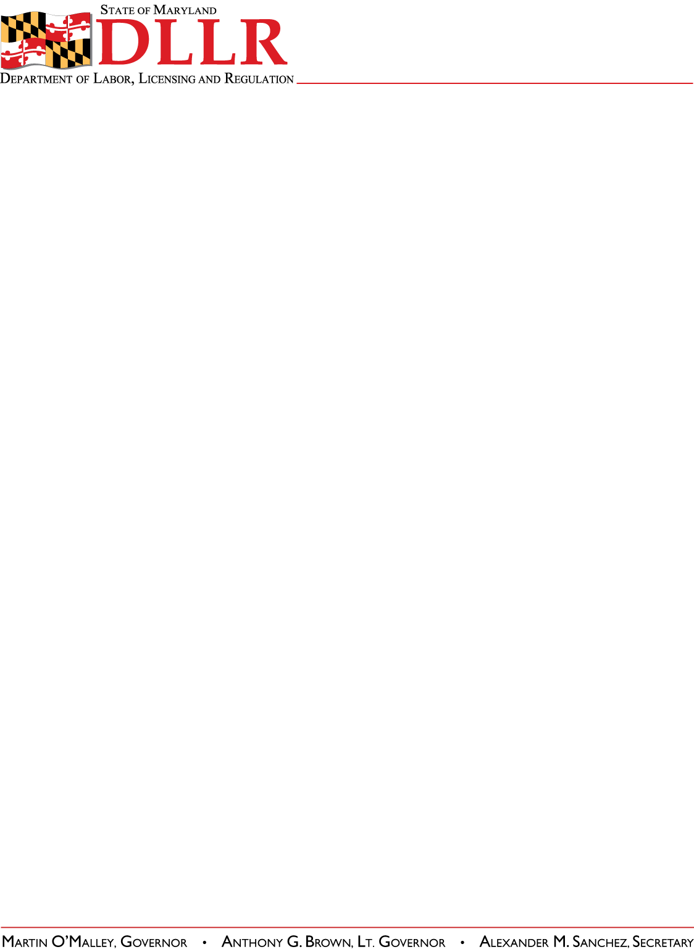
DIVISION OF LABOR AND INDUSTRY
J. RONALD DEJULIIS, COMMISSIONER
MARYLAND OCCUPATIONAL SAFETY AND HEALTH
ERIC M. UTTENREITHER, ASST. COMMISSIONER
10946 GOLDEN WEST DRIVE, SUITE 160
HUNT VALLEY, MD 21031-8212

MOSH INSTRUCTION

INSTRUCTION NUMBER: 13-6 | EFFECTIVE DATE: July 19, 2013
SUBJECT: Revisions to MOSH Field Operations Manual (FOM) | ISSUANCE DATE: July 19, 2013
CANCELLATION: None | EXPIRATION: Effective until replaced by a new Instruction.

Purpose: This Instruction establishes revisions to the MOSH Field Operations Manual.

Scope: MOSH-wide

Reference: OSHA Directive CPL 02-00-150 – April 2011 Revisions to Field Operations Manual and
OSHA Directive CPL 02-00-148 – November 2009 Field Operations Manual (FOM)

Contact: Chief of MOSH Compliance Services
See MOSH Website for Current Information
http://www.dllr.maryland.gov/labor/mosh.html

Background:

MOSH is moving forward to update its FOM to reflect the significant changes identified by OSHA in the adoption of its updated FOM.

Maryland’s updated FOM is available here http://www.dllr.state.md.us/labor/mosh/moshguidance.shtml. It incorporates the significant changes identified in CPL 02-00-150, effective April 22, 2011 and CPL 02-00-148, effective November 9, 2009. The MOSH FOM reflects MOSH procedures and laws and regulations. For ease of reference, below is a side by side guide to demonstrate where the language changes have been made.

Significant Change |  | MOSH Action
CPL 02-00-150, effective April 22, 2011
http://www.osha.gov/OshDoc/Directive_pdf/CPL_02-00-150.pdf
A new Table of Contents for the entire FOM is added | The MOSH Table of Contents has been updated
A new References section for the entire FOM is added | No change made - MOSH will work on this non-substantive change in the future. MOSH law and regulations are generally contained on line and accessible through the MOSH home page.
A new Cancellations section for the entire FOM is added. | No change made - MOSH will work on this non-substantive change when OSHA issues the next FOM.
Adds a Maritime Industry Sector to Section III of Chapter 10, Industry Sectors. | MOSH will evaluate the need to adopt this section once the jurisdictional issues are resolved.
Revises sections referring to the Enhanced Enforcement Program (EEP) replacing the information with the Severe Violator Enforcement Program (SVEP). | MOSH has adopted the SVEP policy and references to that policy have been integrated into the MOSH FOM. See MOSH Instruction 11-3 - Enforcement Policies and Procedures for MOSH's Severe Violator Enforcement Program (SVEP) http://www.dllr.state.md.us/labor/instructions/11-3.shtml
Adds Chapter 13, Federal Agency Field Activities. | No change made – Not Part of the MOSH Plan
Cancels OSHA Instruction FAP 01-00-003, Federal Agency Safety and Health Programs, May 17, 1996. | No change made – Not Part of the MOSH Plan
CPL 02-00-148, effective November 9, 2009

Clarifies that “critical inspections,” for consultation visits in progress, may include referrals. | No change made - MOSH FOM already included referrals, because it used the broader term unprogrammed inspection
Clarifies that compliance officers are to present their credentials whenever they make contact with management representatives, employees or organized labor representatives while conducting inspections. | No change made - Consistent with 29 CFR 1903.7, MOSH regulations requires that the credentials be presented at the opening conference. MOSH will continue to act in accordance with the regulations.
Clarifies that although employers have four hours to provide recordkeeping records, compliance officers are to begin the walk around inspections as soon as the opening conference is completed. | Language added
Clarifies final order dates for repeated violations. | Language added
Clarifies that when the proposed penalty for a posting violation would amount to less than $100, a $100 penalty shall be proposed. | Language added
Clarifies that only the penalty reduction factor for “Size” shall apply when proposing penalties for any §1903.19 violations. | Language added
Clarifies the definitions of formal and non-formal complaints, and referrals. | No change made – No substantive difference in definitions
Clarifies that a formal complaint alleging a recordkeeping deficiency indicating the existence of a serious safety or health violation is a criterion warranting an inspection. | Language added

Action:

1. Supervisors shall ensure that this instruction is reviewed will all compliance officers and consultants.

2. MOSH compliance and consultation personnel shall become familiar with and abide by all changes.

By and Under the Authority of

__________________________________________
Eric M. Uttenreither, Assistant Commissioner

cc: J. Ronald DeJuliis, Commissioner, Division of Labor and Industry
Jonathan Krasnoff, Assistant Attorney General
Office of Administrative Hearings

