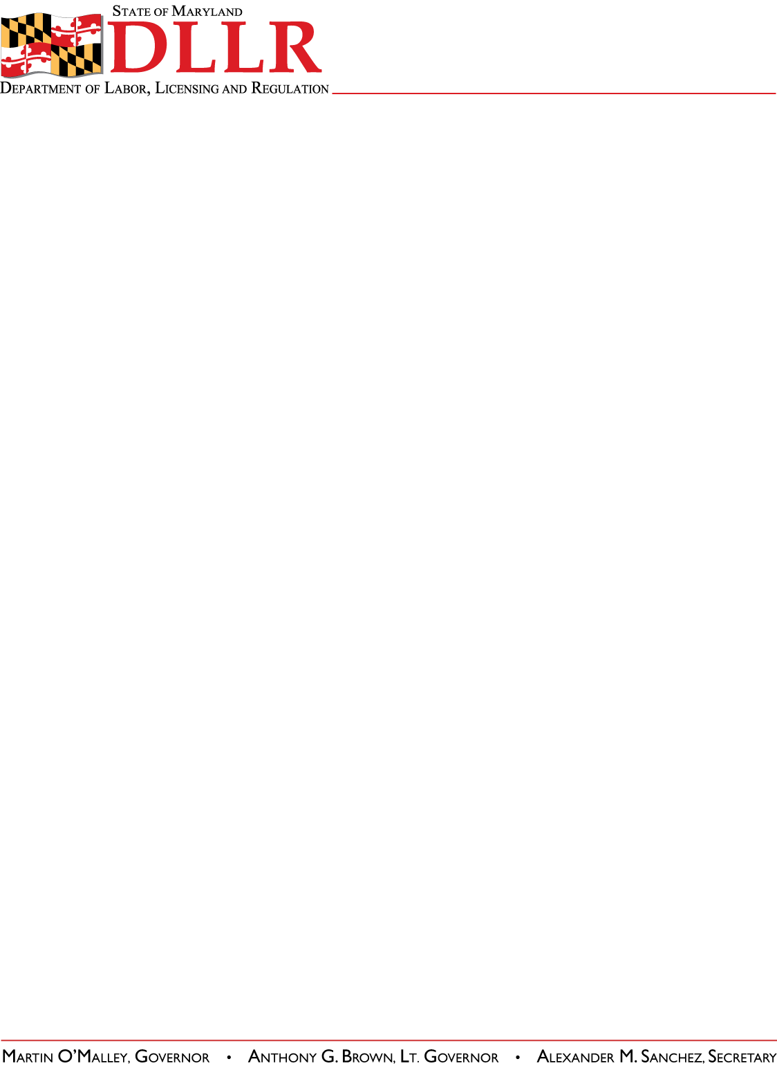
DIVISION OF LABOR AND INDUSTRY
J. RONALD DEJULIIS, COMMISSIONER
MARYLAND OCCUPATIONAL SAFETY AND HEALTH
ERIC M. UTTENREITHER, ASST. COMMISSIONER
10946 GOLDEN WEST DRIVE, SUITE 160
HUNT VALLEY, MD 21031-8212

MOSH INSTRUCTION

INSTRUCTION NUMBER: 11-5 | EFFECTIVE DATE: October 1, 2011
SUBJECT: Local Emphasis Program (LEP) Fall Hazards in Construction | ISSUANCE DATE: October 1, 2011
CANCELLATION: MOSH Instruction 10-10 | EXPIRATION: One year from the effective date, unless replaced earlier by a new Instruction.

Purpose: This Instruction establishes a Local Emphasis program for fall hazards in the construction industry

Scope: MOSH-wide

Reference: OSHA Region III Directive 2006-61 (CPL 04) Fall Hazards in Construction

Contact: Chief of MOSH Compliance Services
See MOSH Website for Current Information
http://www.dllr.maryland.gov/labor/mosh/

Background:
Construction has long been recognized as a high hazard industry and is one of the industries targeted in MOSH’s five-year Strategic Plan. Accidents related to falls from elevations are one of the leading causes of serious injuries and fatalities. It is believed that through a local emphasis program that increases awareness and accelerates enforcement activity, injuries can be reduced. It is also recognized that a tracking mechanism for these type inspections would prove beneficial in monitoring the area of fall hazards. In the past, many un-programmed inspections have been conducted through CSHO self-referrals, imminent danger complaints, or accident investigations. This LEP is designed to increase inspection activity, provide tracking, enhance expertise, and formalize procedures.
Action:
MOSH compliance personnel shall ensure that the procedures contained in this Instruction are followed when conducting this LEP. The Regional Offices will implement the procedures described in this Instruction in response to imminent dangers or serious fall hazards that are identified on construction sites. The Regional Supervisors shall use this LEP as a basis for scheduling and conducting safety inspections of construction sites. This LEP is intended to be used on any construction site where fall hazards have been

MOSH INSTRUCTION (11-5)
October 1, 2011
Page 2

alleged and/or identified to initiate safety inspections. These inspections shall be expanded to comprehensive inspections of multi-employer construction sites in accordance with the guidelines established in the FOM.
Procedures:
- An inspection targeting system which encompasses identification of sites at the beginning of the quarter and the random selection of sites is not practical. Hazards related to falls on construction sites are normally transient and of limited duration. This limits the practicality of targeting the site in advance. Therefore, inspections conducted under this LEP would be initiated by several means: Compliance Officer observance, non-formal complaints, and referrals from other outside sources.
B. All work sites where fall hazards are observed by Compliance Officers will be selected for inspection under this LEP. Employee exposure to the fall hazard does not have be observed, only the presence of a potential fall hazards (i.e. unguarded wall openings, missing guardrails, etc.) need to be observed to conduct an inspection. These sites shall include, but shall not be limited to:
1. Structural steel erection sites where fall protection is not apparent and potential falls or related hazards exist;
2. Structural steel where fall protection for employees other than ironworkers is not apparent and potential falls or related hazards exist;
3. Structural steel erection where fall protection for ironworkers 10 feet or more above a lower level (in excess of 30 feet or two stories, whichever is less for employees working in controlled decking zones and in excess of 30 feet for connectors) is not apparent and potential falls or related hazards exist;
4. Sites where fall protection for employees on scaffolds 10 feet or more above a lower level is not apparent;
5. Sites where fall protection for employees on walking/working surfaces 6 feet or more above a lower level is not apparent;
6. Other activities which constitute potential fall hazards and no protective systems are in use such as erection of tanks, communication and broadcast towers, certain work on cranes and derricks, and activities where employees are working from elevations without fall protection.
C. When a jobsite with potential fall hazards is noted during travel, the Compliance Officer shall notify the Supervisor with the name of the contractor (if known) and the location of the site. The Supervisor will determine if the site has been inspected within the last 30 days.
1. If the site has not been inspected within the last 30 days, permission may be given to inspect the site. Compliance officers will record these inspections as planned inspections.

MOSH INSTRUCTION (11-5)
October 1, 2011
Page 3

2. If the site has been inspected within the last 30 days, an inspection will be authorized only if an imminent danger appears to be present or at the Regional Supervisor’s discretion. These inspections will normally be limited to the imminent danger situation and other serious plain view hazards. The Compliance Officer will remain at the site to observe the abatement procedures and/or to recommend abatement methods. Compliance officers will record these inspections as referral inspections.
D. A large number of fall hazards are reported via referrals and complaints, both of a formal and a non-formal nature. Formal complaints of fall hazards on construction sites will continue to be scheduled before programmed inspections.
E. The IMIS identifier code to be used in item 25c on the OSHA-1 will be “FALL HAZARDS IN CONSTRUCTION”.

By and Under the Authority of

__________________________________________ ___/____/_____
Eric M. Uttenreither, Assistant Commissioner Date

Attachment
cc: J. Ronald DeJuliis, Commissioner, Division of Labor and Industry
Craig D. Lowry, Deputy Commissioner, Division of Labor and Industry
Jonathan Krasnoff, Assistant Attorney General
Office of Administrative Hearings

