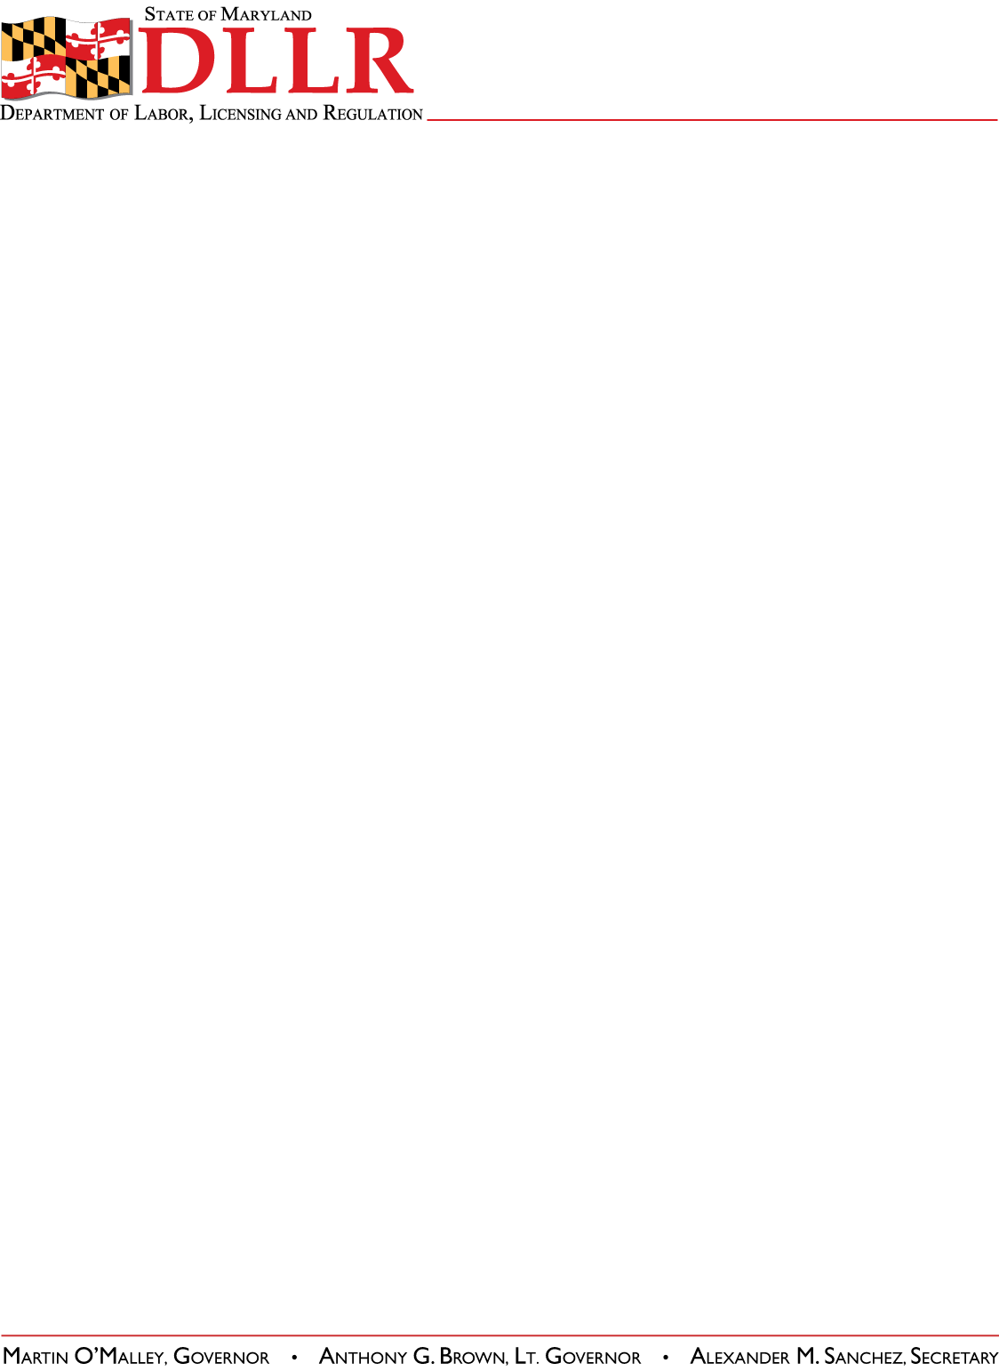
DIVISION OF LABOR AND INDUSTRY
J. RONALD DEJULIIS, COMMISSIONER
MARYLAND OCCUPATIONAL SAFETY AND HEALTH
ERIC M. UTTENREITHER, ASST. COMMISSIONER
10946 GOLDEN WEST DRIVE, SUITE 160
HUNT VALLEY, MD 21031-8212

MOSH INSTRUCTION

INSTRUCTION NUMBER: 11-4 | EFFECTIVE DATE: October 1, 2011
SUBJECT: Accident Report Local Emphasis Program (LEP) | ISSUANCE DATE: October 1, 2011
CANCELLATION: NONE | EXPIRATION: One year from the effective date, unless replaced earlier by a new Instruction.

Purpose: This instruction provides Regional Office personnel with policy and guidelines on responding to and documenting accident investigations.

Scope: MOSH-wide

Contact: Chief of MOSH Compliance Services
See MOSH Website for Current Information
http://www.dllr.maryland.gov/labor/mosh/

Policy: In order to ensure consistency across the State the following policy shall be used when responding to and documenting accident investigations. This policy does not apply to fatalities or catastrophes (3 or more employees hospitalized).

When an accident with or without injury is reported from any source an inspection may be conducted when the cause of the accident appears to be occupationally-related. All field documentation and procedures will remain the same as fatality and catastrophe investigations and as outlined in the Field Operations Manual including a sketch and an accident log. However, neither an OSHA-36 form nor an OSHA-170 form will be generated for accident investigations which are not fatalities or catastrophes. Instead, an OSHA-90 will be generated for the employer involved in the incident and all other related inspections will be conducted as “Un-programmed Related” inspections. The referral shall contain a description of the accident, the time of accident, victim's name, and date of birth.

Inspections under this LEP will be given a priority immediately below that of fatality and catastrophe investigations.

IMIS: The following guidelines shall be applied when recording inspections conducted under this LEP:

1. For Inspection Type enter “Referral”.

Phone: 410-527-4499 • INTERNET: www.dllr.state.md.us./labor/mosh/

MOSH INSTRUCTION (11-4)
October 1, 2011
Page 2

2. Under Local Emphasis select “Accident Investigation” and any other applicable LEP’s

By and Under the Authority of

__________________________________________ ___/____/_____
Eric M. Uttenreither, Assistant Commissioner Date

Attachment

cc: J. Ronald DeJuliis, Commissioner, Division of Labor and Industry
Craig D. Lowry, Deputy Commissioner, Division of Labor and Industry
Jonathan Krasnoff, Assistant Attorney General
Office of Administrative Hearings

