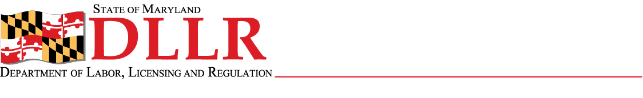
DIVISION OF LABOR AND INDUSTRY
J. RONALD DEJULIIS, COMMISSIONER
MARYLAND OCCUPATIONAL SAFETY AND HEALTH
ERIC M. UTTENREITHER, ASSISTANT COMMISSIONER
10946 GOLDEN WEST DRIVE, SUITE 160
HUNT VALLEY, MD 21031-8212

MOSH INSTRUCTION
INSTRUCTION NUMBER: 11-2 | EFFECTIVE DATE: October 26, 2010
SUBJECT: PSM Covered Chemical Facilities NEP | ISSUANCE DATE: April 1, 2011
CANCELLATION: MOSH Instruction 09-9 | EXPIRATION DATE: One year from effective date

Purpose: This instruction provides guidelines for using OSHA’s dynamic list (s) of questions (referred to in CPL 02-10-05 at the dynamic list) when conducting inspections in facilities with highly hazardous chemicals (HHCs) in amounts at or greater than the threshold quantities listed in 1910.119 that are in the following 5 categories: PSM General, Ammonia Refrigeration, Water and/or Wastewater Treatment, Storage and Chemical Processing. The Directorate of Enforcement Programs (DEP) will periodically change the questions on the dynamic lists.

Scope: This Instruction applies MOSH-wide.

References: OSHA Instruction, Directive CPL 02-10-05 PSM Covered Chemical Facilities National Emphasis Program.

Contact: Chief of MOSH Compliance Services
See MOSH Website for Current Information
http://www.dllr.maryland.gov/labor/mosh

By and Under the Authority of

Eric M. Uttenreither
Assistant Commissioner

Summary

This instruction provides guidance to MOSH compliance personnel for implementing the use of OSHA’s dynamic lists when conducting programmed planned or unprogrammed inspections in PSM covered facilities. This instruction is replacing MOSH’s previous instruction (MI 09-9) on PSM Covered Chemical Facilities NEP.

MOSH Instruction 11-2
Page Two

Actions

- Compliance and Consultation supervisors shall ensure compliance with Paragraph X. Sections D., E., and H. of OSHA Instruction, Directive Number CPL 02-10-05 – PSM Covered Chemical Faclities National Emphasis Program.

- Supervisors shall ensure that this instruction is reviewed with all compliance officers.

- Supervisors shall evaluate all programmed and unprogrammed inspection activity that may involve an application of the PSM standard prior to assignment to a CSHO.

- Supervisors shall ensure the use of current Chemical NEP Dynamic Lists maintained at the following OSHA Intranet website: http://intranet.osha.gov/compliance/psm/psm_general_list.html ,for PSM facilities covered by this instruction.

- This instruction will expire one year after the date of issue.

__________________________________________ ___/____/_____
Eric M. Uttenreither, Assistant Commissioner Date

cc: J. Ronald DeJuliis, Commissioner, Division of Labor and Industry
Craig D. Lowry, Deputy Commissioner, Division of Labor and Industry
Jonathan Krasnoff, Assistant Attorney General
Office of Administrative Hearings

