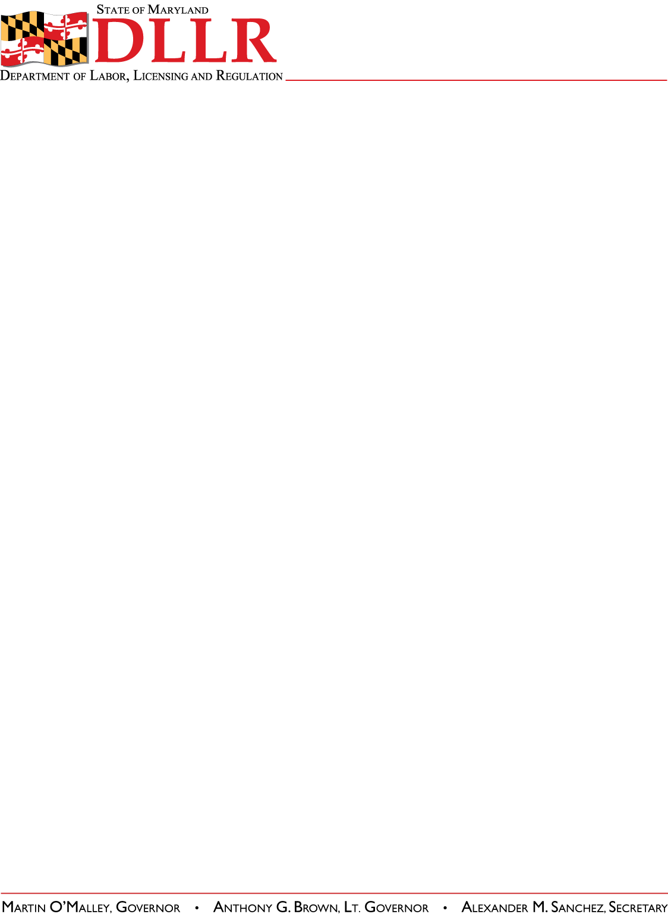
DIVISION OF LABOR AND INDUSTRY
J. RONALD DEJULIIS, COMMISSIONER
MARYLAND OCCUPATIONAL SAFETY AND HEALTH
ERIC M. UTTENREITHER, ASST. COMMISSIONER
10946 GOLDEN WEST DRIVE, SUITE 160
HUNT VALLEY, MD 21031-8212

MOSH INSTRUCTION

INSTRUCTION NUMBER: 11-11 | EFFECTIVE DATE: October 1, 2011
SUBJECT: Local Emphasis Program (LEP) Maryland High Hazard Industries | ISSUANCE DATE: October 1, 2011
CANCELLATION: MOSH Instruction 10-09 | EXPIRATION: One year from the effective date, unless replaced earlier by a new Instruction.

Purpose: This Instruction establishes a Local Emphasis Program for High Hazard Industries in Maryland

Scope: MOSH-wide

Reference: MOSH Instruction 11-08 (SST-11)

Contact: Chief of MOSH Compliance Services
See MOSH Website for Current Information
http://www.dllr.maryland.gov/labor/mosh.html

Purpose . This Instruction establishes a LEP for High Hazard Industries in general industry.

Scope . This Instruction applies to all Regional Offices & Outreach

References . MOSH Instruction 11-08 (SST-11)

Expiration . This Instruction expires on September 30, 2012.

Action Information .

Responsible Office: Office of the Assistant Commissioner
Action Office: All Regional Offices & Outreach
Information Office: Office of the Assistant Commissioner

MOSH Instruction 11-11
October 1, 2011
Page 2

Action . MOSH compliance personnel shall ensure that the procedures contained in this directive are followed when conducting this LEP. The Chief of Compliance or designee will randomize establishments of the same NAICS/SIC identified through the High Hazard Industries listed in Section VIII.B and assign in cycles concurrently with SST-11 Secondary List (see MOSH Instruction 11-08). These inspections will be scheduled in accordance with MOSH’s FOM Chapter 2.

Background . General Industry injuries and illnesses are tracked by several different methods. By analyzing the results of injury and illness data, employment data, and fatalities over a three year period to determine ascending or descending trends results in a list of High Hazard Industries that indicates where MOSH needs to focus its resources. This data is based on Bureau of Labor and Statistics databases from 2004 to 2008 as well as MOSH fatal reports from 2004 to 2009.

Procedures . This LEP will be conducted throughout the State.

The Chief of Compliance, or designee, will create a randomized establishment inspection list by extracting the industries listed in Paragraph B of this section from an establishment database.

List of Identified High Hazard Industries by NAICS Codes:

Food Manufacturing | 311000
Soft Drink & Ice Manufacturing | 312111
Apparel Manufacturing | 315000
Wood Product Manufacturing | 321000
Paper Manufacturing | 322000
Other Plastics Product Manufacturing | 326190
Non-metallic Mineral Product Manufacturing | 327300
Fabricated Metal Manufacturing | 332000
Machinery Manufacturing | 333000
Motor Vehicle & Motor Vehicle Parts & Supplies Wholesalers | 423100
Lumber & Other Construction Materials Wholesalers | 423300
Grocery & Related Product Wholesalers | 424400
Beer, Wine, & Distilled Alcoholic Beverage Wholesalers | 424800
Building Material & Supplies Dealers | 444100
Air Transportation | 481000
Transit and Ground Passenger Transportation | 485000
Couriers & Messengers | 492000
Waste Management and Remediation Services | 562000

C. Any unprogrammed inspection or investigation such as a complaint, referral, fatality, etc., will be expanded to a comprehensive safety or health inspection for any establishment that is already included within the high hazard list without regard to scheduling order.

D. This list will also serve as a state specific High Hazard list for Consultation coding and targeting efforts for VPP, CCP, SHARP, Alliances, and Training and Education activities.

Recording in IMIS . The IMIS identifier code to be used in item 25c on the OSHA-1 will be “HIGHHAZD”.
MOSH Instruction 11-11
October 1, 2011
Page 3

By and Under the Authority of

________________________________________ ____/_____/______
Eric M. Uttenreither, Assistant Commissioner Date

Attachment

cc: J. Ronald DeJuliis, Commissioner, Division of Labor and Industry
Craig D. Lowry, Deputy Commissioner, Division of Labor and Industry
Jonathan Krasnoff, Assistant Attorney General
Office of Administrative Hearings

