MOSH INSTRUCTION NUMBER: 10-1A | EFFECTIVE DATE: May 3, 2010
SUBJECT: Injury and Illness Recordkeeping National Emphasis Program (RK NEP) | ISSUANCE DATE: May 3, 2010
CANCELLATION: Revisions to MOSH Instruction 10-1 | EXPIRATION DATE: May 2, 2012

MOSH INSTRUCTION

Purpose: This instruction establishes enforcement procedures to inspect the accuracy of the Occupational Injury and Illness Recordkeeping and Reporting Requirements for low rate establishments in selected industries. [Appendix A]

Scope: This Instruction applies MOSH-wide.

References: OSHA Instruction, Directive Number CPL 02-10-02 Injury and Illness Recordkeeping National Emphasis Program (RK NEP) February 19, 2010.

Maryland Occupational Safety and Health Act, July 1, 1973.

29 CFR Part 1904, Recordkeeping and Reporting Occupational Injuries and Illnesses.

Bureau of Labor Statistics (BLS), table SNR02. Highest incident rates of nonfatal occupational injury and illness cases with days away from work, restricted work activity, or job transfer, in private industry 2007.

Contact: Chief of MOSH Compliance Services
See MOSH Website for Current Information
http://www.dllr.maryland.gov/labor/mosh.html

By and Under the Authority of
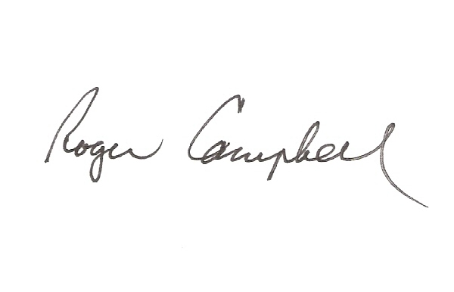

Roger Campbell

Assistant Commissioner

MOSH Instruction 10-1A
May 3, 2010
Page 2

Summary

Recently, several academic studies have asserted varying degrees of under-recording of workplace injuries and illnesses on the OSHA Form 300; (e.g., Boden L.I., Ozonoff A. Capture-Recapture Estimates of Nonfatal Workplace Injuries and Illnesses, 2008 and Rosenman K.D. How Much Work-Related Injury and Illness is Missed By the Current National Surveillance System, 2006). At the request of the Senate Committee on Health, Education, Labor and Pensions and the House Committee on Education and Labor, the Government Accountability Office (GAO) initiated a study on the accuracy of employer injury and illness records. In an effort to identify and correct under-recorded and incorrectly recorded cases and to work cooperatively with the GAO, OSHA is initiating this NEP. This NEP also complements the Bureau of Labor Statistics’ efforts to investigate factors accounting for differences in the number of workplace injuries and illnesses estimated by the BLS and other data sources.

OSHA postulates the most likely places where under-recorded injuries and illnesses may exist would be low rate establishments operating in historically high rate industries. The NEP will pilot test OSHA’s ability to effectively target establishments to identify under-recording of occupational injuries and illnesses.

MOSH is participating in this NEP to assist OSHA in its effort to address the issue of inaccurate recording of occupational injuries and illnesses.

Significant Changes

The expiration date is extended by one year (see section IV).

The deletion criteria for establishments with NAICS codes other than those listed in Appendix A has been removed. OSHA will continue to select establishments for inspection based on NAICS codes listed in Appendix A. However, if during the inspection it is discovered that the establishment’s true NAICS code is not listed on Appendix A, the inspection will be conducted as long as the industry is not exempted under Part 1904.2 from the recordkeeping requirements.

The Questionnaires contained in Appendix C have been modified to gather additional information.

The IMIS coding will no longer be captured in Item 46 Optional Information but will be captured in item 25d, NEP coding (see section XV).

MOSH INSTRUCTION 10-1A
May 3, 2010
Page 3

Action:

- The Assistance Commissioner shall ensure that the policies and procedures set forth in this instruction are followed, and that professional judgment is used when conducting inspections under this NEP.

- The Chief of Compliance shall request a list of establishments to be inspected from the Office of Statistical Analysis. The list shall not exceed five establishments. Public sector establishments that appear on the list will not be deleted from the list.

- The Chief of Compliance shall ensure that inspections conducted under this NEP are conducted in accordance with OSHA Instruction, Directive Number CPL 02-10-02, dated 02/19/10.

________________________________________ 05/03/2010
Roger Campbell, Assistant Commissioner Date

cc: J. Ronald DeJuliis, Commissioner, Division of Labor and Industry
Craig D. Lowry, Deputy Commissioner, Division of Labor and Industry
Jonathan Krasnoff, Assistant Attorney General
Office of Administrative Hearings

