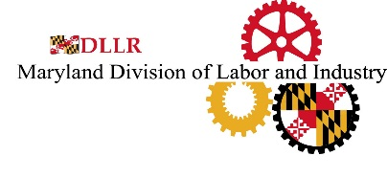
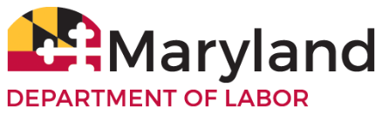
Secure Wage Complaint
(Secure Maryland Wage Act
Labor and Employment Article, Section 3-1601 Annotated Code of Maryland)

The Secure Maryland Wage Act requires employers to pay at least a certain wage rate to covered employees working at Baltimore-Washington International Thurgood Marshall Airport or Pennsylvania Station in Baltimore.

This does not include employees who work at retail establishments, food service facilities, or an on-airport or off-airport motor vehicle rental company, or any other company involved in motor vehicle rental operations.

If you feel your rights may have been violated under this law, complete this form, provide supporting documentation, and mail the complaint form to the address below. Upon receipt, the Commissioner will investigate and notify you of its determination.

For more information, click here to visit the Secure Maryland Wage Act (link to law)

Name:

Address:
City State Zip

Daytime Phone Number(s):

Email Address:

Employer Name:

Employer Address:
City State Zip

Supervisor and/or Business Owner Name:

Describe in detail the nature of the complaint (also, please provide any supporting documentation):

Department of Labor
Division of Labor and Industry
Employment Standards Service
10946 Golden West Drive – Suite 160
Hunt Valley, MD 21031
Telephone Number: (410) 767-2357 • Fax Number: (410) 333-7303
E-mail: DLDLIMdLaborComplaint-dllr@Maryland.gov
Rev: 8/23

