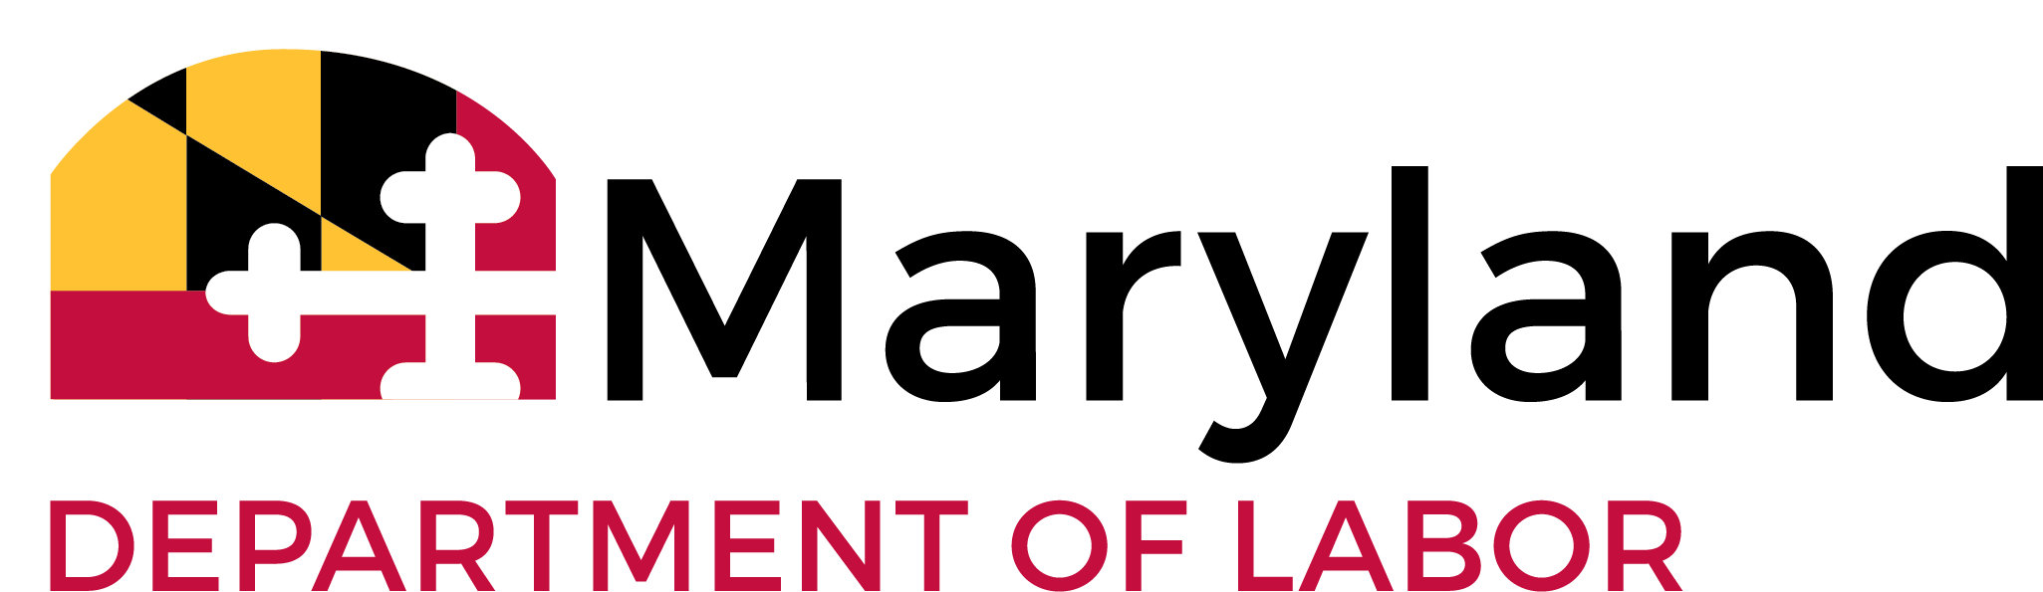
EMPLOYER ACCEPTANCE AGREEMENT
SUPPLEMENTAL FORM

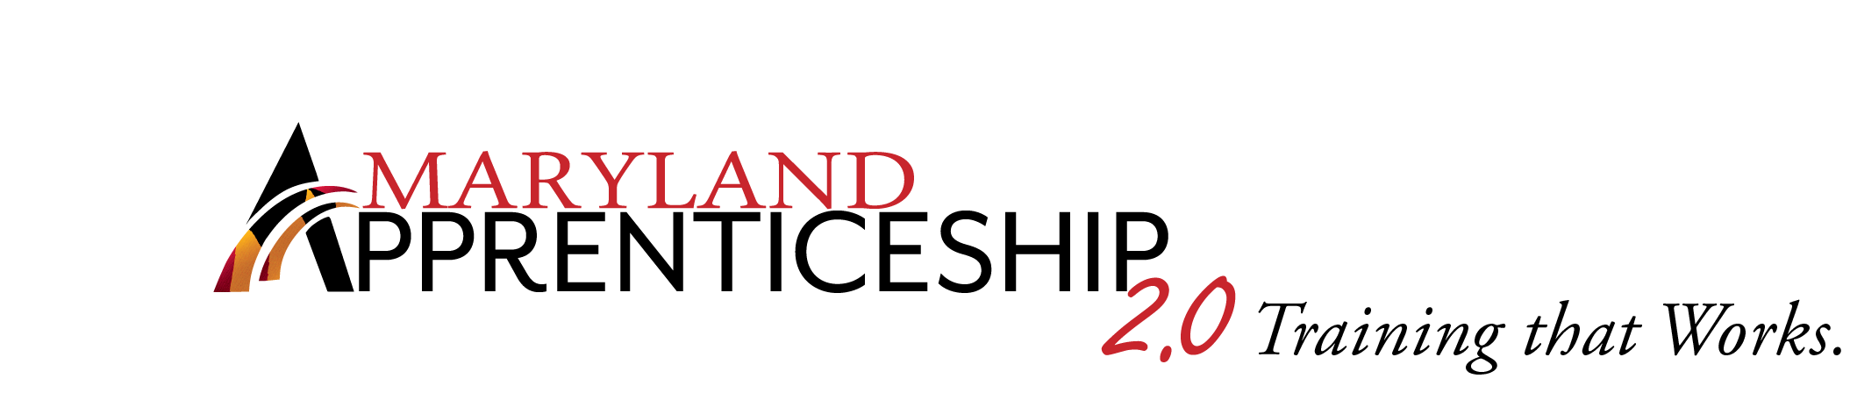

MATC #:
(Sponsor/Association Name)

This form is to be completed and attached to the Employer Acceptance Agreement when requested by the Apprenticeship Committee or by the Maryland Apprenticeship and Training Council.

PARTICIPATING EMPLOYER:

Company Name: #
Address:

Telephone: Fax:
As of: , we employ the following number of persons in the occupation of:
(Month, Day, Year)

(List each occupation on a separate sheet.)

journeypersons, of which are minority and are female.

total apprentices, of which are registered with (Name of Sponsor/Association)
and of which of those are minority and are female.

Our current average journeyperson’s wage rate for this occupation is $ per hour.

SUBMITTED BY:

Employer’s Signature Sponsor/Association’s Signature

Typed or Printed Name Typed or Printed Name

Title Title

Date Signed Date Signed

MD Council B.A.T. Sponsor Participating Employer

Division of Workforce Development and Adult Learning
Maryland Apprenticeship and Training Program
1100 N. Eutaw Street - Room 209
Baltimore, MD 21201
410-767-2246 │Fax: 410-333-5162
e-mail: dlmatpapprenticeshipandtraining-dllr@maryland.gov
Rev. 10/2019
Department of Labor, Licensing and Regulation
Employment Standards Service
1100 North Eutaw Street, Room 607
Baltimore, MD 21201
Telephone Number: (410) 767-2357 • Fax Number: (410) 333-7303
E-mail: dldliemploymentstandards-dllr@maryland.gov

