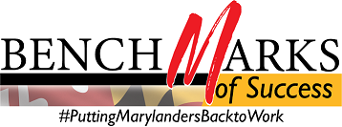

WIOA Alignment Group Meeting
Monday, March 30, 2020, 1:00 – 2:00 PM
Call-in #: 413-961-2625 / Access Code: 322-780-333‬#
‬‬‬‬‬‬
I. Welcome and Introductions
II. 2020 WIOA State Plan Update
III. Partner Updates on COVID-19
- MD Labor DWDAL
- MD Labor UI
- MD Labor GWDB
- DHS
- MSDE DORS
- DHCD
- MWA
- Title II/Community Colleges

IV. Good of the Order All

Next Meeting of the WIOA Alignment Group: Monday, April 27, 2020

