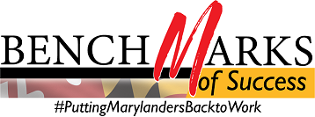

WIOA Alignment Group Meeting
Monday, February 24, 2020, 1:00 – 4:00 PM
Call-in #: 803-820-1265 / Access Code: 772-259-068#
‬‬‬‬
I. Welcome and Introductions Jim Rzepkowski
II. Career Preparation Expansion Act Report (GWDB/MLDS) Mike DiGiacomo and Molly Mesnard
III. 2020 WIOA State Plan Comment Review Lauren Gilwee
IV. May Meeting Date- Decision Point Lauren Gilwee
V. Professional Development and Technical Assistance Committee Membership John Feaster
VI. Good of the Order All

Remaining Critical Activities/Touchpoints for State Plan | Dates
WIOA Alignment Group meets to discuss public feedback | February 24, 2020
Requested partner leadership conducts final review; Draft State Plan and updated State Plan Crosswalk sent to the Governor’s Office | March 9-March 13, 2020
Updated 2018/2020 State Plan Crosswalk presented to the Governor’s Workforce Development Board (reflect changes post-public comment) | March 18, 2020
Submission of State Plan | April 1, 2020
Next Meeting of the WIOA Alignment Group: Monday, March 30, 2020

