WORKFORCE INVESTMENT FIELD INSTRUCTION (WIFI) No. 08-12

DATE: December 3, 2012

TO: Maryland Workforce Investment Act (WIA) Grant Recipients

SUBJECT: National Emergency Grant for RG Steel and Impacted Companies

REFERENCES: Training and Employment Guidance Letter (TEGL) No. 16-03, and Changes 1-5
Workforce Investment Act (WIA), as amended
Trade Adjustment Assistance Reform Act of 2002 (Public Law 107-210), Sections 201, 202 and 203
WIA regulations at 20 CFR Part 671
Training and Employment Guidance Letter (TEGL) No. 14-00, Change 1, “Guidance on the Workforce Investment Act (WIA) Management Information and Reporting System,” dated November 19, 2001
Training and Employment Guidance Letter (TEGL) No. 10-02, “Use of National Emergency Grant Funds Under the Workforce Investment Act, as amended, to Develop systems for Health Insurance Coverage Assistance for Trade-Impacted Workers,” dated October 10, 2002
Training and Employment Guidance Letter (TEGL) No. 20-02, “Use of National Emergency Grant (NEG) Funds under the Workforce Investment Act (WIA), as amended, to Support Health Insurance Coverage Assistance for Trade-Impacted Workers,” dated March 3, 2003
Training and Employment Notice (TEN) No. 8-02, “Implementation of Common Measures for Job Training and Employment Programs,” dated March 2, 2003
Training and Employment Guidance Letter (TEGL) No. 17-05, “Common Measures Policy for the Employment and Training Administration’s (ETA) Performance Accountability System and Related Performance Issues.”

BACKGROUND
INFORMATION: On May 23, 2012, the owner of RG Steel, located at Sparrows Point, Baltimore County filed a WARN notification with DLLR, laying off 1,975 employees with an effective date of June 4, 2012. As referenced in Trade Petition 74919, this action also impacted a number of other local firms that depended upon RG Steel for much of their business. In addition to the companies covered under that Trade Petition, the following companies are also eligible under the NEG due to closures and downsizing directly related to the RG Steel event:

- Kinder Morgan (Baltimore, MD)
- KT Grant, Inc. (Sparrows Point, MD)
- Maryland PIG Iron (Sparrows Point, MD)
- Onsite Innovations (Sparrows Point, MD)
- Phoenix Services (Fort Howard, MD)
- Siemens VAI Services LLC (Baltimore, MD)
- Signode Eastern Operations (Baltimore, MD)
- AS&L (Baltimore, MD)
- AMG Resources (Dundalk, MD)
- Heidtman Steel Products (Baltimore, MD)
- DTE Sparrows Point LLC (Sparrows Point, MD)
- Quality Industrial Services (LaPorte, IN)

PURPOSE: The main purpose of a Dual Enrollment National Emergency Grant is to provide trade-eligible dislocated workers with “wrap around” services that are not available through the Trade program, and when formula Dislocated Worker (DW) program funds are not sufficient to provide such services.

The program’s name is the RG Steel Dual Enrollment National Emergency Grant. The grant performance period is June 30, 2012 to June 30, 2014. Initial enrollment of program participants must be concluded by December 31, 2012.

ACTION TO
BE TAKEN: Eligibility
- All eligible participants must be fully enrolled by December 31, 2012
- All eligible participants must meet the definition of a dislocated worker under WIA
- All eligible participants must be enrolled under the “RG Steel Dual Enrollment” Statewide Program
- All eligible participants must be co-enrolled in WIA DW and, if eligible, in TAA

Maryland Workforce Exchange (MWE) Procedures for Tracking the
RG Steel Dual Enrollment National Emergency Grant
To comply with regulatory reporting requirements and determine the success of RG Steel NEG investments, NEG grantees must report characteristics, services received, and outcomes of participants served with WIA, TAA and NEG funds. Such information is critical to determine the success of these investments.

RG Steel NEG customers must be enrolled in the MWE system. As part of the enrollment process, it is mandatory to enter using the NEG project ID. Additionally, all RG Steel Dual Enrollment NEG participants must be co-enrolled in the WIA Dislocated Worker Program and, if eligible, the TAA Program.

Steps for assigning NEG to a participant in MWE

- Staff must first complete the WIA application to determine eligibility in WIA Dislocated Worker Program, and must select under the NEG/SAA/Statewide Grants section as the 1st NEG grant- RG Steel Dual Enrollment, must be made eligible for statewide DW, and be eligible for Local DW (Dislocated Worker).

  - The dislocated worker statewide is currently a must, in order to have the NEG grant available to assign services. A service must be assigned using the Dislocated Worker Local funding and a service assigned using the RG Steel Dual Enrollment NEG grant to count as reportable services received. All NEGs are included in our federal extracts for reporting on a quarterly and annual basis.

- All RG Steel NEG participants must be co-enrolled in WIA Dislocated Worker and made eligible for TAA (Trade) when applicable.

- To co-enroll, need to assign Dislocated Worker (DW) service to local DW funding, it can be the same service assigned to RG Steel Dual Enrollment NEG

- The following are recommended services that can be funded with NEG: intensive services (any 200 level service) and training services (any 300 level service) in the MWE. Funds may not be used to pay for any costs of Core Services.

- Staff must complete the TAA application to determine eligibility in TAA. The individual must be covered by a certificate or pending a determination under the Trade Adjustment Assistance (TAA) program. After determination of TAA eligibility and to enroll the individual as a participant, create participation in MWE and then create an activity by supplying a service. Note: An application must be completed for TAA and a person must be eligible for TAA, but it is not required that they are a TAA participant.

  - Please note, participants who are affected by the RG Steel layoff with total or partial separation from employment by Signode Eastern Operations, are still eligible for TAA under TA-W-74919, however the employer has not yet filed. Therefore, no petition number is currently available.

- All RG Steel Dual Enrollment NEG activities (any service supported by the RG Steel Dual Enrollment NEG) must end by 6/30/14.

- A person can continue to receive services after RG Steel NEG end date of 6/30/14 under Dislocated Worker (DW) local funding and TAA for however long services are provided and funding is available.

Employment at Exit
In MWE, the use of service 122 “Employment During Participation” must be used to show the start date of employment following the NEG funded services. This will allow the number of participants employed at exit or who received employment after NEG services to be accurately recorded.

Timely Reporting in MWE
Data must be entered correctly and completely into the MWE in a reasonable time. Quarterly extracts for TAA and WIA are pulled 2 weeks following the quarter end date. (Example: 9/30/12: due 10/14/12; 12/31/12: due 1/14/13) All data not in the system by then will not be included in the reports. Delays in data entry and data entry errors adversely affect the quarterly performance of the state and the local workforce areas, resulting in inaccurate quarterly reports.

Performance Measures
NEG project performance goals must align with the state negotiated Entered Employment Rate (EER) (87%), Employment Retention Rate of 91% and the Average Six Month Earnings goals for the WIA DW program ($18,346), at a minimum. Outcomes will be measured according to common measures for employment and training programs.

Reporting for Fiscal and Programmatic Reports (MSR)
Project Operators are required to submit monthly Status Reports for all program activity, including financial reporting of Administrative and Program costs (see Attachments A and B). Monthly status reports must be received by DLLR no later than the 10th of the month following the month of reported activity.

Please forward completed reports to the attention of:

Fiscal (Attachment A)
Doreen Shahan
Fiscal Specialist
1100 North Eutaw, Room 209
Baltimore, MD 21201

Programmatic (Attachment B; refer to Attachment C for instructions)
Grace Fendlay
Director, Discretionary Grants
1100 North Eutaw, Room 209
Baltimore, MD 21201

CONTACT

PERSON: Grace Fendlay, Director of Discretionary Grants
(410) 767-0044 or gfendlay@dllr.state.md.us

EFFECTIVE: June 30, 2012

Ellen Flowers-Fields
Deputy Assistant Secretary
Division of Workforce Development and Adult Learning

Attachments

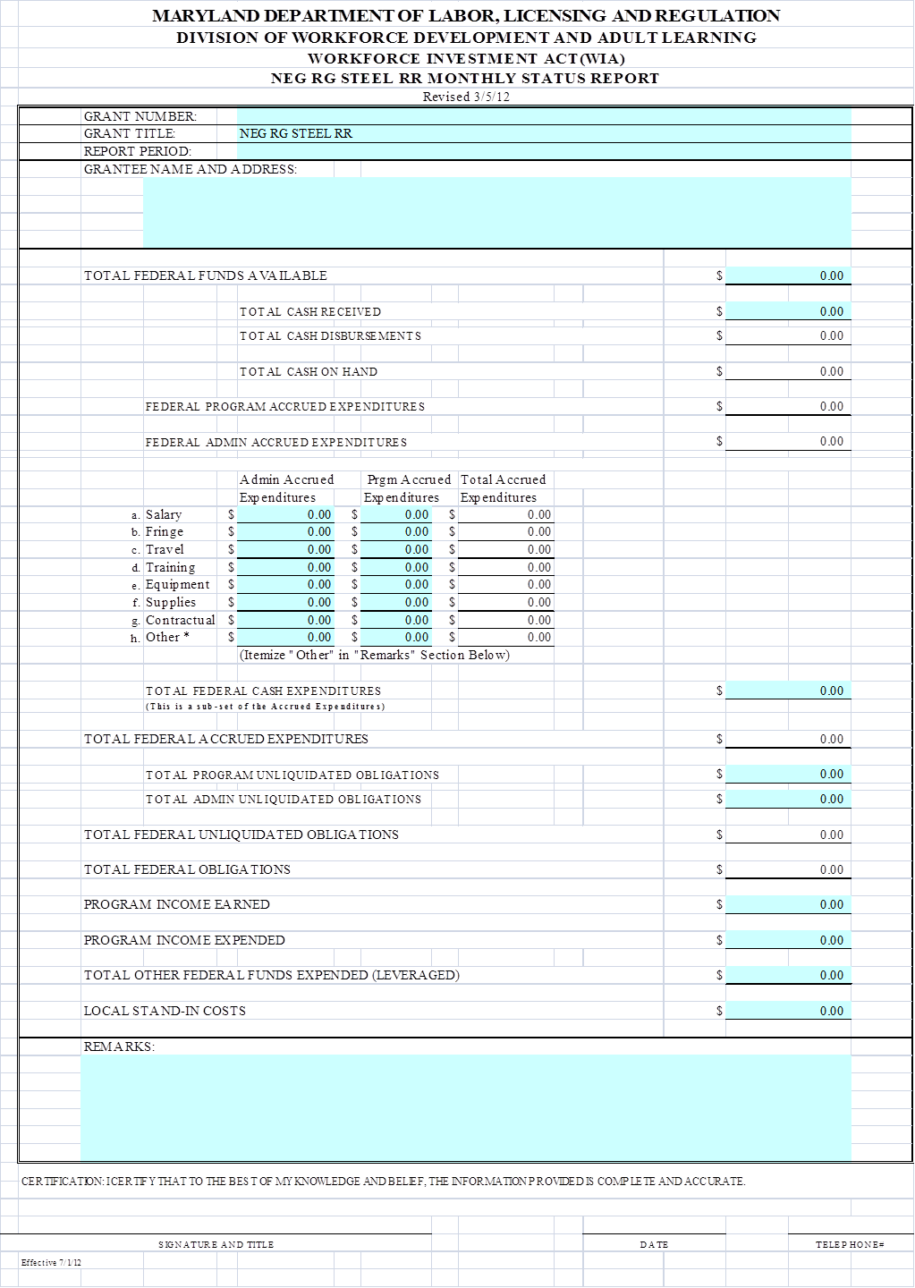

RG STEEL NEG MONTHLY REPORT

RG Steel Project Manager:

Month Ending: Workforce Area:

Participant Category | New Activity | Cumulative  To Date Activity | Comments
# of Participants receiving Intensive Services
# Enrolled In NEG-Funded Training
# Receiving NEG-Funded Supportive Services
# of Participants Exited
# of Participants Entering Employment At Exit
Total Participants

Narrative: (Summary of “Best Practices” or “What’s Working”) - required

Narrative: (Issues, Challenges & Concerns) – required

Instructions for Attachment B. Each field in Section B is explained below:

Receiving Intensive Services (all grant types except HCTC): The cumulative number of grant participants who are receiving or who have received intensive services that have been paid, in whole or in part, with funds provided by this NEG. Intensive services may include, but are not limited to, comprehensive and specialized assessments of the skill levels and service needs of eligible individuals, individual career plans, group or independent counseling, career planning, and short-term pre-vocational services. Additional information regarding allowable WIA intensive services is available at 20 CFR 663.200. (WIA Section 134(d)(3)(C)).

Enrolled in NEG-Funded Training (all grant types except HCTC): The cumulative number of grant participants who are receiving or who have received training funded, in whole or in part, by the NEG. Training services may include: (1) on-the-job training; (2) skill upgrading and training; (3) entrepreneurial training; (4) adult basic education or employment services in combination in training; and (5) customized training. Additional information regarding allowable WIA training services is available at 20 CFR 663.300. For Dual Enrollment NEG projects do not include grant participants whose training is funded exclusively through TAA. (WIA Sec. 134(d)(4)(D)).

Receiving NEG-Funded Supportive Services (all grant types): The cumulative number of grant participants who are receiving or who have received supportive services funded, in whole or in part, by the NEG. Participants receiving needs-related payments are not included in this count, as they are captured in a separate line item. Supportive services include, but are not limited to, assistance with transportation, child care, dependent care, and housing that are necessary to enable the individual to participate in training and employment activities authorized under WIA Title IB. For Dual Enrollment projects, this does not include any grant participants receiving transportation assistance payments, job search allowances, and/or relocation allowances paid exclusively with TAA funds. (WIA Sections 101(46) and 134(e)(2) and (3) and 20 CFR 663.800 and 20 CFR 617.27-28, 617.30-35 and 617.40-48 and Trade Act of 1974, 19 USC, Chapter 12, §2296(b), §2297 and §2298).

Exits (all grant types except HCTC): The cumulative number of grant participants who have not received a service funded by the grant or a One-Stop partner program for 90 consecutive calendar days and are not scheduled for future services. The date of exit is applied retroactively to the last day on which an individual received a service funded by the grant or other program.

Entering Employment at Exit (all grant types except HCTC): The cumulative number of grant participants who are employed anytime once a participant begins receiving services from the NEG through completion of the NEG period of performance. Participants should be reported in the Entering Employment at Exit count for the report quarter in which they are also reported as exited and in any quarter thereafter. Participants can only be counted once in this field. Employment is defined as working any number of hours and making a wage greater than $0. OJT placement received through OJT NEGs and temporary jobs received through Disaster NEGs do not count as employment.

What data sources can be used to verify employment? Supplemental data sources should be used to verify employment on the QPR. Allowable sources of supplemental data for tracking employment include case management notes, automated database systems, One-Stop operating systems’ administrative records, surveys of participants, and contacts with employers. For any given report period, the entry for “Entering Employment at Exit” cannot exceed the entry for “Exits.”

Which participants should be included in the Entering Employment at Exit count in specific QPR submissions? Entering Employment at Exit is a program management count used to assess whether participants have obtained employment by the time the NEG grant period ends. Verified employment should be reported on the QPR in the same quarter in which a participant is reported as exited or any quarter thereafter, up to the last day of the grant period.

TEGL 17-05, “Common Measures Policy for the Employment and Training Administration’s (ETA) Performance Accountability System and Related Performance Issues.”

