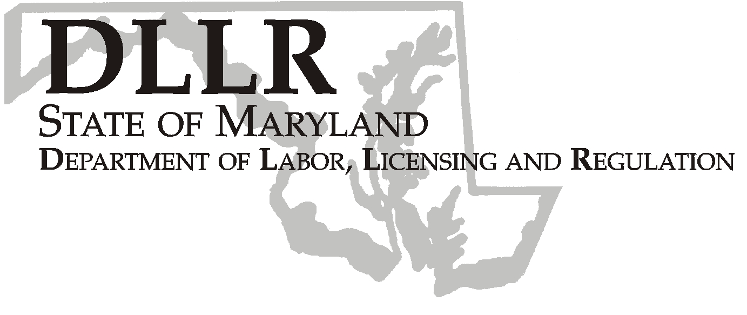
MARTIN O’MALLEY, Governor
ANTHONY G. BROWN, Lt. Governor
THOMAS E. PEREZ, Secretary

Andrew Moser, Assistant Secretary

Division of Workforce Development

DLLR Home Page • http://www.dllr.state.md.us
E-mail • amoser@dllr.state.md.us

WORKFORCE INVESTMENT FIELD INSTRUCTION (WIFI) No. 08-07

DATE: June 16, 2008

TO: Maryland Workforce Investment Act (WIA) Grant Recipients

SUBJECT: Revised Federal Poverty Level Guidelines and Lower Living Standard Income Levels (LLSIL)

REFERENCES: Public Law 105-220 – Workforce Investment Act
20 CFR 652 – Workforce Investment Act: Final Rule
Federal Register/Vol. 72, No. 15
Federal Register/Vol. 72, No 106

BACKGROUND INFORMATION:

Under Title I of the Workforce Investment Act, the Secretary of Labor annually determines the Lower Living Standard Income Level (LLSIL) for uses defined in the law. WIA defines the term “low income individual” as one who qualifies under various criteria, including an individual who received income that does not exceed the higher of the poverty line or 70 percent of the lower living standard income level. In accordance with the Act, Health and Human Services/Office of the Secretary has released the revised 2008 figures for poverty levels and the Department of Labor has released the revised 2008 LLSIL.

ACTION TO BE TAKEN:

All Maryland WIA grant recipients should use one of the attached charts, either the 2008 Poverty Income Guidelines or the 2008 70 percent LLSIL (whichever is higher), to determine if applicants are low income for those programs that require it. These new poverty income guidelines are now available in MWE. All intake personnel are to be advised of the changes and refer to the revised guidelines.

CONTACT PERSON: Valerie Myers (410-767-2825)

EFFECTIVE DATE: April 25, 2008

Attachment

Andrew Moser
Assistant Secretary

Division of Workforce Development
2008 Lower Living Standard Income Level (LLSIL)- 70%
and
Poverty Income Guidelines for The State of Maryland
2008 HHS Poverty Guidelines
Size of Family |  |  |  |  |  |  |  |  |  |  |  | Poverty Guideline
1………………….......…………………………………………………………………..…… |  |  |  |  |  |  |  |  |  |  |  | $10,400
2………………….......…………………………………………………………………..…… |  |  |  |  |  |  |  |  |  |  |  | $14,000
3………………….......…………………………………………………………………..…… |  |  |  |  |  |  |  |  |  |  |  | $17,600
4………………….......…………………………………………………………………..…… |  |  |  |  |  |  |  |  |  |  |  | $21,200
5………………….......…………………………………………………………………..…… |  |  |  |  |  |  |  |  |  |  |  | $24,800
6………………….......…………………………………………………………………..…… |  |  |  |  |  |  |  |  |  |  |  | $28,400
7………………….......…………………………………………………………………..…… |  |  |  |  |  |  |  |  |  |  |  | $32,000
8………………….......…………………………………………………………………..…… |  |  |  |  |  |  |  |  |  |  |  | $35,600
*For family units with more than 8 members, add $3,600 for each additional person.
70% LLSIL
Area | 1 |  | 2 |  | 3 |  | 4 |  | 5 |  | 6 |  | Over 6 Add
Anne Arundel County WIA | 10,088 * |  | 16,532 |  | 22,691 |  | 28,009 |  | 33,057 |  | 38,660 |  | 5,603
Baltimore City WIA | 10,088* |  | 16,532 |  | 22,691 |  | 28,009 |  | 33,057 |  | 38,660 |  | 5,603
Baltimore County WIA | 10,088* |  | 16,532 |  | 22,691 |  | 28,009 |  | 33,057 |  | 38,660 |  | 5,603
Frederick County WIA | 10,088* |  | 16,532 |  | 22,691 |  | 28,009 |  | 33,057 |  | 38,660 |  | 5,603
Lower Shore WIA | 7,753* |  | 12,701* |  | 17,431* |  | 21,518 |  | 25,394 |  | 29,698 |  | 4,304
Mid Maryland WIA
Carroll County | 10,088* |  | 16,532 |  | 22,691 |  | 28,009 |  | 33,057 |  | 38,660 |  | 5,603
Howard County | 10,088* |  | 16,532 |  | 22,691 |  | 28,009 |  | 33,057 |  | 38,660 |  | 5,603
Montgomery County WIA | 10,088* |  | 16,532 |  | 22,691 |  | 28,009 |  | 33,057 |  | 38,660 |  | 5,603
Prince George's County WIA | 10,088* |  | 16,532 |  | 22,691 |  | 28,009 |  | 33,057 |  | 38,660 |  | 5,603
Southern Maryland WIA
Calvert County | 10,088* |  | 16,532 |  | 22,691 |  | 28,009 |  | 33,057 |  | 38,660 |  | 5,603
Charles County | 10,088* |  | 16,532 |  | 22,691 |  | 28,009 |  | 33,057 |  | 38,660 |  | 5,603
St. Mary's County | 7,753* |  | 12,701* |  | 17,431* |  | 21,518 |  | 25,394 |  | 29,698 |  | 4,304
Susquehanna Region WIA
Cecil County | 9,194* |  | 15,063 |  | 20,677 |  | 25,524 |  | 30,125 |  | 35,225 |  | 5,100
Harford County | 10,088* |  | 16,532 |  | 22,691 |  | 28,009 |  | 33,057 |  | 38,660 |  | 5,603
Upper Shore WIA | 7,753* |  | 12,701* |  | 17,431* |  | 21,518 |  | 25,394 |  | 29,698 |  | 4,304
Queen Anne's County | 10,088* |  | 16,532 |  | 22,691 |  | 28,009 |  | 33,057 |  | 38,660 |  | 5,603
Western Maryland WIA
Allegany County | 8,112* |  | 13,292* |  | 18,243 |  | 22,523 |  | 26,583 |  | 31,089 |  | 4,506
Washington County | 8,112* |  | 13,292* |  | 18,243 |  | 22,523 |  | 26,583 |  | 31,089 |  | 4,506
Garrett County | 7,753* |  | 12,701* |  | 17,431* |  | 21,518 |  | 25,394 |  | 29,698 |  | 4,304
* Poverty level is greater than the LLSIL figures
Effective 04/25/2008

