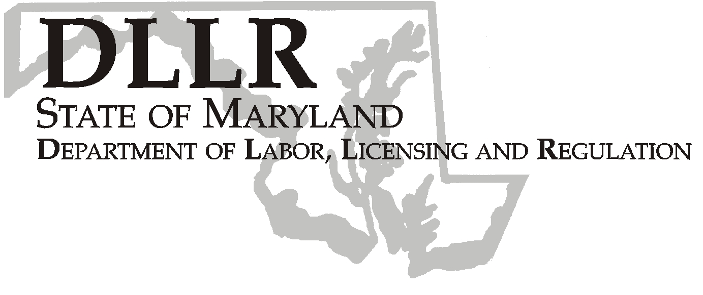
Workforce Investment Field Instruction (WIFI) No. 05-09
MARTIN O’MALLEY, Governor
ANTHONY G. BROWN, Lt. Governor
ALEXANDER SANCHEZ, Secretary

Andrew Moser, Assistant Secretary

Division of Workforce Development and Adult Learning
DLLR Home Page • http://www.dllr.state.md.us
E-mail • amoser@dllr.state.md.us

DATE: November 19, 2009

TO: Maryland Workforce Investment Grant Recipients

SUBJECT: Recipient Reporting Requirements Section 1512 American Recovery and Reinvestment Act Funds

REFERENCES: American Recovery and Reinvestment Act of 2009, Division A
Title VIII, P.L. 111-5;
Public Law 105-220 – Workforce Investment Act
20 CFR 652 – Workforce Investment Act; Interim Final Rule
Office of Management and Budget (OMB) Implementing
Guidance for the Reports on Use of Funds Pursuant to the
American Recovery and Reinvestment Act of 2009 (OMB M-
09-21), dated June 22, 2009.
Training and Employment Guidance Letter No. 1-09, Change
1, and Change 2 Reporting Requirements Under Section
1512 of the American Recovery and Reinvestment Act of
2009
Training and Employment Notice No. 7-09, Technical
Assistance on American Recovery and Reinvestment Act of
2009 Section 1512 Reporting Requirements
Training and Employment Guidance Letter No. 29-08, Dun
and Bradstreet (D &B) Data Universal Numbering System
(DUNS) Number/Central Contractor Registration Mandatory
Requirement for Federal Grant Sub-recipients under the
American Recovery and Reinvestment Act of 2009
Training and Employment Guidance Letter No. 17-08,
American Recovery and Reinvestment Act (Recovery Act)
Funds Financial Reporting Requirements
Training and Employment Guidance Letter No. 14-08,
Guidance for Implementation of the Workforce Investment Act
and Wagner-Peyser Act Funding in the American Recovery
and Reinvestment Act of 2009 and State Planning
Requirements for Program Year 2009

BACKGROUND: President Barack Obama has called for an unprecedented level of transparency for how Federal dollars are being spent under the American Recovery and Reinvestment Act of 2009

(Recovery Act). As envisioned by the Recovery Act, this level of transparency is essential to drive accountability for the timely, prudent and effective spending of recovery dollars. It is therefore critical that all recipients of employment and training funds under the Recovery Act immediately prepare to implement the requirements of Section 1512 of the Recovery Act.

Section 1512 of the Recovery Act requires recipients to report on the use of Recovery Act funding, and provide detailed information, such as: total amount of funds received; the amount spent on projects and activities; a list of those projects and activities funded, including name, description, completion status and estimates of jobs created and retained; and details on sub-awards and other payments.

The Office of Management and Budget (OMB) issued implementing guidance which Provides details on Section 1512 recipient reporting on June 22, 2009

(OMB M-09-21). The Employment and Training Administration (ETA) has synthesized this information to provide initial guidance to its grantees, including reporting requirements and data elements. Note: this guidance complements the OMB guidance and provides customized guidance for ETA funding recipients.
All funding recipients are strongly encouraged to read the full OMB guidance, http://www.whitehouse.gov/omb/assets/memoranda_fy2009/m09-21.pdf. The final detailed reporting requirements, along with data entry instructions, will be posted on
www.FederalReporting.gov.

Section 1512 recipient reports are an OMB requirement and must be submitted
separately from the ETA 9130 financial reports (OMB No. 1205-0461). The Section 1512 recipient reports will contain detailed information about the projects and activities funded by the Recovery Act. In addition to being posted on ETA’s Web site, www.doleta.gov, the reports will also be posted on www.recovery.gov to maximize transparency and the public’s access to information about Recovery Act funded activities and projects.

Section 1512 of the Recovery Act requires recipients of Recovery Act funds to report on the use of Recovery Act funding no later than the 10th day after the end of each calendar quarter (beginning the quarter ending September 30, 2009), and prime recipients (usually states and other direct grantees) have the 11th day through the 21st day to review and correct data. After a brief Federal agency review, DOL will post the information on its web site no later than the 30th day after the end of that quarter.

All direct recipients of ETA Recovery Act funds are required to report through a central electronic reporting solution system (portal) at www.FederalReporting.gov. Reports will contain cumulative data from inception of the grant award with the first report submitted for the quarter ending September 30, 2009, due no later than October 30, 2009. Grantees are also required to maintain a manual version of the report for the period ending June 30, 2009.

Who Must Submit Recovery Act Recipient Reports?

Recovery Act Section 1512 recipient reports must be submitted by all prime grant recipients which in the case of ETA are usually states and direct grantees. Prime recipients may choose to delegate certain reporting requirements to sub-recipients (such as Local Workforce Areas).

Prime recipients are non-Federal entities that receive Recovery Act funding as Federal awards in the form of grants, cooperative agreements, or loans directly from the Federal Government. The prime recipient of Workforce Investment Act formula funds (WIA Adult, Dislocated Worker, and Youth) and Wagner-Peyser formula funds are the fifty states and territories.

A sub-recipient is a non-Federal entity that expends Federal awards received from another entity to carry out a Federal program, but does not include an individual who is a beneficiary of such a program. Sub-recipients are awarded Recovery Act funding through a legal instrument from the prime recipient to support the performance of any portion of the substantive project or program for which the prime recipient received the Recovery Act funding. For WIA formula programs, sub-recipients include all entities that receive their funds directly from a state or territory to carry out Recovery Act funded WIA activities, such as Workforce Investment Boards and Local Workforce Areas.

A vendor is defined as a dealer, distributor, merchant or other seller providing goods or services that are required for the conduct of a Federal program. Prime recipients or sub recipients may purchase goods or services needed to carry out the project or program from vendors. Vendors are not awarded funds by the same means as sub-recipients and are not subject to the terms and conditions of the Federal financial assistance award.

The characteristics of a vendor that make it distinct from a sub-recipient are summarized below.
A vendor:
1. Provides the goods and services within normal business operations;
2. Provides similar goods or services to many different purchasers;
3. Operates in a competitive environment;
4. Provides goods or services that are ancillary to the operation of the Federal program; and
5. Is not subject to compliance requirements of the Federal program.

Prime recipients may delegate some reporting requirements to sub-recipients; however, prime recipients cannot delegate this responsibility to vendors. Maryland will not be delegating reporting requirements to sub-recipients (local areas).

ACTION TO
BE TAKEN: If a sub-recipient is not delegated the responsibility to report FFATA data elements by the prime recipient or any sub-recipient vendor information, the prime and sub-recipients must develop a process by which this information will be reported to the prime recipient in sufficient time to meet the reporting deadlines.

What Data Must be Reported in the Recipient Report?
Below are the basic reporting requirements to be reported by sub-recipients, and sub-recipient vendors. Administrative costs are excluded from the reporting requirements. However, indirect costs should be included in total expenditures reported. The basic reporting requirements below may contain multiple data elements. A detailed description of all data elements is provided in the data dictionary contained in OMB’s Recipient Reporting Data Model. This document is published on OMB's Web site at www.Recovery.gov as supplemental material to the OMB Guidance.

Data about Sub-Recipients (also referred to as FFATA Data Elements)

1. Sub-recipient DUNS Number
2. Subaward Number
3. Sub-recipient Name, Address, City, State, Zip Code, County
4. Sub-recipient Congressional District
5. Sub-recipient type
6. Amount of Sub-award
7. Total Funds Disbursed
8. Sub-award date
9. Sub-recipient place of performance
10. Sub-recipient officer names and compensation (Top 5), if all indicated criteria in the OMB guidance are met.

Data about Sub-Recipient Vendors
1. DUNS or Name and zip code of Headquarters (HQ)

When Do Recipients File Reports? Prime recipients (State of Maryland) must enter their data no later than the 10th day after the end of each quarter, beginning with the quarter ending September 30, 2009. The first reporting deadline for prime recipients was October 10, 2009. All data contained in each quarterly recipient report will be cumulative in order to encompass the total amount of funds expended to date. This means that reports due on October 10, 2009, will include funding and activity from February 17, 2009, (the date the Recovery Act was enacted by Congress) through September 30, 2009. Each subsequent quarterly report will also be cumulative. The report due January 10, 2010, will include the data reported through September 2009 and updated to include accumulated data for the quarter ending December 2009 (October to December). For example, October's report may have contained a project that was 25 percent completed through the end of September. If the project has completed another 25 percent by the end of December, on January 10, the prime recipient will report that the project is 50 percent completed.

The Office of the Governor will submit the reports to the electronic reporting system on the 10th of the month following the end of the quarter. In order to meet this deadline, the Division of Workforce Development and Adult Learning must submit all draft data to the Governor’s Office by the 14th of the last month of the quarter. Therefore, the information from the local areas must be in our office no later than 9th of the last month of the quarter.

Attached is the document you will be required to submit to the Office of Administration on the 9th of the last month of the quarter. The due dates are December 9, 2009, March 9, 2010, June 9, 2010, September 9, 2010, December 9, 2010, March 9, 2011 and June 9, 2011. You are required to submit a separate copy of the attached document for EACH ARRA grant (WIA Adult, Youth and Dislocated Worker; Maryland business Works; Other Statewide Grants, if any). This report is in addition to and does not replace any other ARRA reports (fiscal and programmatic) you currently submit on the appropriate and established due dates to the Department of Labor, Licensing and Regulation. The attached document is to be submitted electronically to the attention of Doreen Shahan (dshahan@dllr.state.md.us). Please copy Dorothee Norton(dnorton@dllr.state.md.us) on your submission.

Immediate action is required for the quarter ended September 30, 2009; we will need two documents to be submitted electronically no later than November 20, 2009. The first submission will be for the period ended June 30, 2009. The second submission will be for the period that ended September 30, 2009 but includes all prior periods. For future periods the report will be due as stated in the previous paragraphs.

In addition to the required action items above, each local area is required to submit a 2-3 page plan outlining the priorities and operational plans the local area have set in order to effectively use the Recovery Act funds they have been allocated. The plan should include the following:

- The priorities for spending your Adult, Dislocated Worker and Youth funds
- Your strategy for achieving your goals
- Planned Outcomes
- Technical assistance needs to achieve your planned outcomes

CONTACT: Laura Ferguson, Director, Office of Administration
410 767-2038

EFFECTIVE
DATE: Immediately



Andrew Moser
Assistant Secretary
Division of Workforce Development and Adult Learning

Attachments: Report template
ARRA Definitions

