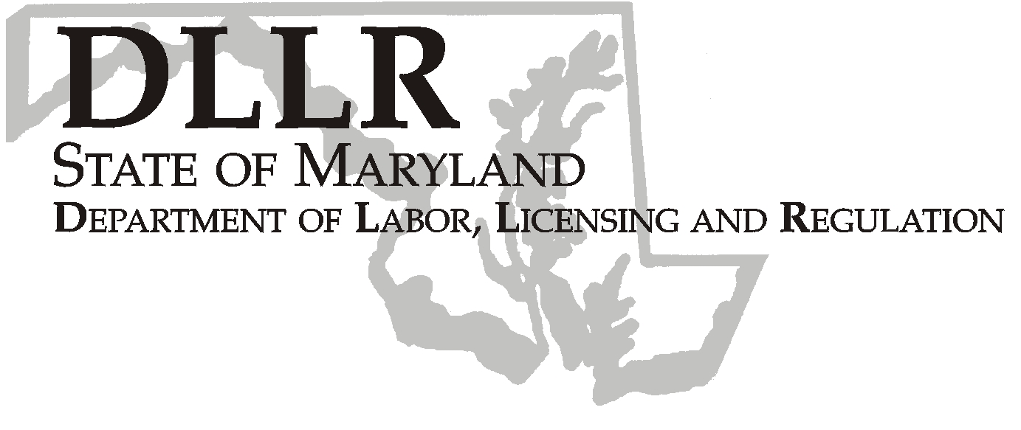
MARTIN O’MALLEY, Governor
ANTHONY G. BROWN, Lt. Governor
THOMAS E. PEREZ, Secretary

Andrew Moser, Assistant Secretary

Division of Workforce Development

DLLR Home Page • http://www.dllr.state.md.us
E-mail • amoser@dllr.state.md.us

Workforce Investment Field Instruction (WIFI) No. 4-08

DATE: March 16, 2009

TO: Local WIA Grant Recipients

SUBJECT: American Recovery and Reinvestment Act

REFERENCES: H.R. 1 The American Recovery and Reinvestment Act

BACKGROUND
INFORMATION:

On February 17, 2009, President Obama signed H.R., 1 the American Recovery and Reinvestment Act (Recovery Act), which increases funding by $3.95 billion for Workforce Investment Act (WIA) programs and provides new funding for reemployment services and other workforce programs. It also extends Emergency Unemployment Compensation, provides interest-free loans to States, encourages states to enact unemployment insurance (UI) benefit expansions, and provides additional funding for UI administration. Additionally, the legislation provides tax incentives and subsidies to assist low-income and recently unemployed individuals.

The formula funding to states will provide for employment and training programs under the Workforce Investment Act (WIA) of 1998, including:

- Dislocated Worker Program: $1.25 billion for training and reemployment services for dislocated workers.

- Adult Program: $500 million to serve eligible low income adults.

- Youth Program: $1.2 billion for youth activities including summer jobs for youth. The eligibility age for youth recovery funds is extended to age 24.

The Secretary of Labor will receive discretionary funding for competitive grants to states in the following three programs:

- High Growth and Emerging Industry Sectors: $750 million is provided for worker training and job placement in high growth and emerging industry sectors. Of that amount, $500 million is reserved to prepare workers for efficiency and renewable energy careers.

1100 NORTH EUTAW STREET . ROOM 616
BALTIMORE, MD, 21201

Keeping Maryland Working and Safe
PHONE: 410-767-2997 FAX: 410-333-5355
TTY USERS, CALL VIA THE MD RELAY SERVICE

- Dislocated Workers Assistance National Reserve: $200 million for national emergency grants, with an emphasis on serving areas of high unemployment or high poverty and providing the income and support services necessary for an individual to participate in job training.

- YouthBuild: $50 million to help at-risk youth gain education and occupational credentials while building or rehabilitating affordable housing. For program years 2008 and 2009, the program can serve youth who have dropped out of high school and re-enrolled in alternative school provided that reenrollment is part of a sequential service strategy.

Unemployment Insurance (UI) Modernization

$500 million in UI administrative funding is provided to all states. $7 billion in incentive payments is available for States who enact specific reforms designed to increase UI coverage among low-wage, part-time and other jobless workers.
Senators Harkin, Murray, and Stabenow clarified the intent of the Workforce Investment Act formula grants in the American Recovery and Reinvestment Act in a discussion in the Senate Chamber on February 25, 2009. The Senators said the intent of the WIA formula grants for Adults and Dislocated Workers should be used to serve certain priority populations, such as those with low incomes and those with multiple barriers to employment, including older workers, those with low skill levels, and individuals with disabilities. The grants should also focus on helping individuals obtain the education, skills training and support services they need to obtain jobs in high demand occupations, specifically those in the green jobs and healthcare sectors.
In regards to the training provided under the WIA Adult and Dislocated Workers funding, the Senators said the formula grants should help retool workers who have lost their jobs due to the recession and those in distressed industries, including those in the green-collar sector. Training for workers in these industries should be supported by strategic partnerships among state and local workforce boards; institutions of higher education, including community colleges and other training providers; labor organizations; industry; and economic development entities and that use sector or cluster-based training approaches for developing job training strategies and career pathway initiatives that lead to economic self-sufficiency.
The training may be provided through the award of contracts to institutions of higher education, as long as a customer's choice is not limited. Such training may include the provision of adult basic education or English language education services, as long as these services are provided in connection with a job for which the individual is preparing. These services may be provided through community colleges and other high quality public programs that offer postsecondary education and training within a community or region.
In regards to the WIA Youth formula grants, the Senators affirmed the belief that, in addition to summer and year-round employment opportunities, the funding may be used to provide related educational enrichment, skills training, and supportive services that enable participants to work in high demand occupational areas, such as in the green jobs and health care industries, with the goal that such employment and enrichment activities will lead to further education or employment.
The Employment and Training Administration in the U.S. Department of Labor is expected to release guidance letters regarding the use of the Recovery Act formula funding to states by mid March 2009.

The Impact of the Recovery Act on Maryland

Under the Recovery Act, DLLR expects to receive roughly $34 million in Workforce Investment Act and Wagner-Peyser dollars and roughly $9 million to administer the state’s unemployment insurance program. The Act also contemplates the creation and retention of thousands of jobs through funding for infrastructure, school construction, “greening” and weatherization projects as well as modernization of health records, among others. While the funding for these projects and programs will go directly to a variety of other state agencies, the job training component will require close coordination with DLLR and the state’s workforce development system. DLLR looks forward to expanding our existing partnerships with our sister agencies to capitalize on this unprecedented opportunity to prepare Maryland’s workforce.

Workforce Investment Act Funds

Maryland is poised to receive an additional $27.8 million in adult, dislocated worker and youth funds under the Workforce Investment Act. By law, 85% of these funds must be allocated to local workforce investment areas (WIAs) using a pre-determined federal formula.

Wagner-Peyser Funds

DLLR will also receive $6.7 million in Wagner Peyser funds that can be used for a variety of employment-related labor-exchanges services including job search assistance, job referrals, re-employment services for unemployment insurance claimants, and job search workshops. These funds might also be used for job fairs and hiring additional one-stop staff, improvement of the statewide labor exchange database, and IT infrastructure for case management and statistical reporting. There is no formula requirement for these funds.

ACTION TO
BE TAKEN: To be determined.

CONTACT
PERSON: Crystal Martin, 410-767-2996, crmartin@dllr.state.md.us

EFFECTIVE
DATE : February 17, 2009

Andrew Moser
Assistant Secretary
Division of Workforce Development

