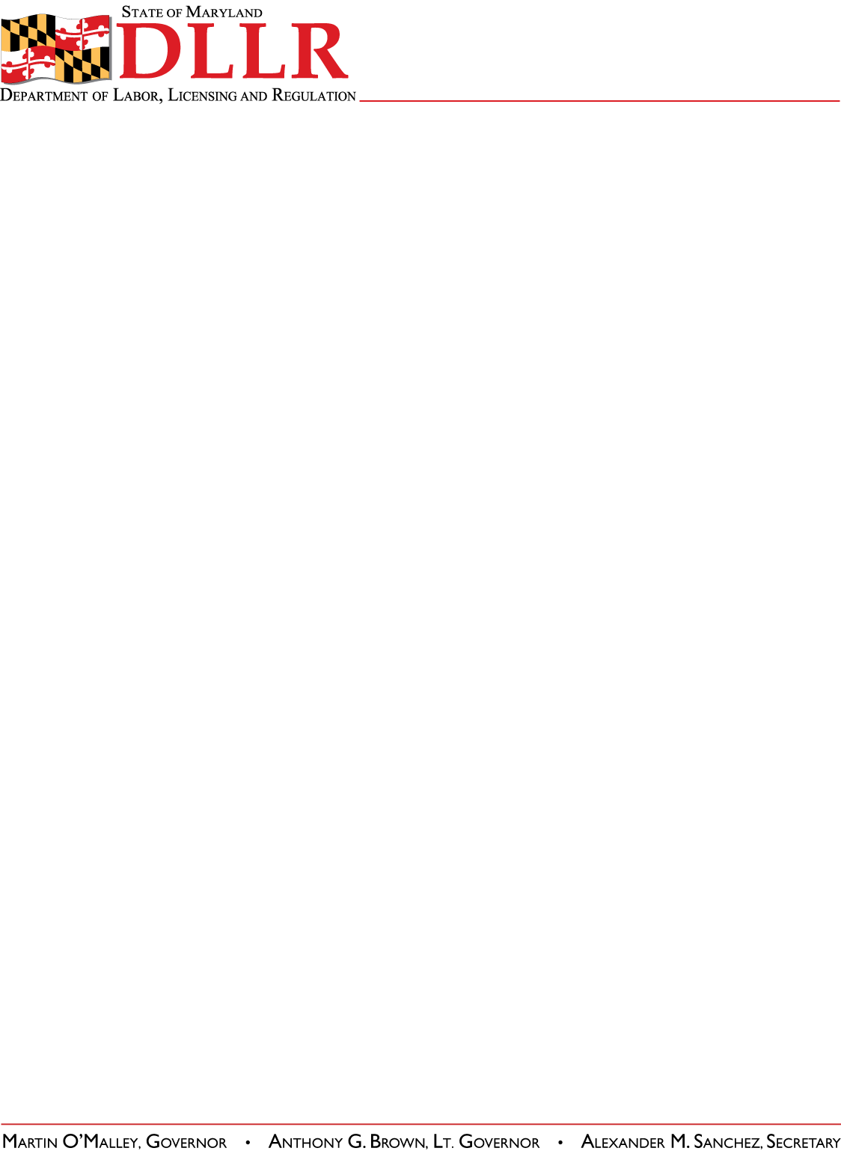
Division of Workforce Development
and Adult Learning
1100 N. Eutaw Street
Room 209
Baltimore, MD 21201

WORKFORCE INVESTMENT FIELD INSTRUCTION (WIFI) No. 03-11

DATE: October 14, 2011

TO: Maryland Workforce Investment Act (WIA) Grant Recipients
Labor Exchange Administrators (LEAs)
Management Information System (MIS) Managers

FROM: Paulette Francois
Assistant Secretary
Division of Workforce Development and Adult Learning

SUBJECT: Source Documentation to Verify Attainment of General Equivalency Diploma (GED)

REFERENCES: U.S. Department of Labor (DOL) Employment and Training Administration (ETA) Training and Employment Guidance Letter (TEGL) No. 27-10 Change 1 and Attachment A, Source Documentation Requirements for Program Year (PY) 2010 Workforce Investment Act (WIA) Data Element Validation

BACKGROUND
INFORMATION: TEGL No. 27-10 Change 1, Attachment A: Source Documentation Requirements for PY 2010 WIA Data Element Validation defines the Source Documentation Requirements for Data Element #668 Attained Diploma, GED, or Certificate as “transcripts, certificates, diploma, letter or other documentation from school system.”

The Department of Labor, Licensing and Regulation (DLLR), Division of Workforce Development and Adult Learning (DWDAL), Office of Adult Learning, GED Testing Office produces a document entitled, “Training Providers Report,” also known as the “Maryland 500 Report.” The Maryland 500 Report is generated monthly and lists the names, last four digits of the social security number, test date, scores, and test status/results of program participants who have taken the GED test. The U.S. Department of Labor, Employment and Training Administration advised DLLR that the Maryland 500 Report is acceptable source documentation to verify GED attainment.

In addition to Data Element #668, the Maryland 500 Report has been added as acceptable source documentation for Data Element #669 to verify “Date Attained Degree or Certificate,” Data Element #670 to verify “School Status at Exit,” and Data Element #129 to verify “School Status at Participation.”

Phone: 410-767-2173 • FAX: 410-333-5162 • INTERNET: www.dllr.maryland.gov

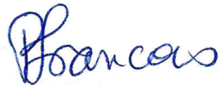

ACTION TO
BE TAKEN: The Maryland 500 Report will be added to the Maryland Workforce Exchange (MWE) as federally approved documentation to verify GED attainment.

Local Workforce Investment Areas may use the Maryland 500 Report to verify and document the attainment of a GED. This source document must include both the Maryland 500 Report and its accompanying cover page to be valid.

The Maryland 500 Report is provided to a local school system, community college, program vendor or program sub recipient that is registered with DLLR, DWDAL, Office of Adult Learning, GED testing Office and that has provided GED instruction to program participants.

All workforce development staff who verifies GED attainment should receive a copy of this field instruction.

CONTACT
PERSON: Sheree Finley
Director
Office of Workforce Development
(410) 767-2995 or sfinley@dllr.state.md.us

EFFECTIVE: October 14, 2011

