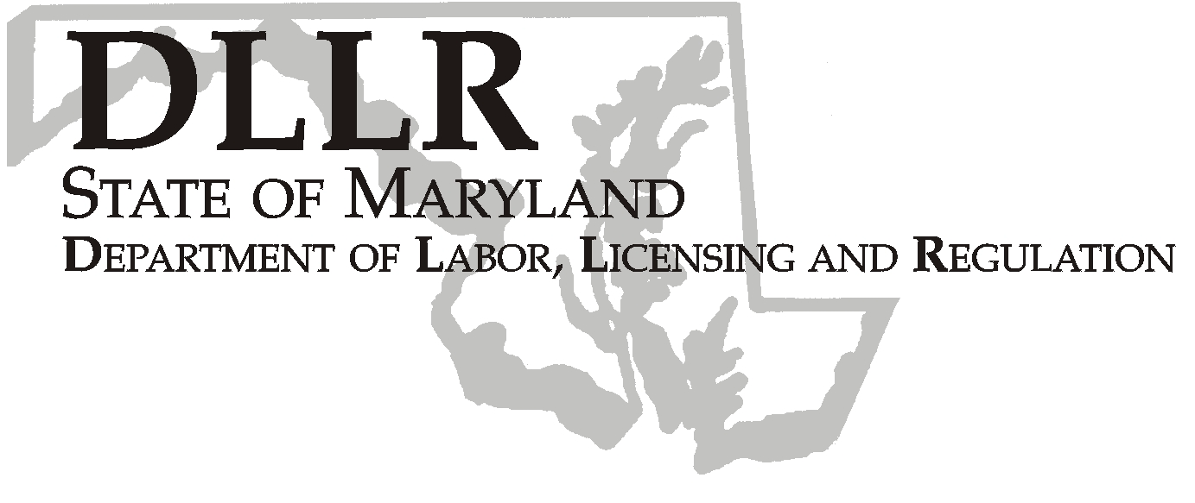
MARTIN O’MALLEY, Governor
ANTHONY G. BROWN, Lt. Governor
THOMAS E. PEREZ, Secretary

Andrew Moser, Assistant Secretary

Division of Workforce Development

DLLR Home Page • http://www.dllr.state.md.us
E-mail • amoser@dllr.state.md.us

notes, but a printed copy must be maintained in the files. Each local are must but In addition, you must ensure that the appropriate documentation to

Keeping Maryland Working and Safe

Workforce Investment Field Instruction (WIFI) # 03-07

DATE: January 3, 2008

TO: Maryland Workforce Investment Act Grant Recipients and Labor Exchange Administrators

SUBJECT: Program Income – Staff Responsibilities and Reporting Requirements

REFERENCES: 29 CFR Part 97 – Uniform Administrative Requirements For Grants and Cooperative Agreements To State And Local Governments

BACKGROUND
INFORMATION: The requirements governing the use of program income are found at 29 CFR for non-profits and at 29 CFR 97.25 for governmental grantees. These regulations define program income and encourage earning program income as a method of defraying program costs.

Program income is defined at 29 CFR 97.25 (b) as the gross income received by the grantee or subgrantee directly generated by a grant supported activity, or earned only as a result of the grant agreement during the grant period.

Program income must be used for the purposes and under the conditions of the grant agreement. Program Income is limited to uses allowable within the Federal Regulation for that specific program such as, WIA, Trade, Wagner-Peyser, etc.

The accounting for Program Income and safeguards related to the tracking require procedures that meet generally accepted accounting procedures. One-Stop Administrators, their staff and partners are required to follow the procedures with the same vigor for handling federally allocated grant funds. These requirements must also be followed by the State WIA and W/P Administration and any locally based administrators and staff.

ACTION TO

BE TAKEN: Labor Exchange Administrators and their staff must follow the procedures provided in the attached GAP related Field Office Cash Receipts Policy– Revised 02-27-2007. It is imperative that field staff and administrators understand any funding secured from activities performed by staff that generates program income is to follow these cash receipt procedures. If State employees are involved in the planning, development and implementation of income generating events, Program Income must be reported to DLLR by the appropriate State employee regardless of whether the fees are collected by the State employee or partner agency. The State is directly responsible for accounting for said funds or the State share of the program income.

The LEA is responsible for ensuring that all procedures are followed and all funds are reported.

Finally, the costs associated with events generating program income must be allowable, necessary and reasonable.

CONTACT
PERSON: Valerie Myers (410) 767-2825

EFFECTIVE: Immediately

Andy Moser
Assistant Secretary
Division of Workforce Development

