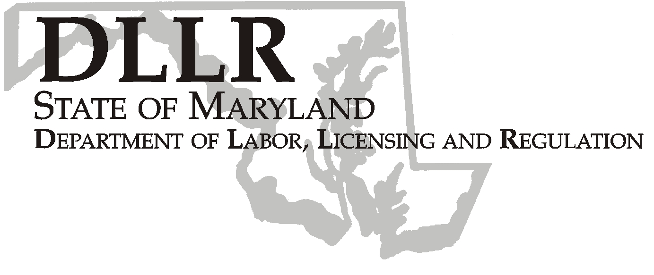
MARTIN O’MALLEY, Governor
ANTHONY G. BROWN, Lt. Governor
THOMAS E. PEREZ, Secretary

Andrew Moser, Assistant Secretary

Division of Workforce Development

DLLR Home Page • http://www.dllr.state.md.us
E-mail • amoser@dllr.state.md.us

notes, but a printed copy must be maintained in the files. Each local are must but In addition, you must ensure that the appropriate documentation to

Keeping Maryland Working and Safe

Workforce Investment Field Instruction (WIFI) No. 2-08

DATE: December 15, 2008

TO: Local WIA Grant Recipients

SUBJECT: Apprenticeship Program Navigator

REFERENCES: Federal Register, Employment and Training Administration
29 CFR Part 29 Apprenticeship Programs, Labor Standards for Registration,
Amendment of Regulations; Final Rule

BACKGROUND
INFORMATION: In response to the need to better coordinate our WIA programs and support linkages with the State Apprenticeship System, DLLR will address the coordination of these activities through the hiring of a statewide apprenticeship program navigator. The navigator will receive guidance and supervision from Mr. Roger Lash, Director of Apprenticeship Programs.

The purpose of the navigator function is to provide assistance to the local workforce investment areas in reference to outreach, training, and employment opportunities as well as to provide expertise and resource assistance to the workforce system. The navigator will expand consumer choice by addressing the needs of customers that are seeking apprenticeship opportunities through the One-Stop. The navigator position is intended to increase employment and self-sufficiency for customers by linking them to employers and by facilitating access to supports and services that will enable the transition to apprenticeships and employment. Each local grant recipient shall designate a staff person to coordinate the apprenticeship activities in the local area with the apprenticeship program navigator.

ACTION TO
BE TAKEN: Local grant recipients should submit the following information to DLLR by January 31, 2009:

Name of the Local Contact person
Title
Address
Phone Number
Fax Number
Email address

CONTACT
PERSON: Valerie Myers - 410 767-2825, vmyers@dllr.state.md.us

EFFECTIVE
DATE: Immediately

Andrew Moser
Assistant Secretary
Division of Workforce Development

