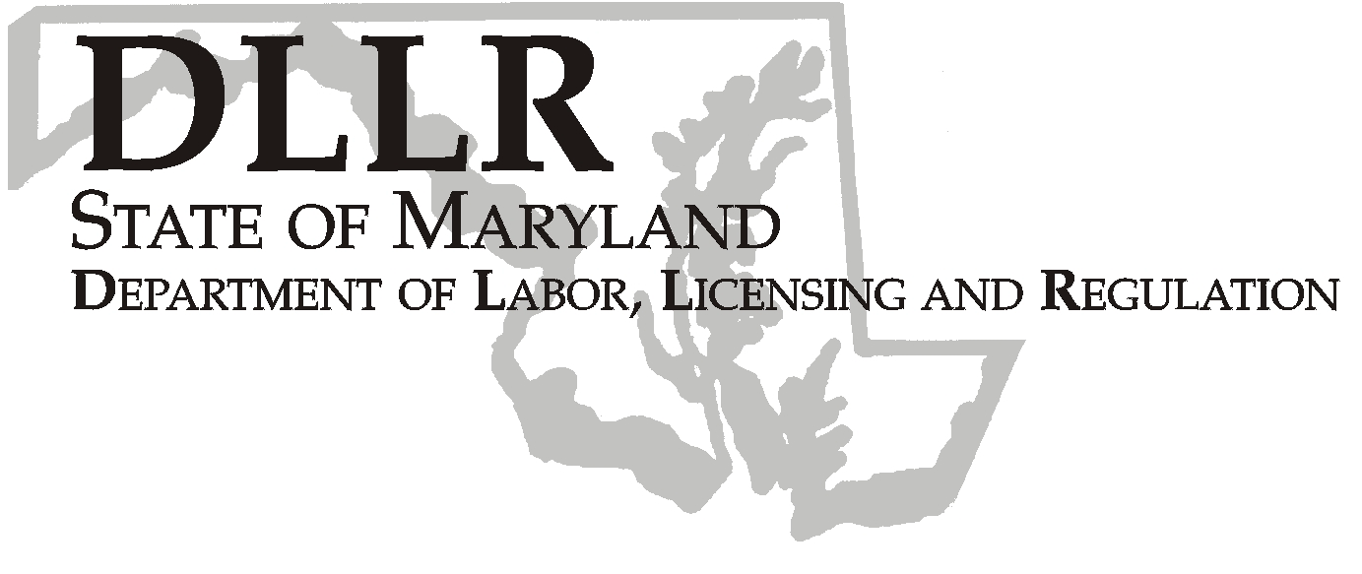
MARTIN O’MALLEY, Governor
ANTHONY G. BROWN, Lt. Governor
THOMAS E. PEREZ, Secretary

Andrew Moser, Assistant Secretary

Division of Workforce Development

DLLR Home Page • http://www.dllr.state.md.us
E-mail • amoser@dllr.state.md.us

notes, but a printed copy must be maintained in the files. Each local are must but In addition, you must ensure that the appropriate documentation to

Keeping Maryland Working and Safe

WORKFORCE INVESTMENT FIELD INSTRUCTION (WIFI) No. 12-04 Change 2

DATE: September 11, 2007

TO: Maryland Workforce Investment Act (WIA) Grant Recipients

SUBJECT: WIA Participant Case Record Management

REFERENCES: WIA Participant Case Record Management
Single Audit Reports for FY2005 and FY 2006
WIFI 12-04 Change 1

BACKGROUND INFORMATION:

WIFI 12-04 Change 1 addressed the DLLR audit findings relating to WIA client file maintenance, lack of documentation for WIA eligibility and WIA files lacking organization for the audit period ending June 30, 2005 and June 30, 2006. Listed below are the following changes to WIFI 12-04 Change Number 1 only.

Page 1 last paragraph, first sentence: LWIB is deleted from the sentence and is revised to read, Due to file maintenance weaknesses, DLLR has been charged with the following.

Page 2 first paragraph: Deleted the first sentence in this section: May continue to use the MWE to record the case notes, but a printed copy must be maintained in the file. This section is revised to include two additional statements (1) Each local area must maintain a printed copy of case notes in the client files. (2) Maintaining an electronic duplicate set of case notes in MWE is optional.

ACTION TO BE TAKEN:

Local areas should follow the revised instructions in this WIFI.

.

CONTACT: Valerie Myers (410) 767-2825 or vmyers@dllr.state.md.us

EFFECTIVE: September 11, 2007

Andrew Moser
Assistant Secretary
Division of Workforce Development

