
Division of Workforce Development and Adult Learning
1100 N. Eutaw Street, Room 209
Baltimore, MD 21201

WORKFORCE INVESTMENT FIELD INSTRUCTION (WIFI) No. 11-11

DATE: March 28, 2012

TO: Maryland Workforce Investment Act (WIA) Grant Recipients and Subrecipients
Labor Exchange Administrators

SUBJECT: Revised Federal Poverty Guidelines and Lower Living Standard Income Level (LLSIL)

REFERENCES: Workforce Investment Act of 1998, (29 United States Code 2801 et seq.),
Public Law 105-220, as amended
20 CFR 652 – Workforce Investment Act: Final Rule
Federal Register/Vol. 77, No. 17
Federal Register/Vol. 77, No. 60

BACKGROUND
INFORMATION: Under Title I of the Workforce Investment Act, the Secretary of Labor annually determines the Lower Living Standard Income Level (LLSIL) for uses defined in the law. WIA defines the term “low income individual” as one who qualifies under various criteria, including an individual who received income that does not exceed the higher of the poverty line or 70 percent of the lower living standard income level. In accordance with the Workforce Investment Act, the U.S. Department of Health and Human Services (HHS) has released the revised 2012 figures for poverty levels and the U.S. Department of Labor has released the revised 2012 LLSIL.

ACTION TO

BE TAKEN: All Maryland WIA grant recipients and subrecipients should use one of the attached charts, either the 2012 Poverty Guidelines or the 2012 LLSIL - 70 percent (whichever is higher), to determine if applicants are low income for those programs that require it. These income guidelines are available in the Maryland Workforce Exchange Virtual One Stop (MWE/VOS) system. All intake personnel are to be advised of the changes and refer to the revised guidelines.

CONTACT PERSON: Sheree Finley (410) 767-2995 or sfinley@dllr.state.md.us

EFFECTIVE DATE: March 28, 2012

Attachment

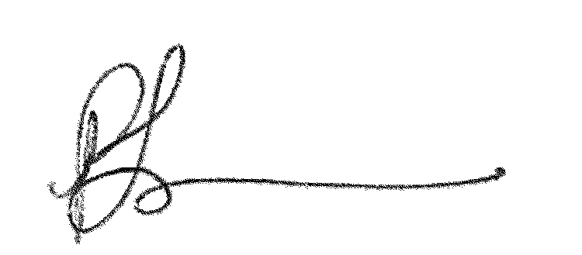

Paulette Francois
Assistant Secretary
Division of Workforce Development and Adult Learning

2012 Poverty Guidelines and 2012 Lower Living Standard Income Level (LLSIL) - 70% for The State of Maryland
2012 HHS Poverty Guidelines
Size of Family |  |  |  |  |  |  |  |  |  |  |  | Poverty Guideline
1………………….......…………………………………………………………………..…… |  |  |  |  |  |  |  |  |  |  |  | $11,170
2………………….......…………………………………………………………………..…… |  |  |  |  |  |  |  |  |  |  |  | $15,130
3………………….......…………………………………………………………………..…… |  |  |  |  |  |  |  |  |  |  |  | $19,090
4………………….......…………………………………………………………………..…… |  |  |  |  |  |  |  |  |  |  |  | $23,050
5………………….......…………………………………………………………………..…… |  |  |  |  |  |  |  |  |  |  |  | $27,010
6………………….......…………………………………………………………………..…… |  |  |  |  |  |  |  |  |  |  |  | $30,970
7………………….......…………………………………………………………………..…… |  |  |  |  |  |  |  |  |  |  |  | $34,930
8………………….......…………………………………………………………………..…… |  |  |  |  |  |  |  |  |  |  |  | $38,890
*For family units with more than 8 members, add $3,960 for each additional person.
2012 Lower Living Standard Income Level (LLSIL) - 70%
Area | 1 |  | 2 |  | 3 |  | 4 |  | 5 |  | 6 |  | Over 6 Add
Anne Arundel County WIA | 10,994 * |  | 18,016 |  | 24,729 |  | 30,524 |  | 36,026 |  | 42,132 |  | 6,106
Baltimore City WIA | 10,994* |  | 18,016 |  | 24,729 |  | 30,524 |  | 36,026 |  | 42,132 |  | 6,106
Baltimore County WIA | 10,994* |  | 18,016 |  | 24,729 |  | 30,524 |  | 36,026 |  | 42,132 |  | 6,106
Frederick County WIA | 10,994* |  | 18,016 |  | 24,729 |  | 30,524 |  | 36,026 |  | 42,132 |  | 6,106
Lower Shore WIA | 8,595* |  | 14,081* |  | 19,326 |  | 23,857 |  | 28,154 |  | 32,925 |  | 4,771
Mid Maryland WIA
Carroll County | 10,994* |  | 18,016 |  | 24,729 |  | 30,524 |  | 36,026 |  | 42,132 |  | 6,106
Howard County | 10,994* |  | 18,016 |  | 24,729 |  | 30,524 |  | 36,026 |  | 42,132 |  | 6,106
Montgomery County WIA | 10,994* |  | 18,016 |  | 24,729 |  | 30,524 |  | 36,026 |  | 42,132 |  | 6,106
Prince George's County WIA | 10,994* |  | 18,016 |  | 24,729 |  | 30,524 |  | 36,026 |  | 42,132 |  | 6,106
Southern Maryland WIA
Calvert County | 10,994* |  | 18,016 |  | 24,729 |  | 30,524 |  | 36,026 |  | 42,132 |  | 6,106
Charles County | 10,994* |  | 18,016 |  | 24,729 |  | 30,524 |  | 36,026 |  | 42,132 |  | 6,106
St. Mary's County | 8,595* |  | 14,081* |  | 19,326 |  | 23,857 |  | 28,154 |  | 32,925 |  | 4,771
Susquehanna Region WIA
Cecil County | 9,832* |  | 16,108 |  | 22,112 |  | 27,294 |  | 32,214 |  | 37,669 |  | 5,455
Harford County | 10,994* |  | 18,016 |  | 24,729 |  | 30,524 |  | 36,026 |  | 42,132 |  | 6,106
Upper Shore WIA | 8,595* |  | 14,081* |  | 19,326 |  | 23,857 |  | 28,154 |  | 32,925 |  | 4,771
Queen Anne's County | 10,994* |  | 18,016 |  | 24,729 |  | 30,524 |  | 36,026 |  | 42,132 |  | 6,106
Western Maryland WIA
Allegany County | 8,718* |  | 14,284* |  | 19,606 |  | 24,205 |  | 28,568 |  | 33,411 |  | 4,843
Washington County | 8,718* |  | 14,284* |  | 19,606 |  | 24,205 |  | 28,568 |  | 33,411 |  | 4,843
Garrett County | 8,595* |  | 14,081* |  | 19,326 |  | 23,857 |  | 28,154 |  | 32,925 |  | 4,771
* Poverty level is greater than the LLSIL figures
Effective 03/28/2012

