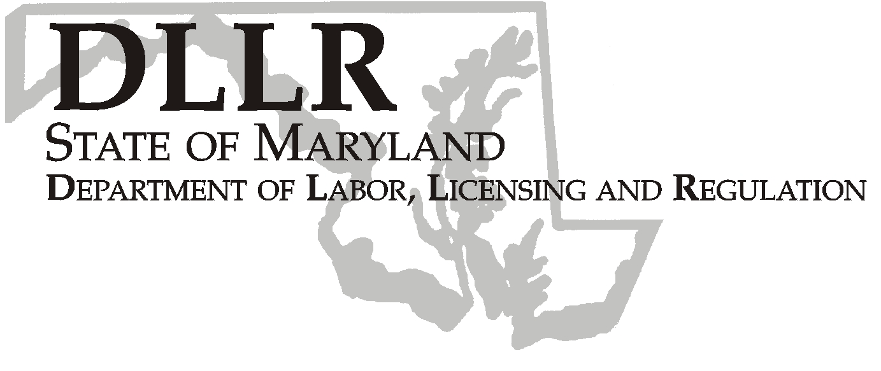
MARTIN O’MALLEY, Governor
ANTHONY G. BROWN, Lt. Governor
THOMAS E. PEREZ, Secretary

Elizabeth Williams, Acting Assistant Secretary

Division of Workforce Development

DLLR Home Page • http://www.dllr.state.md.us
E-mail • ewilliams@dllr.state.md.us

Workforce Investment Field Instruction (WIFI) No. 10-06 Change 1

DATE: April 20, 2007

TO: Maryland Workforce Investment Grant Recipients

SUBJECT: Local Workforce Investment Five-Year Plan (PY2007/PY2008)

REFERENCES: Public Law 105-220 – Workforce Investment Act
20 CFR 652 – Workforce Investment Act; Interim Final Rule
WIFI 10-99, 3-04 and 3-04 Changes 1-3
WIFI 10-06
Training and Employment Guidance Letter No.22-06
Workforce Investment Act (WIA) Adult, Dislocated Worker
And Youth Activities Program Allotments for Program Year 2007
BACKGROUND
INFORMATION: The Workforce Investment Act (WIA) requires that Local Workforce Investment Boards (LWIB) submit a five-year strategic plan to the State Department of Labor, Licensing and Regulation (DLLR) in accordance with Section 118 of the Law and section 661.345 of the Regulations. The current five-year planning cycle covers Program Years 2005 through 2009. Anticipating that pending WIA Reauthorization legislation would significantly impact the way local workforce development systems operate, DLLR issued WIFI 3-04 in February 2005, which required the submission of a two year modification to the previous five-year local strategic plan (for PY2005 and PY2006). At the present time, WIA Reauthorization legislation has not yet been enacted.

ACTION TO BE
TAKEN: WIFI 10-06 provides guidance to Local Workforce Investment
Boards regarding the submission of a two-year extension to existing local five- year plans.

Change Number 1 to WIFI 10-06 includes your Final PY 2007 WIA allocations. In addition, the LWIB must submit three signed copies of the final plan to DLLR by June 1, 2007.

CONTACT: Valerie Myers (410) 767-2825 or Dorothee Norton (410) 767-2283

EFFECTIVE DATE: April 20, 2007

Elizabeth Williams
Acting Assistant Secretary

Attachments
PHONE: 410-767-2997 . FAX: 410-333-5355
TTY USERS, CALL VIA THE MD RELAY SERVICE

1100 NORTH EUTAW STREET . ROOM 616
BALTIMORE, MD, 21201

Keeping Maryland Working and Safe

WORKFORCE INVESTMENT ACT
PY 2007 Allocations
 |  |  |  | DISLOCATED
 | ADMIN | ADULT | YOUTH | WORKER | TOTAL
ANNE ARUNDEL | $95,987 | $199,492 | $198,539 | $465,850 | $959,868
BALTIMORE CITY | $705,260 | $2,466,281 | $2,578,109 | $1,302,952 | $7,052,602
BALTIMORE CO | $322,694 | $806,941 | $916,117 | $1,181,189 | $3,226,941
FREDERICK | $53,416 | $80,558 | $93,099 | $307,088 | $534,161
LOWER SHORE | $131,285 | $369,184 | $415,926 | $396,459 | $1,312,854
MID-MARYLAND | $95,245 | $80,860 | $76,124 | $700,226 | $952,455
MONTGOMERY | $176,474 | $315,628 | $265,702 | $1,006,932 | $1,764,736
PRINCE GEORGE's | $375,416 | $1,187,013 | $1,394,742 | $796,988 | $3,754,159
SOUTHERN MD | $46,990 | $81,651 | $89,781 | $251,477 | $469,899
SUSQUEHANNA | $102,935 | $295,195 | $312,294 | $318,929 | $1,029,353
UPPER SHORE | $124,933 | $161,063 | $167,440 | $795,897 | $1,249,333
WESTERN MD | $154,960 | $472,234 | $471,032 | $451,359 | $1,549,585
7/1/07 Allocations
ANNE ARUNDEL | $40,834 | $35,134 | $198,539 | $133,830 | $408,337
BALTIMORE CITY | $376,308 | $434,351 | $2,578,109 | $374,315 | $3,763,083
BALTIMORE CO | $155,285 | $142,115 | $916,117 | $339,334 | $1,552,851
FREDERICK | $21,723 | $14,188 | $93,099 | $88,221 | $217,231
LOWER SHORE | $66,093 | $65,019 | $415,926 | $113,896 | $660,934
MID-MARYLAND | $32,392 | $14,241 | $76,124 | $201,162 | $323,919
MONTGOMERY | $67,840 | $55,587 | $265,702 | $289,273 | $678,402
PRINCE GEORGE | $203,639 | $209,052 | $1,394,742 | $228,960 | $2,036,393
SOUTHERN MD | $19,601 | $14,380 | $89,781 | $72,245 | $196,007
SUSQUEHANNA | $50,656 | $51,988 | $312,294 | $91,623 | $506,561
UPPER SHORE | $47,161 | $28,366 | $167,440 | $228,647 | $471,614
WESTERN MD | $75,986 | $83,166 | $471,032 | $129,666 | $759,850
10/01/07 Allocations
ANNE ARUNDEL | $55,153 | $164,359 | $0 | $332,020 | $551,532
BALTIMORE CITY | $328,952 | $2,031,930 | $0 | $928,638 | $3,289,520
BALTIMORE CO | $167,409 | $664,826 | $0 | $841,855 | $1,674,090
FREDERICK | $31,693 | $66,370 | $0 | $218,867 | $316,930
LOWER SHORE | $65,192 | $304,165 | $0 | $282,564 | $651,921
MID-MARYLAND | $62,854 | $66,619 | $0 | $499,063 | $628,536
MONTGOMERY | $108,633 | $260,041 | $0 | $717,659 | $1,086,333
PRINCE GEORGE | $171,777 | $977,962 | $0 | $568,028 | $1,717,767
SOUTHERN MD | $27,389 | $67,271 | $0 | $179,232 | $273,892
SUSQUEHANNA | $52,279 | $243,206 | $0 | $227,307 | $522,792
UPPER SHORE | $77,772 | $132,697 | $0 | $567,250 | $777,719
WESTERN MD | $78,974 | $389,067 | $0 | $321,691 | $789,732

