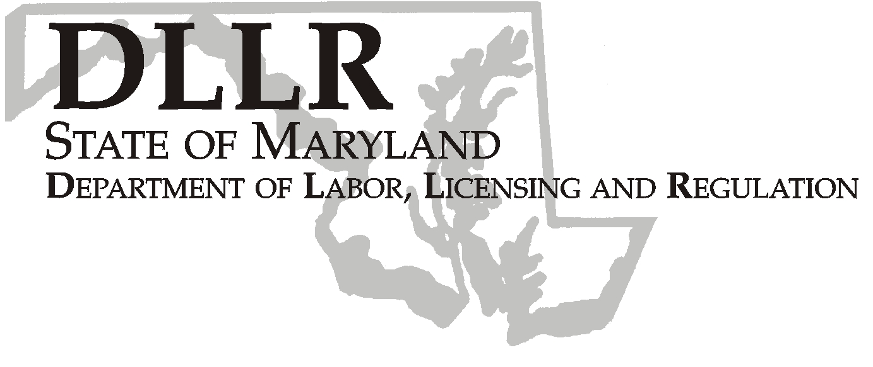
MARTIN O’MALLEY, Governor
ANTHONY G. BROWN, Lt. Governor
THOMAS E. PEREZ, Secretary

Andrew Moser, Assistant Secretary

Division of Workforce Development

DLLR Home Page • http://www.dllr.state.md.us
E-mail • amoser@dllr.state.md.us

notes, but a printed copy must be maintained in the files. Each local are must but In addition, you must ensure that the appropriate documentation to

Keeping Maryland Working and Safe

Workforce Investment Field Instruction (WIFI) No. 10 - 05 Change 2

DATE: February 29, 2008

TO: Maryland Workforce Investment Act Grant Recipients

SUBJECT: Workforce Investment Act Program Year 2006 Rescission

REFERENCES: Public Law 105-220 – Workforce Investment Act
20 CFR 652 – Workforce Investment Act; Final Rule

BACKGROUND INFORMATION:

On August 28, 2006, the State of Maryland provided local areas with the final allocations for WIA Program Year (see WIFI 10-05 Change 1).
In January 2008, the U.S. Department of Labor informed the State Workforce Agencies of a 1% rescission that was applied to the PY 2006 funding. At the local level, the rescission affects the Adult, Dislocated Worker and Admin funding.

ACTION TO BE TAKEN:

LWIBs must submit a grant modification narrative and three original WIA Signature Sheets by March 15, 2008. The revised funding amounts are listed below.

CONTACT: Laura Ferguson (410) 767-2038 or Dorothee Norton (410) 767-2283

EFFECTIVE DATE: Immediately

Andrew Moser
Assistant Secretary
Division of Workforce Development

Attachments

PY 2006 Revised WIA Allocations
 |  |  |  | DISLOCATED
 | ADMIN | ADULT | YOUTH | WORKER
ANNE ARUNDEL | $88,913 | $186,512 | $184,371 | $429,338
BALTIMORE CITY | $726,459 | $2,584,145 | $2,731,547 | $1,222,441
BALTIMORE CO | $296,386 | $838,050 | $951,530 | $877,897
FREDERICK | $55,457 | $111,490 | $135,390 | $252,228
LOWER SHORE | $136,176 | $415,587 | $448,056 | $361,941
MID-MARYLAND | $93,472 | $83,164 | $78,345 | $679,742
MONTGOMERY | $169,264 | $405,636 | $360,093 | $757,649
PRINCE GEORGE's | $358,317 | $1,069,730 | $1,273,850 | $881,268
SOUTHERN MD | $43,345 | $91,002 | $100,663 | $198,435
SUSQUEHANNA | $107,129 | $336,178 | $354,382 | $273,604
UPPER SHORE | $110,066 | $171,421 | $180,447 | $638,729
WESTERN MD | $147,984 | $475,066 | $502,065 | $354,719

PY 2006 Rescission Amounts
ANNE ARUNDEL | -$515 | -$1,549 | $0 | -$3,082
BALTIMORE CITY | -$3,360 | -$21,467 | $0 | -$8,775
BALTIMORE CO | -$1,474 | -$6,962 | $0 | -$6,302
FREDERICK | -$304 | -$926 | $0 | -$1,811
LOWER SHORE | -$672 | -$3,452 | $0 | -$2,598
MID-MARYLAND | -$619 | -$691 | $0 | -$4,879
MONTGOMERY | -$979 | -$3,370 | $0 | -$5,439
PRINCE GEORGE | -$1,690 | -$8,887 | $0 | -$6,326
SOUTHERN MD | -$242 | -$756 | $0 | -$1,424
SUSQUEHANNA | -$529 | -$2,793 | $0 | -$1,964
UPPER SHORE | -$668 | -$1,424 | $0 | -$4,585
WESTERN MD | -$721 | -$3,947 | $0 | -$2,546

