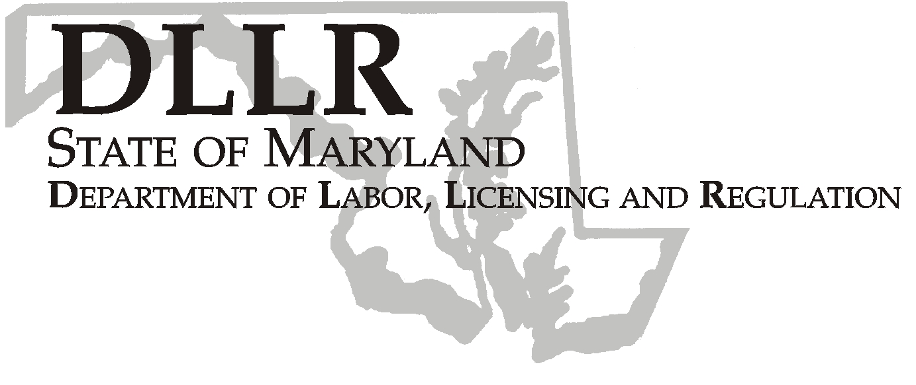
MARTIN O’MALLEY, Governor
ANTHONY G. BROWN, Lt. Governor
THOMAS E. PEREZ, Secretary

Andrew Moser, Assistant Secretary

Division of Workforce Development

DLLR Home Page • http://www.dllr.state.md.us
E-mail • amoser@dllr.state.md.us

notes, but a printed copy must be maintained in the files. Each local are must but In addition, you must ensure that the appropriate documentation to

Keeping Maryland Working and Safe
WORKFORCE INVESTMENT FIELD INSTRUCTION (WIFI) No. 01- 07, Change 1

DATE: February 19, 2008

TO: Local WIA Grant Recipients

SUBJECT: Workforce ONE Maryland Project:
Regional Base Realignment and Closure (BRAC) Project Coordinators

REFERENCES: WIFI No. 01-07
Workforce Investment Act (WIA) Title I Section 173
Training and Employment Guidance Letter (TEGL) No. 16-03
TEGL No. 16-03 Change 1, Change 2, Change 4
WIRED Tools- WIRED 6 Step Method

BACKGROUND
INFORMATION: In response to the 2005 Base Realignment and Closure (BRAC), the U.S. Department of Labor (USDOL) made Workforce Investment Act National Emergency Grant (NEG) funding available to assist several states with the planning and implementation of workforce development initiatives related to BRAC. USDOL expects that funded states will adopt the WIRED 6 Step Method to approaching BRAC-related workforce development challenges. The purpose of WIRED is to create a regional approach by ignoring political boundaries and creating regional shared visions based on regional assets, strengths, and resources.

Maryland’s Department of Labor, Licensing and Regulation’s (DLLR) Division of Workforce Development (DWD) was awarded a $4 million grant to assist in the State’s planning and implementation of projects that address the workforce challenges created by the 2005 BRAC process.
Maryland’s Program, Workforce ONE Maryland (WOM), will address the
coordination of workforce development activities, initiatives and projects
across all regions in and around Maryland by utilizing the WIRED
approach. To assist with the facilitation of the WOM Program, Regional BRAC Project Coordinators have been funded through various Maryland WIAs.

On October 10, 2007, WIFI No. 01-07 was released to outline the role, job description and funding for the Regional BRAC Project Coordinators. This update clarifies the primary function of the Coordinator in relation to the Workforce ONE Maryland RFP/Projects. During the RFP process,
coordinators will facilitate collaborations between potential partners and objectively assist with providing all project applicants with resources,
information and data upon request. Proposals will be reviewed and rated
by an independent team of reviewers. After funding decisions have been finalized and projects have begun, coordinators will monitor the project
vendors on a regular basis and provide vendors with technical assistance
and resources as needed.

In addition, Coordinators will be responsible for creating a regional work
plan, assessing regional workforce challenges, coordinating and/or
participating in local, regional, State and out of State workforce
development initiatives and resources, and attending BRAC-related
meetings and events.

ACTION TO
BE TAKEN: Local WIA Grant Recipients should inform their Regional BRAC Project Coordinators about the clarification in their roles. Coordinators are
encouraged to communicate directly with the Workforce ONE Maryland
Project Director, Sara Muempfer, with questions or technical assistance
needs.

In addition to the submission of monthly fiscal and programmatic reports,
Regional BRAC Project Coordinators are asked to submit a regional work
plan. Coordinators will be given a work plan template and timelines during
their orientation session.

CONTACT
PERSON: Sara Muempfer- 443-248-3583, smuempfer@dllr.state.md.us

EFFECTIVE
DATE: Immediately

Andrew Moser
Assistant Secretary
Division of Workforce Development

