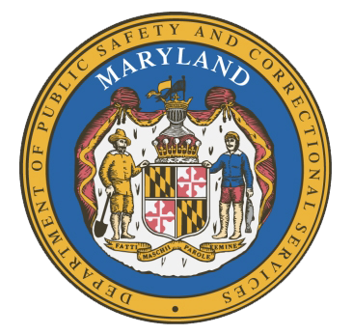
MARYLAND
Department of Public Safety and Correctional Services
In
Partnership
With



Correctional Education Council-Hybrid Meeting
Conference Call – Phone Number ‪(US) + ‪(US) +1 561-614-0676‬ PIN: ‪405 201 372‬#

September 12, 2022
10:00 a.m. – 12:00 p.m.
For those that wish to join us in person, please meet in:
LABOR-DWD-CR1-209-LG-Eutaw

Council Meeting Agenda

Welcome Secretary Tiffany Robinson
Review/Vote on June 13, 2022 Minutes

DPSCS Updates Secretary Robert Green

Labor Updates Secretary Tiffany Robinson

Correctional Education Updates
- Staff Vacancies Dr. Jack Cunning
- Academic Patrick Hruz
- Special Education Katharine Lander
- Occupational Dr. Tamara Barron
- Transition Dr. Jack Cunning

Regional Principal Updates
- Western Region Laura Martin
- Central Region Tricia Hopkins
- Eastern Region and Library Updates June Brittingham

Community Partner TBD

Navigator Updates Marshel Lawrence
James Grossman
Ellen Bredt
Janell Johnson
Henry Franklin

Employer Engagement Committee Updates Jack Weber

Concluding Remarks Secretary Tiffany Robinson
Secretary Robert Green

