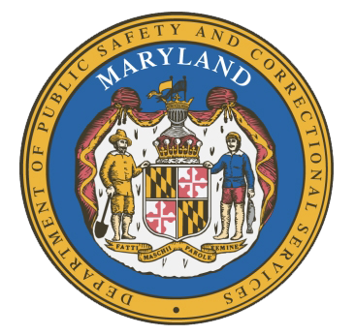
MARYLAND
Department of Public Safety and Correctional Services
In
Partnership
With



Correctional Education Council
Conference Call – Phone Number 617-675-4444‬ PIN: ‪624 304 754 1761‬#

September 13, 2021
10:00 a.m. – 12:00 p.m.
State of Maryland Department of Labor
1100 North Eutaw Street, Room 108
Baltimore, MD 21201

Council Meeting Agenda

Welcome Secretary Tiffany Robinson
Review/Vote on June 14, 2021 Minutes

DPSCS Updates Secretary Robert Green

Labor Updates Secretary Tiffany Robinson

Final Action on the Proposed Amendments to the Regulations Danielle Cox
Correctional Education Updates
- Staff Vacancies Dr. Jack Cunning
- Academic Patrick Hruz
- Special Education Katharine Lander
- Occupational Dr. Tamara Barron
- Transition Dr. Erica DuBose

Regional Principal Updates
- Western Region Deron Crawford
- Central Region Dr. Ri’chard McCarthy
- Eastern Region and Library Updates June Brittingham

Community Partner Wesley Wilson
Enoch Pratt Free Library
Navigator Updates Marshel Lawrence
James Grossman
Ellen Bredt
Jarah Hall

Employer Engagement Committee Updates Jack Weber

Concluding Remarks Secretary Tiffany Robinson
Secretary Robert Green

