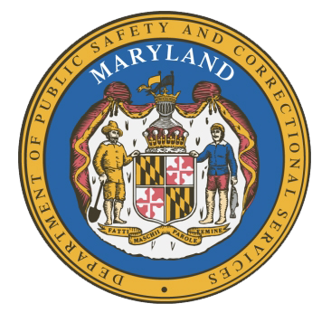
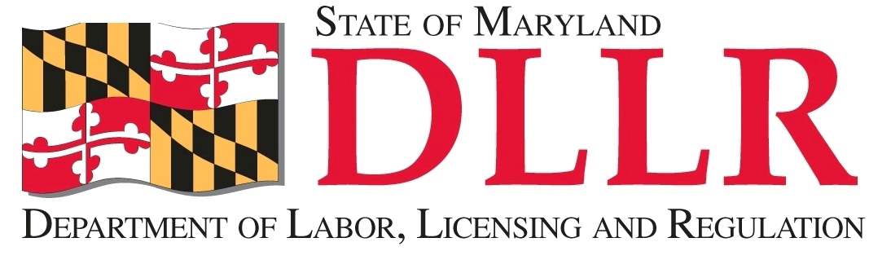
MARYLAND
Department of Public Safety and Correctional ServiceS
In
Partnership
With

Correctional Education Council
Conference Call – Phone Number 866-247-6034, Code 5812736994
For those who wish to attend in person, we will be meeting in Room 108.

September 11, 2017 | 10:00 a.m. – 12:00 p.m.
Department of Labor, Licensing and Regulation
1100 North Eutaw Street, Room 108
Baltimore, MD 21201

Council Meeting Agenda

Welcome/Review of Prior Meeting Minutes Secretary Kelly Schulz
Deputy Secretary Michael Zeigler

DLLR Updates Secretary Kelly Schulz

DPSCS Updates Deputy Secretary Michael Zeigler

Review of the Correctional Education Council Annual Report All

Update on the Tablet Erica DuBose and Danielle Cox

Strategies to Develop Social and Emotional Competence in Youth Dr. Fran Tracy-Mumford

Correctional Education Updates Alice Wirth and Staff
- Staff Vacancies Jack Cunning
- Correctional Education GED® Numbers Danielle Cox
- Occupational Updates Tamara Barron
- Transitional Updates Erica DuBose

Employer Engagement Committee Updates Jack Weber

Concluding Remarks Secretary Kelly Schulz
Deputy Secretary Michael Zeigler

