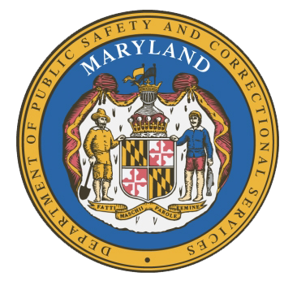
MARYLAND
Department of Public Safety and Correctional Services
In
Partnership
With



Correctional Education Council-Hybrid Meeting
Conference Call – Phone Number ‪(US) +1 617-675-4444‬ PIN: ‪823 772 144 8126‬#

March 14, 2022
10:00 a.m. – 12:00 p.m.
For those that wish to join us in person, please meet in:
LABOR-DWD-CR1-209-LG-Eutaw

Council Meeting Agenda

Welcome Secretary Tiffany Robinson
Review/Vote on December 13, 2021 Minutes

DPSCS Updates Secretary Robert Green

Labor Updates Secretary Tiffany Robinson

Correctional Education Updates
- Staff Vacancies Dr. Jack Cunning
- Academic Patrick Hruz
- Special Education Katharine Lander
- Occupational Dr. Tamara Barron
- Transition Dr. Erica DuBose

Regional Principal Updates
- Western Region Deron Crawford
- Central Region Cynthia Blackwell
- Eastern Region and Library Updates June Brittingham

Community Partner Bill Gaertner
Gatekeepers
Washington County

Navigator Updates Marshel Lawrence
James Grossman
Ellen Bredt

Employer Engagement Committee Updates Jack Weber

Concluding Remarks Secretary Tiffany Robinson
Secretary Robert Green

