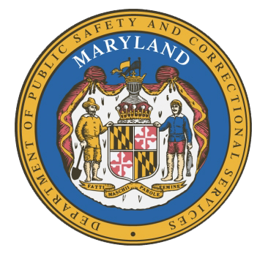
MARYLAND
Department of Public Safety and Correctional Services
In
Partnership
With

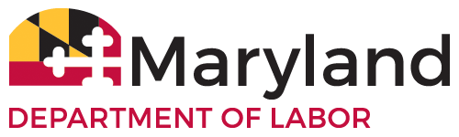

Correctional Education Council
Conference Call – Phone Number (US) +1 617-675-4444‬ PIN: ‪459 108 035 3228‬#
March 8, 2021
10:00 a.m. – 12:00 p.m.
State of Maryland Department of Labor
1100 North Eutaw Street, Room 108
Baltimore, MD 21201

Council Meeting Agenda

Welcome Secretary Robinson
Review/Vote on December 14th, 2020 Minutes

DPSCS Updates Secretary Robert Green

Labor Updates Secretary Robinson

Correctional Education Updates
- Staff Vacancies Dr. Jack Cunning
- Academic Patrick Hruz
- Occupational Dr. Tamara Barron
- Transitional Dr. Erica DuBose
- CE System Updates Danielle Cox

Regional Principal Updates
- Western Region Peggy Stanford
- Central Region Dr. Ri-Chard McCarthy
- Eastern Region and Library Updates June Brittingham

Navigator Updates Marshel Lawrence
James Grossman
Ellen Bredt
Sandy Graham
Jarah Hall

Community Partner- Nicole Cameron
Greater Baltimore Urban League

Employer Engagement Committee Updates Jack Weber

Concluding Remarks Secretary Robinson
Secretary Robert Green

