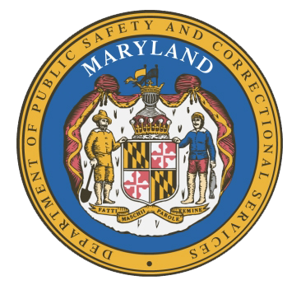
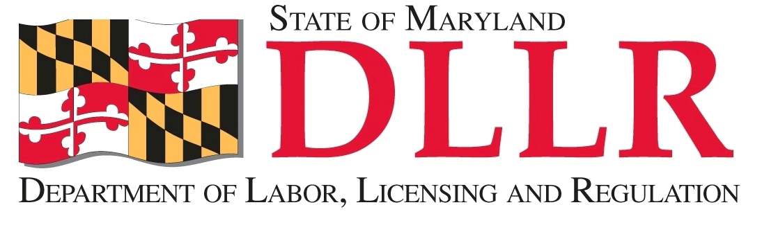
MARYLAND
Department of Public Safety and Correctional Services
In
Partnership
With

Correctional Education Council
Conference Call – Phone Number 252-397-0135, Code 201137563#

March 18, 2019
10:00 a.m. – 12:00 p.m.
Department of Labor, Licensing and Regulation
1100 North Eutaw Street, Room 108
Baltimore, MD 21201

Council Meeting Agenda

Welcome/Review of December 17, 2018 Minutes Deputy Secretary David McGlone
Deputy Secretary Michael Zeigler

DPSCS Updates Deputy Secretary Michael Zeigler

DLLR Updates Deputy Secretary David McGlone

Correctional Education Updates Alice Wirth and Staff
- Staff Vacancies Jack Cunning
- Academic Updates Danielle Cox
- Occupational Updates Tamara Barron
- Transitional Updates Erica DuBose

Employer Engagement Committee Updates Jack Weber

Concluding Remarks Deputy Secretary Michael Zeigler
Deputy Secretary David McGlone

For those who wish to attend in person, we will be meeting in Room 108.

