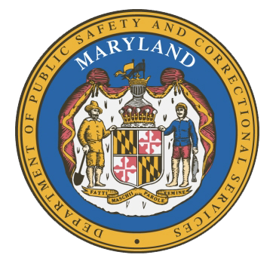
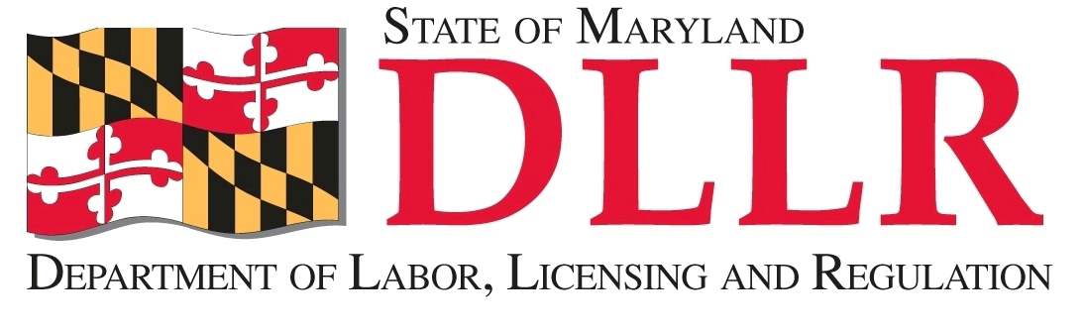
MARYLAND
Department of Public Safety and Correctional ServiceS
In
Partnership
With

Correctional Education Council
Conference Call – Phone Number 866-247-6034, Code 5812736994
March 13, 2017
10:00 am – 12:00 pm
Department of Labor, Licensing and Regulation
1100 North Eutaw Street, Room 108
Baltimore, MD 21201

Council Meeting Agenda

Welcome/Review of the September and December 2016 Minutes Secretary Kelly Schulz
Secretary Stephen Moyer

DPSCS Updates Secretary Stephen Moyer

DLLR Updates Secretary Kelly Schulz

Mayor’s Office of Employment Development
Reentry Center Prison to One Stop Project Shaborah Wright

Employer Engagement Subcommittee Report Jack Weber

Update on the Diesel Program Tamara Barron

Correctional Education Updates Alice Wirth and Staff
- Reallocation of General Funds for CE Programs Alice Wirth
- New Staff and Staff Vacancies Jack Cunning
- Correctional Education GED Numbers Alice Wirth
- Occupational Updates Tamara Barron
- Transitional Updates Erica DuBose

Concluding Remarks Secretary Kelly Schulz
Secretary Stephen Moyer

For those who wish to attend in person, we will be meeting in Room 108.

