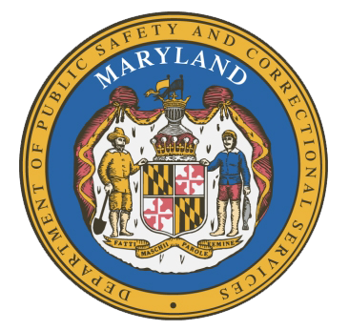

MARYLAND
Department of Public Safety and Correctional Services
In
Partnership
With

Correctional Education Council
Conference Call – Phone Number 617-675-4444‬ PIN: ‪706 802 946 4615‬#

June 14, 2021
10:00 a.m. – 12:00 p.m.
State of Maryland Department of Labor
1100 North Eutaw Street, Room 108
Baltimore, MD 21201

Council Meeting Agenda

Welcome Secretary Tiffany Robinson
Review/Vote on March 8, 2021 Minutes

DPSCS Updates Secretary Robert Green

Labor Updates Secretary Tiffany Robinson

Vote on Draft Regulations Danielle Cox

Correctional Education Updates
- Staff Vacancies Jack Cunning
- Academic Patrick Hruz
- Special Education Katharine Lander
- Occupational and Transition Danielle Cox
- Libraries June Brittingham
Regional Principal Updates
- Western Region Jack Bentley
- Central Region Dr. Ja’Ken Caston
- Eastern Region Melissa Murphy

Navigator Updates Marshel Lawrence
James Grossman
Ellen Bredt
Jarah Hall
Sandy Graham

Community Partner Council Chair Calvin S. Hawkins
Prince George’s County Council

Employer Engagement Committee Updates Jack Weber

Concluding Remarks Secretary Tiffany Robinson
Secretary Robert Green

