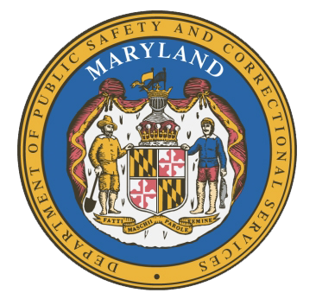

MARYLAND
Department of Public Safety and Correctional Services
In
Partnership
With

Correctional Education Council
Conference Call – Phone Number +1 617-675-4444‬ PIN: ‪483 962 274 6388‬#

June 15, 2020
10:00 a.m. – 12:00 p.m.
State of Maryland Department of Labor
1100 North Eutaw Street, Room 108
Baltimore, MD 21201

Council Meeting Agenda

Welcome Secretary Tiffany Robinson
Review/Vote on March 9th, 2020 Minutes

DPSCS Updates Secretary Robert Green

Labor Updates Secretary Tiffany Robinson

Correctional Education Updates
- Staff Vacancies Jack Cunning
- Academic Fran Mumford
- Occupational Tamara Barron
- Transitional Erica DuBose
- CE System Updates Danielle Cox

Regional Principal Updates
- Western Region Peggy Stanford
- Central Region Tricia Hopkins
- Eastern Region June Brittingham

Navigator Updates Marshel Lawrence
James Grossman
Ellen Bredt
Sandy Graham
Jarah Hall

Community Partner- Chris Hadfield
Associated Builders and Contractors (ABC)-
Baltimore

Employer Engagement Committee Updates Jack Weber

Concluding Remarks Secretary Tiffany Robinson
Secretary Robert Green

