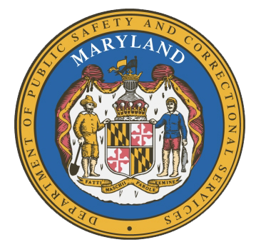
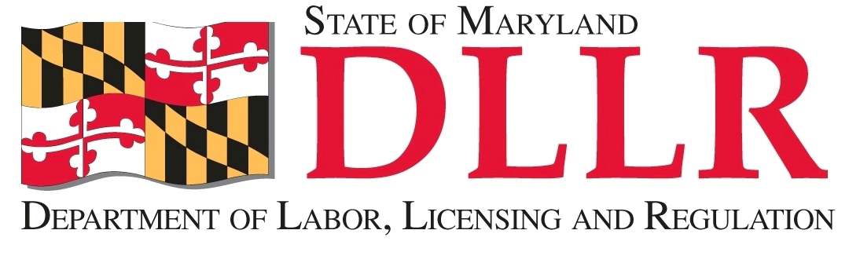
MARYLAND
Department of Public Safety and Correctional Services
In
Partnership
With

Correctional Education Council

June 18, 2018
10:00 am – 12:00 pm
Department of Labor, Licensing and Regulation
1100 North Eutaw Street, Room 108
Baltimore, MD 21201

Council Meeting Agenda

Welcome and Review of the March 19th Minutes Secretary Stephen Moyer
Deputy Secretary David McGlone

DPSCS Updates Secretary Stephen Moyer

DLLR Updates Deputy Secretary David McGlone

Review of APDS Tablet Data Use Susan Lockwood, APDS

Role of a ReEntry Navigator Shaborah Wright

Correctional Education Updates Alice Wirth and Staff
- Staff Vacancies Jack Cunning
- Academic Updates Danielle Cox
- Occupational Updates Tamara Barron
- Transitional Updates Erica DuBose

Employer Engagement Committee Updates Jack Weber

CE Advocates Update on Their Legislative Efforts John Linton and Brad Keller
(Presenting at Their Request)

Concluding Remarks Secretary Stephen Moyer
Deputy Secretary David McGlone

The conference call phone number is 866-247-6034, Code 5812736994 if you cannot attend in person.

