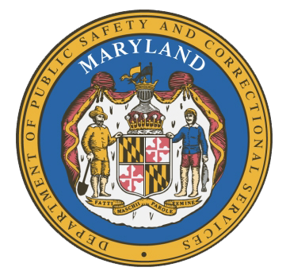
MARYLAND
Department of Public Safety and Correctional Services
In
Partnership
With



Correctional Education Council-Hybrid Meeting
Conference Call – Phone Number ‪(US) +1 617-675-4444‬ PIN: ‪823 772 144 8126‬#

December 13, 2021
10:00 a.m. – 12:00 p.m.
For those that wish to join us in person, please meet in:
LABOR-DWD-CR1-209-LG-Eutaw

Council Meeting Agenda

Welcome Secretary Tiffany Robinson
Review/Vote on September 13, 2021 Minutes

DPSCS Updates Secretary Robert Green

Labor Updates Secretary Tiffany Robinson

Vote on 2022 Meeting Dates Danielle Cox
Correctional Education Updates
- Staff Vacancies Dr. Jack Cunning
- Academic Patrick Hruz
- Special Education Katharine Lander
- Occupational Dr. Tamara Barron
- Transition Dr. Erica DuBose

Regional Principal Updates
- Western Region Peggy Stanford
- Central Region Edward Schwabeland
- Eastern Region and Library Updates June Brittingham

Community Partner Jamaal L. Ferguson
Easter Seals DC/MD/VA
Lead HVRP Veteran Employment Specialist

Navigator Updates Marshel Lawrence
James Grossman
Ellen Bredt

Employer Engagement Committee Updates Jack Weber

Concluding Remarks Secretary Tiffany Robinson
Secretary Robert Green

CEC 2022 MEETING DATES

- March 14, 2022
- June 13, 2022
- September 12, 2022
- December 12, 2022

