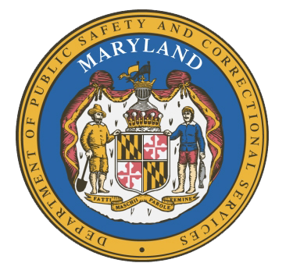
MARYLAND
Department of Public Safety and Correctional Services
In
Partnership
With



Correctional Education Council-Hybrid Meeting
Conference Call – Phone Number ‪(US) CEC Annual Report Vote
Tuesday, December 20 · 11:00 – 11:30am
Google Meet joining info
Video call link: https://meet.google.com/ptw-vxzi-mpk
Or dial: ‪(US) +1 636-452-0124‬ PIN: ‪991 191 095‬#

December 20, 2022
11:00 a.m. – 11:30 a.m.

Council Meeting Agenda

Welcome Secretary Tiffany Robinson
Review/Vote on Annual CEC Report
September 12, 2022 Minutes

Concluding Remarks Secretary Tiffany Robinson
Secretary Robert Green

