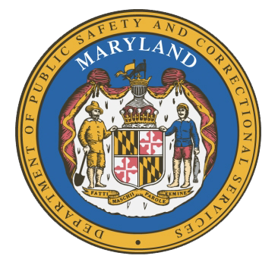
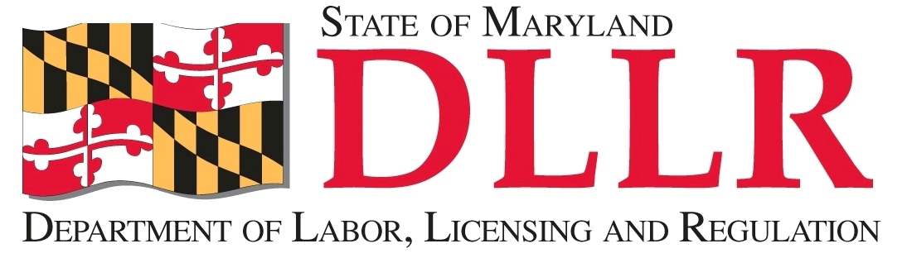
MARYLAND
Department of Public Safety and Correctional ServiceS
In
Partnership
With

Correctional Education Council
December 21, 2017
12:00 pm – 2:00 pm
Department of Labor, Licensing and Regulation
1100 North Eutaw Street, Room 108
Baltimore, MD 21201

Council Meeting Agenda

Welcome/Review of Prior Meeting Minutes (June and September) Secretary Kelly Schulz
Deputy Secretary Michael Zeigler

DLLR Updates Secretary Kelly Schulz

DPSCS Updates Deputy Secretary Michael Zeigler

Update on the Tablet Danielle Cox

Justice Reinvestment Act Constance Parker

Correctional Education Updates Alice Wirth and Staff
- Staff Vacancies Jack Cunning
- Correctional Education GED Numbers Danielle Cox
- Occupational Updates Tamara Barron
- Transitional Updates Erica DuBose

Employer Engagement Committee Updates Jack Weber

Maryland Alliance for Justice Reform (MAJR) John Linton and Steve Steurer
(Presenting at their request)

Concluding Remarks Secretary Kelly Schulz
Deputy Secretary Michael Zeigler

The conference call phone number is 866-247-6034, Code 5812736994 if you cannot attend in person.

